Research Report Open Access
Comparison of Expression Activity of Key Genes in Strawberry Fruit Development
Liu Wei ^{1,2}, Huo Chensi ^{1,2}, Wang Guoping ^{1,2}, Shang Yongjin ^{1,2}, Fan Xinping ^{1,2}
1 Institute of Pomology, Shanxi Agricultural University, National and Local Joint Engineering Research Center for Detoxification and Breeding Technology of Horticultural Plants (Shanxi), Taigu, 030815, China
2 Shanxi Key Laboratory of Germplasm Improvement and Utilization in Pomology, Shanxi Agricultural University, Taiyuan, 030031, China
Corresponding author email: gssfxp-919@163.com
Molecular Plant Breeding, 2020, Vol.11, No.21 doi: 10.5376/mpb.2020.11.0021
Received: 02 Sep., 2020
Accepted: 04 Sep., 2020
Published: 18 Sep., 2020
Copyright © 2020 Liu et al., This article was first published in Molecular Plant Breeding in Chinese, and here was authorized to translate and publish the paper in English under the terms of Creative Commons Attribution License, which permits unrestricted use, distribution, and reproduction in any medium, provided the original work is properly cited.
Preferred citation for this article:
Liu W., Huo C.S., Wang G.P., Shang Y.J., and Fan X.P., 2020, Comparison of expression activity of key genes in strawberry fruit development, Molecular Plant Breeding, 11(21): 1-7 (doi: 10.5376/mpb.2020.11.0021)
Abstract Key genes in strawberry fruit development play an important role in the development and maturation of strawberry fruit, and are also important in molecular breeding and genetic improvement. UPL probes was used to quantitatively analyze the expression of strawberry genes FaNCED1, FaPG, FaEXP5 and FaDFR at different stages of fruit development and in different organs. The results showed that FaPG and FaEXP5 significantly increased expression in the late stage of fruit development. And FaPG had significant fruit-specific expression. At every stage of fruit development, FaDFR showed a higher level of expression than other genes. This study provides some theoretical reference for the development and utilization of key genes in strawberry fruit development..
Keywords Strawberry (Fragaria×ananassa); Fruit; Developmental period; Gene expression
Strawberries (Fragaria × ananassa), apples, pears, peaches, plums, apricots and other important fruits belong to the Rosaceae. Strawberry planting area is wide, the growth cycle is short, the reproduction is fast, not only can be planted in the open air but also suitable for facility cultivation. Compared with other fruit trees, strawberry is easy to be transformed by agrobacterium, so it is often used as the model material of Rosaceae for scientific research. Cultivated strawberries are usually octaploid, originating from four diploid ancestors (Shulaev et al., 2011). Strawberry fruit is formed by the expansion of the receptacle, rich in anthocyanin and vitamin C, with high nutritional value (Afrin et al., 2016). For a long time, breeders have been committed to improving the color, flavor and nutrition of strawberry fruits (Kayesh et al., 2013; Pillet et al., 2015). Further research on key genes of strawberry fruit development can provide theoretical basis for the related mechanism of fruit quality formation and contribute to the creation of excellent germplasm (Carvalho and Folta, 2017).
In order to realize its function, a gene can be regulated at many levels, among which the regulation of transcriptional expression is particularly important. Regulatory sequences of transcriptional expression can include promoters, 5'UTR, 3'UTR, introns, and even sequences further from the encoding region. The most important regulatory sequence is the promoter.The promoter controls when and to what extent the target gene is expressed.Promoters can be classified into constituent promoters, tissue specific promoters and inducible promoters(Zeng et al., 2018). Constitutive promoters are not tissue specific and keep gene expression intensity at a fixed level. Constitutive promoters are not tissue specific and keep gene expression intensity at a fixed level. Inducible promoters usually initiate gene transcription only after receiving induction of a response signal. Tissue-specific promoters are also called organ-specific promoters. Under the regulation of this promoter, gene expression generally occurs only in some specific organ or tissue sites, and often shows the characteristics of regulating development. Analysis of tissue-specific genes is helpful to explore the function of tissue-specific promoters (Shahan et al., 2019).

Some genes closely related to fruit development have been published, according to previous research reports. For example, 9-cis-epoxycarotenoid Dioxygenase (NCED) is a key enzyme in the biosynthetic pathway of ABA in higher plants (Sun et al., 2012). NCED is synthesized in plants under the conditions of ripening, wilt and water shortage. Many NCED genes in plants have been cloned and identified. Silencing of NCED gene in sweet cherry may lead to a colorless phenotype (Shen et al., 2014). The accumulation of anthocyanin in strawberry is regulated by abscisic acid. When the ABA synthase FaNCED1 is inactivated or the ABA receptor is blocked, anthocyanin cannot form in the fruit (Jia et al., 2011). Polygalacturonase (PG) acts on pectin molecules, causing pectin degradation and cell wall structure disintegration, leading to fruit softening. It was confirmed in the ripening process of tomato (Jiang et al., 2019), peach (Chen et al., 2009), strawberry (Hao et al., 2009) and other fruits. Expansin (EXP) is a kind of plant extension protein that is coded by a large family of genes. EXP expression is closely related to growth and maturation in many plant (Sampedro and Cosgrove, 2005). In strawberries, FaEXP1, FaEXP2 and FaEXP5 have been identified to be closely related to fruit firmness (Dotto et al., 2006). Dihydroflavonol reductase (DFR) is an enzyme required as the last step in the catalytic flavonoid biosynthesis pathway and can lead to anthocyanin and proanthocyanidin production. DFR is a key enzyme expressed downstream of anthocyanin biosynthesis pathway in fruits, which is highly expressed in fruits with bright colors under normal conditions.
In general, the promoter of regulatory genes is weak, while the promoter of structural genes is strong. In this study, specific structural genes of fruit were selected, belonging to four different metabolic pathways. NCED1 is a key enzyme in ABA synthesis pathway, PG is related to cell wall synthesis, EXP5 is an important gene that causes cell expansion in vivo, and DFR is a structural gene downstream of anthocyanin synthesis. Through the analysis and comparison of the expression activities of these structural genes in different tissues and different fruit development stages of strawberry, the change rules of these structural genes in the fruit development process were grasped, which provided theoretical support for further exploring the function of specific promoters of fruit and gene engineering breeding.
1 Results and Analysis
1.1 Physical and chemical characteristics analysis of FaNCED1, FaPG, FaEXP5 and FaDFR genes
In this study, strawberry FaNCED1, FaPG, FaEXP5 and FaDFR gene sequences were obtained from NCBI database. According to the statistical analysis of gene sequences on the website of ExPASy (Table 1), the CDS sizes of FaNCED1, FaPG, FaEXP5 and FaDFR genes were 679 bp, 1 218 bp, 488 bp and 1 026 bp, respectively, encoding 226,405,162,341 amino acids, with molecular weights ranging from 17.57 to 43.31 kD. The hydrophilic values of the proteins ranged from -0.248 to -0.146, all of which were hydrophilic proteins. The predicted isoelectric values of the four proteins ranged from 6.47 to 9.14, including three basic proteins and one acidic protein. The instability index of all four proteins was less than 40, indicating that the protein structure was relatively stable.
Table 1 Physical and chemical properties of the key genes in strawberry fruit development
Gene name | Gene ID | Length of the sequence (bp) | Number of amino acids | Molecular weight (kD) | Grand average of hydropathicity | Theoretical pI | Instability index
FaNCED1 | HQ290318.1 | 679 | 226 | 25 475.33 | -0.181 | 7.23 | 35.33
FaPG | DQ458990.1 | 1 218 | 405 | 43 309.31 | -0.146 | 8.47 | 32.12
FaEXP5 | AF226702.1 | 488 | 162 | 17 566.89 | -0.248 | 9.14 | 30.14
FaDFR | AY575057.1 | 1 026 | 341 | 38 053.88 | -0.192 | 6.47 | 36.66
1.2 Analysis of expression characteristics of different genes in different organs of strawberry
Different genes often have different expression patterns, and their expression is different in different organs, and there are often specific expressions in some organs. In this study, expression characteristics of FaNCED1, FaPG, FaEXP5 and FaDFR in strawberry root, fruit, flower, runner, petiole and leave were analyzed using Roche UPL universal probe assay (Figure 1). The results showed that the expression of FaNCED1 was higher in root, runner and petiole than in fruit, flower and leaf. FaPG was significantly higher in fruit than other tissues and organs. The expression patterns of FaEXP5 and FaDFR were similar, and the expression level in fruit was significantly higher than that in other organs. It can be seen that the expressions of FaPG, FaEXP5 and FaDFR in fruits all have certain significance.
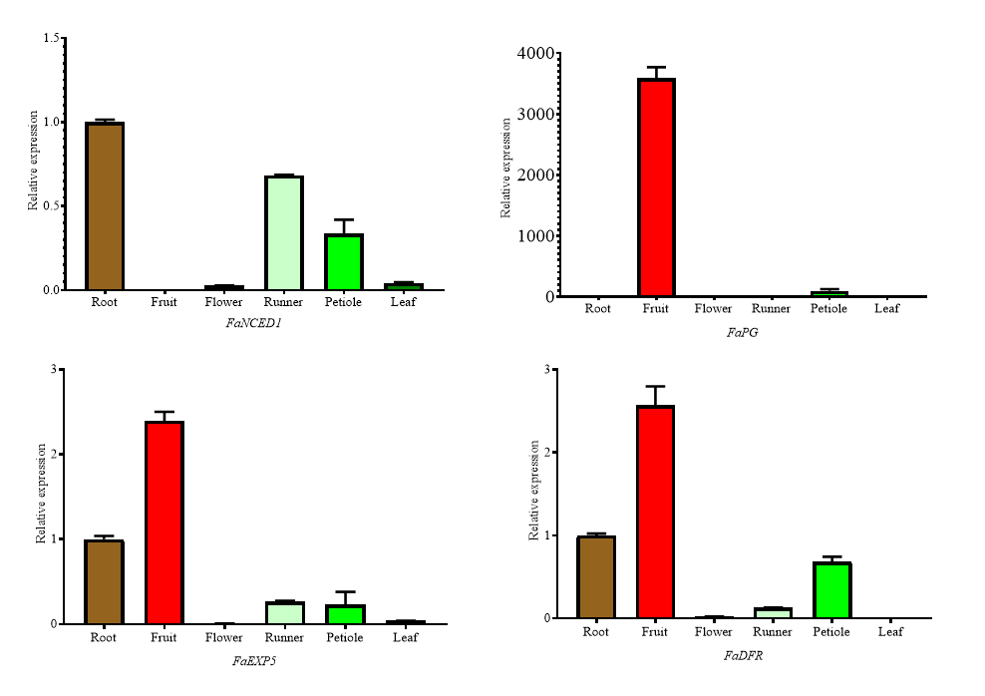
Figure 1 Expression of FaNCED1, FaPG, FaEXP5 and FaDFR in different organs of strawberry
1.3 Analysis of the expression characteristics of different genes in different development stages of strawberry fruits
There are seven obvious stages in strawberry fruit development, namely SG (Small green), BG (Big green), DG (Degreening), Wt (White fruit), IR (Initial red), PR (Partial red) and FR (Full red).In this study, the expression characteristics of FaNCED1, FaPG, FaEXP5 and FaDFR in different development stages of strawberry fruits were also studied by using Roche UPL universal probe detection technique (Figure 2).The results showed that the expression of FaNCED1 and FaDFR fluctuated with the development of the fruit, and the expression of FaNCED1 reached the first peak in the DG period, followed by a decrease, and then increased with the fruit gradually ripening. The expression of FaDFR reached its first peak in the BG period, followed by a decline, and then an up-regulation, and maintained a high expression level after IR period. The expression of FaPG began at the IR period, then increased gradually, and reached its peak when the fruit was fully ripe. The expression level of FaEXP5 was relatively low before fruit ripening and significantly increased at fruit ripening stage. The expressions of FaNCED1, FaPG and FaEXP5 gradually increased in the stage of IR, PR and FR, and reached the highest level in the stage of full-ripening. FaDFR expression was relatively high in strawberry fruits at IR, PR and FR stages.
1.4 Analysis of expression differences of different genes in the same period of fruit development
Since the expression of each gene was different at different fruit development stages, the expressions of FaNCED1, FaPG, FaEXP5 and FaDFR at the same fruit development stage were compared and analyzed (Figure 3). The expression of FaDFR was significantly higher than that of the other three genes from SG to IR stage. However, FaPG expression was significantly higher than that of other genes in the half-ripe and full-ripe stages. It can be seen that compared with other genes, FaDFR is highly expressed throughout the development of strawberry fruits, while FaPG may play an important role in the later stage of fruit development.
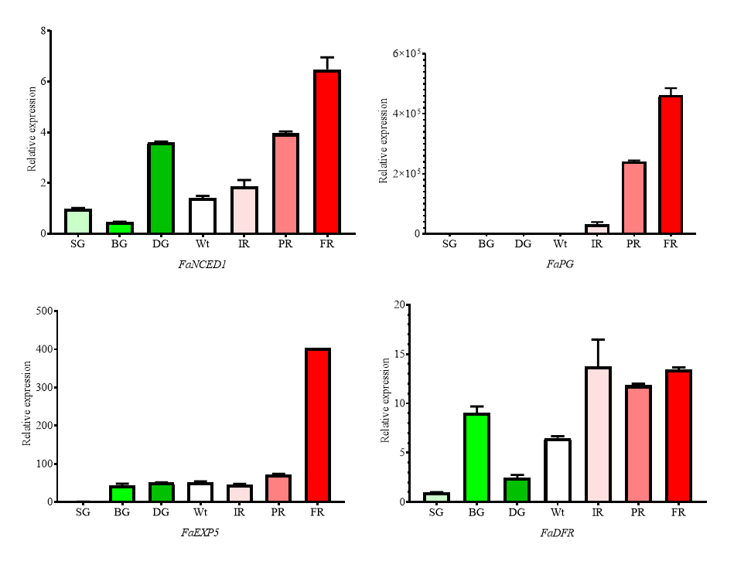
Figure 2 Expression of FaNCED1, FaPG, FaEXP5 and FaDFR in the different development periods of strawberry fruit
Note: SG: Small green period; BG: Big green period; DG: Degreening period; Wt: White fruit period; IR: Initial red period; PR: Partial red period; FR: Full red period
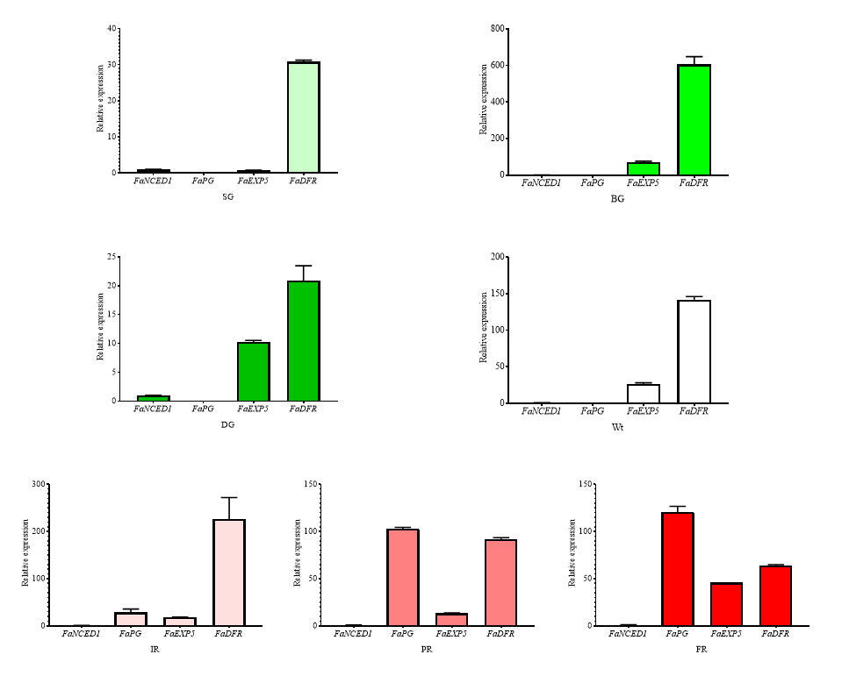
Figure 3 Comparison of expression differences of FaNCED1, FaPG, FaEXP5 and FaDFR in the same development period of strawberry fruit
2 Discussion
FaNCED1 is a key gene in ABA synthesis. It has been reported that FaNCED1 gene is expressed in strawberry roots, stems, leaves, calyx and fruits. During the fruit ripening process, FaNCED1 expression reached two peaks, respectively at white fruit stage and fruit maturity stage, and the expression level is the highest at fruit maturity stage, which is consistent with ABA accumulation (Zhu et al., 2012). In this study, the first expression peak of FaNCED1 occurred at the DG stage, which was speculated to be caused by the differences between varieties. Studies have shown that the expression of FaEXP2 and FaEXP5 increased significantly in Fragaria chiloensis with the rapid decrease of fruit hardness during fruit development (Figueroa et al., 2009). Dotto et al. (2006) confirmed that the expression of FaEXP5 was related to the firmness of strawberry fruit. With the decrease of fruit hardness, the expression of FaEXP5 increased. The expression patterns were different in different strawberry varieties. In this study, the expression of FaEXP5 increased with the decrease of fruit firmness and reached a peak in the fruit ripening stage, which was consistent with the results in other studies. At the same time, FaPG gene promoted fruit softening (Mercado et al., 2009), and its expression increased with fruit softening, reaching the highest level at the ripening stage. Moyano et al. (1998) proved that FaDFR was first detected in the fruit expansion stage, then its expression declined, and it increased sharply at the beginning of anthocyanin accumulation at the beginning of fruit ripening. This is basically consistent with the expression of FaDFR during fruit development in this study. In addition, from the perspective of tissue specificity, FaPG, FaEXP5 and FaDFR all have certain characteristics of specific expression in fruits, and FaPG is particularly significant. From the perspective of fruit development, all the four genes reached the highest expression level in the later stage of fruit development, indicating that they had a certain relationship with fruit maturation and development. From the comparison of the expression activity of different genes at each stage of development, it can be seen that the expression level of FaDFR is maintained at a relatively high level compared with other genes. This indicates that it may play an important role in every stage of fruit development.
3 Materials and Methods
3.1 Total RNA extraction and cDNA synthesis of strawberry
The experiment was conducted in 2017-2018 at National and Local Joint Engineering Research Center for Detoxification and Breeding Technology of Horticultural Plants (Shanxi). The strawberry variety tested was " Benihoppe ". In December, the strawberry plants in the greenhouse were selected to be labeled, and the fruits at different stages were collected after flowering (Fait et al., 2008; Jia et al., 2011), namely SG, BG, DG, Wt, IR, PR, FR. The fruit was frozen with liquid nitrogen and then put in the refrigerator at -70℃ for later use. Total RNA was extracted by Tiangen RNAprep Pure extraction kit, and cDNA was synthesized by reverse transcription.
3.2 Analysis of physical and chemical properties of strawberry gene
First, FaNCED1, FaPG, FaEXP5, FaDFR gene sequences were found in GenBank database of NCBI website, and the obtained gene sequences were imported into ExPASy website to analyze the physical and chemical properties of genes.
3.3 Design of qRT-PCR primer and probe
For qRT-PCR primers and probe design, first found in GenBank FaNCED1, FaPG, FaEXP5, FaDFR and FaACTIN cDNA sequences, then in accordance with the Roche Universal Probe Library Assay Design Center designed to gene primers and probes, ensure that the sensitivity and specificity in the process of qRT-PCR reaction. The primer and probe sequences are shown in Table 2:
3.4 Analysis of qRT-PCR
Roche Light Cycler 96 qRT-PCR instrument was used for qRT-PCR test, and Excel 2007 and GraphPad Prism 8 software were used for data statistical analysis and plotting. All reaction kits are provided by Roche. A 10 µL reaction system was set for each reaction, including 1 µL cDNA, 5 µL reaction mix, 0.4 µL forward primer, 0.4 µL reverse primer, 0.2 µL probe, and 3 µL ddH₂O. The reaction procedure was: 95°C for 10 min; 95°C for 10 s, 60°C for 30 s, 45 cycles.The experiment was set up for three biological repeats. Finally using 2 ^{- Δ Δ CT} analysis method (Livak and Schmittgen, 2001) to analyze relative gene expression level.
Table 2 The sequences of Primers and probes for qRT-PCR
Name | Forward primer | Reverse primer | Probe
FaACTIN | cccaaggctaatcgtgagaa | aacagcttgaatggccacat | GACCCAGA
FaNCED1 | tgcacgacttcgccatta | atctccgggaggttgaaga | CAGCAGGT
FaPG | tgcaagtagagtcgcacagttt | cccaccatatttcggacttg | AGCTCCTG
FaEXP5 | tgcactccctaacaacaacg | ctgggcgagatcgaaatg | TCCTCAGC
FaDFR | aagcaatgccaatacgttcac | tcggatgctcgtagaggaata | CTCTGCCA
Authors’ contributions
Liu Wei is the experimental designer and executor of this research; Liu Wei and Huo Chensi jointly completed the data analysis and the writing of the first draft of the paper; Wang Guoping and Shang Yongjin participated in experimental design and analysis of experimental results; Fan Xinping is the initiator and responsible person of the project, guiding experimental design, data analysis, paper writing and modification. All authors read and agree to the final text.
Acknowledgement
This study was jointly funded by the Natural Science Foundation of Shanxi Province (201601D102043), the Doctoral Research Fund of Shanxi Academy of Agricultural Sciences (YBSJJ1609) and the Agricultural Science and Technology Innovation Project of Shanxi Academy of Agricultural Sciences (YCX2017D2218).
Reference
Afrin S., Gasparrini M., Forbes-Hernandez T.Y., Reboredo-Rodriguez P., Mezzetti B., Varela-López A., Giampieri F., and Battino M., 2016, Promising health benefits of the strawberry: A focus on clinical studies, J. Agric. Food Chem., 64(22): 4435-4449
https://doi.org/10.1021/acs.jafc.6b00857
PMid:27172913
Carvalho R.F., and Folta K.M., 2017, Assessment of promoters and a selectable marker for development of strawberry intragenic vectors, Plant Cell Tiss. Org. Cult., 128(2): 259-271
https://doi.org/10.1007/s11240-016-1105-3
Chen X., Li W., Wang W.T., and Yang D.L., 2009, Cloning and sequencing of cDNA of polygalacturonase in peach, Shengwu Jishu Tongbao (Biotechnology Bulletin), (6): 96-99
Dotto M.C., Martínez G.A., and Civello P.M., 2006, Expression of expansin genes in strawberry varieties with contrasting fruit firmness, Plant Physiol. Biochem., 44(5-6): 301-307
https://doi.org/10.1016/j.plaphy.2006.06.008
PMid:16889972
Fait A., Hanhineva K., Beleggia R., Dai N., Rogachev I., Nikiforova V.J., Fernie A.R., and Aharoni A., 2008, Reconfiguration of the achene and receptacle metabolic networks during strawberry fruit development, Plant Physiol, 148 (2): 730-750
https://doi.org/10.1104/pp.108.120691
PMid:18715960 PMCid:PMC2556830
Figueroa C.R., Pimentel P., Dotto M.C., Civello P.M., Martínez G.A., Herrera R., and Moya-León M.A., 2009, Expression of five expansin genes during softening of Fragaria chiloensis fruit: Effect of auxin treatment, Postharvest Biology and Technology, 53(1-2): 51-57
https://doi.org/10.1016/j.postharvbio.2009.02.005
Hao Q.N., Ma C., and Ma B.G., 2009, Construction and expression identification of RNAi vector of polygalacturonase gene in strawberry, Shihezi Daxue Xuebao (Journal of Shihezi University (Natural Science)), 27(4): 423-427
Jia H.F., Chai Y.M., Li C.L., Lu D., Luo J.J., Qin L., and Shen Y.Y., 2011, Abscisic acid plays an important role in the regulation of strawberry fruit ripening, Plant Physiol., 157(1): 188-199
https://doi.org/10.1104/pp.111.177311
PMid:21734113 PMCid:PMC3165869
Jiang F., Lopez A., Jeon S., de Freitas S.T., Yu Q., Wu Z., Labavitch J.M., Tian S., Powell A.L.T., and Mitcham E., 2019, Disassembly of the fruit cell wall by the ripening-associated polygalacturonase and expansin influences tomato cracking, Hortic. Res., 6(17): 1-15
https://doi.org/10.1038/s41438-018-0105-3
PMid:30729007 PMCid:PMC6355925
Kayesh E., Shangguan L., Korir N.K., Sun X., Bilkish N., Zhang Y., Han J., Song C., Cheng Z.M., and Fang J, 2013, Fruit skin color and the role of anthocyanin, Acta Physiol. Plant., 35(10): 2879-2890
https://doi.org/10.1007/s11738-013-1332-8

Livak K.J., and Schmittgen T.D., 2001, Analysis of relative gene expression data using real-time quantitative PCR and the 2^{-ΔΔCT} method, Methods, 25(4): 402-408
https://doi.org/10.1006/meth.2001.1262
PMid:11846609
Mercado J.A., Quesada M.A., Blanco-Portales R., Pose S., García-Gago J.A., Jiménez-Bermúdez S., Muñoz-Serrano A., Caballero J.L., Pliego-Alfaro F., and Muñoz-Blanco J., 2009, Antisense down-regulation of the FaPG1 gene reveals an unexpected central role for polygalacturonase in strawberry fruit softening, Plant Physiology, 150(2):1022-1032
https://doi.org/10.1104/pp.109.138297
PMCid:PMC2689968
Moyano E., Portero-Robles I., Medina-Escobar N., Valpuesta V., Muñoz-Blanco J., and Caballero J.L., 1998, A fruit-specific putative dihydroflavonol 4-reductase gene is differentially expressed in strawberry during the ripening process, Plant Physiol., 117(2): 711-716
https://doi.org/10.1104/pp.117.2.711
PMid:9625725 PMCid:PMC34992
Pillet J., Yu H.W., Chambers A.H., Whitaker V.M., and Folta K.M., 2015, Identification of candidate flavonoid pathway genes using transcriptome correlation network analysis in ripe strawberry (Fragaria × ananassa) fruits, J. Exp. Bot., 66(15): 4455-4467
https://doi.org/10.1093/jxb/erv205
PMid:25979996 PMCid:PMC4507756
Sampedro J., and Cosgrove D.J., 2005, The expansin superfamily, Genome Biol., 6(12): 1-11
https://doi.org/10.1186/gb-2005-6-12-242
PMid:16356276 PMCid:PMC1414085
Shahan R., Li D., and Liu Z., 2019, Identification of genes preferentially expressed in wild strawberry receptacle fruit and demonstration of their promoter activities, Hortic. Res., 6(50): 1-10
https://doi.org/10.1038/s41438-019-0134-6
PMid:31044078 PMCid:PMC6491448
Shen X., Zhao K., Liu L., Zhang K., Yuan H., Liao X., Wang Q., Guo X., Li F., and Li T., 2014, A role for PacMYBA in ABA-regulated anthocyanin biosynthesis in red-colored sweet cherry cv. Hong Deng (Prunus avium L.), Plant Cell Physiol., 55(5): 862-880
https://doi.org/10.1093/pcp/pcu013
PMid:24443499
Shulaev V., Sargent D.J., Crowhurst R.N., Mockler T.C., Folkerts O., Delcher A.L., Jaiswal P., Mockaitis K., Liston A., Mane S.P., Burns P., Davis T.M., Slovin J.P., Bassil N., Hellens R.P., Evans C., Harkins T., Kodira C., Desany B., Crasta O.R., Jensen R.V., Allan A.C., Michael T.P., Setubal J.C., Celton J.M., Rees D.J.G., Williams K.P., Holt S.H., Rojas J.J.R., Chatterjee M., Liu B., Silva H., Meisel L., Adato A., Filichkin S.A., Troggio M., Viola R., Ashman T.L., Wang H., Dharmawardhana P., Elser J., Raja R., Priest H.D., Bryant D.W., Fox S.E., Givan S.A., Wilhelm L.J., Naithani S., Christoffels A., Salama D.Y., Carter J., Girona E.L., Zdepski A., Wang W.Q., Kerstetter R.A., Schwab W., Korban S.S., Davik J., Monfort A., Denoyes-Rothan B., Arus P., Mittler R., Flinn B., Aharoni A., Bennetzen J.L., Salzberg S.L., Dickerman A.W., Velasco R., Borodovsky M., Veilleux R.E., and Folta K.M., 2011, The genome of woodland strawberry (Fragaria vesca), Nat. Genet., 43(2): 109-116
https://doi.org/10.1038/ng.740
PMid:21186353 PMCid:PMC3326587
Sun L., Sun Y., Zhang M., Wang L., Ren J., Cui M., Wang Y., Ji K., Li P., Li Q., Chen P., Dai S., Duan C., Wu Y., and Leng P., 2012, Suppression of 9-cis-epoxycarotenoid dioxygenase, which encodes a key enzyme in abscisic acid biosynthesis, alters fruit texture in transgenic tomato, Plant Physiol., 158(1): 283-298
https://doi.org/10.1104/pp.111.186866
PMid:22108525 PMCid:PMC3252109
Zeng X.L., Zhao C.L., Wen G.S., Ding C., Zhang H.L., Xu S., and Gu C.S., 2018, Research advances in prediction and validation methods for structures and functions of promoters, Fenzi Zhiwu Yuzhong (Molecular Plant Breeding), 16(12): 3915-3925
Zhu H.S., Li Y.P., Hua X.F., and Wen Q.F., 2012, Cloning and expression analysis of 9-cis epoxycarotenoid dioxygenase gene FaNCED in strawberry, Yuanyi Xuebao (Acta Horticulturae Sinica), 39(1): 40-48

