Research Insight

**Breeding Potential and Challenges of Glufosinate-Tolerant Rice Variety for Weedy Rice Management**

Haibo Xiong4, Yushan Yin3, Qian Zhu1,2,3, Juan Li1,2,3, Huirong Dong,2,3, Dongsun Lee1,2,3 , Lijuan Chen1,2,3*

1State Key Laboratory for Conservation and Utilization of Bio-Resources in Yunnan, Yunnan Agricultural University, Kunming, 650201, Yunnan, China

2The Key Laboratory for Crop Production and Smart Agriculture of Yunnan Province, Yunnan Agricultural University, Kunming 650201, Yunnan, China

3Rice Research Institute, Yunnan Agricultural University, Kunming, 650201, Yunnan, China

4Chuxiong Normal University, Chuxiong, 675099, Yunnan, China

*Corresponding author: [chenlijuan@hotmail.com](mailto:chenlijuan@hotmail.com)

**Abstract** The research revealed that glufosinate resistance can be transferred from transgenic rice to weedy rice, with significant implications for agronomic performance and weed management. Hybrid populations of transgenic glufosinate-resistant rice and weedy rice exhibited similar plant vigor, density, and seed dormancy compared to non-transgenic populations. The gene flow from transgenic rice to weedy rice occurred at low frequencies but was sufficient to confer herbicide resistance. Additionally, the agronomic performance of hybrids was comparable to that of weedy rice parents, indicating that gene flow could occur under natural conditions. Although glufosinate-tolerant rice has the potential for breeding and crop improvement, it also presents significant challenges for weedy rice management. Effective management strategies are essential to mitigate the risk of herbicide-resistant weedy rice populations and ensure the sustainable use of transgenic herbicide technologies. This review aimed to evaluate the breeding potential and challenges associated with glufosinate-tolerant rice, understand the genetic and agronomic consequences of transferring glufosinate resistance from transgenic rice to weedy rice and assessing the implications for weed management and crop improvement.

**Keywords** Glufosinate-tolerant; Weedy rice; Gene flow; Herbicide resistance; Agronomic performance

**1 Introduction**

Weedy rice (*Oryza sativa* f. *spontanea*) refers to the unwanted plants of the genusOryza that have some undesirable agronomic traits and pose a major threat to sustainable rice production world wide (Chen and Suh, 2015; Nadir et al., 2017). Weedy rice is also referred to as “red rice” because of its red pericarp. It exhibits rapid growth, high tillering, enhanced fertilizer uptake, asynchronous maturation, ease of shattering, and high seedbank longevity, making it more competitive than cultivated rice (Figure 1) (Nadir et al., 2017; Shrestha et al., 2019). The genetic diversity and plasticity of weedy rice contribute to its success in various ecosystems, posing a major threat to rice yields and necessitating effective management strategies (Shrestha et al., 2022). Additionally, weedy rice can serve as a valuable genetic resource for crop improvement, particularly in developing herbicide-tolerant rice varieties.

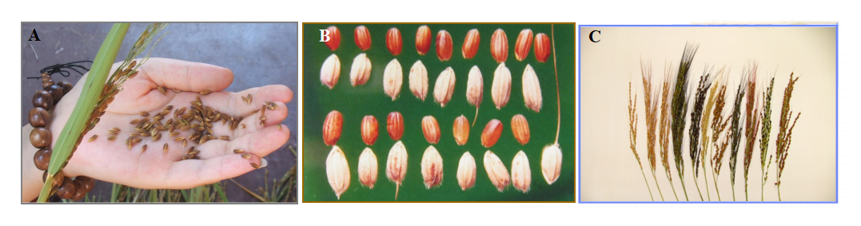

Figure 1. Characteristics of weedy rice. (A) easy seed shattering. (B) pericarp color. (C) weedy rice panicles showing variations in awns, hull color, and panicle size (Adopted from Nadir et al., 2017)

Glufosinate is a broad-spectrum herbicide used to control a wide range of weeds, including weedy rice. The development of glufosinate-tolerant rice varieties has been a focus of research to enhance weed management in rice fields. Studies have shown that certain weedy rice accessions exhibit reduced sensitivity to glufosinate, indicating potential for breeding glufosinate-tolerant rice (Shrestha et al., 2019). However, the bidirectional gene flow between transgenic glufosinate-resistant rice and weedy rice raises concerns about the emergence of herbicide-resistant weedy rice populations, which could pose significant agro-ecological risks (Chen et al., 2004; Lu et al., 2014; Zhang et al., 2018; Shrestha et al., 2020). The agronomic performance of hybrids between weedy rice and transgenic glufosinate-resistant rice suggests that gene flow from cultivated rice to weedy rice can occur under natural conditions, further complicating weed management (Song et al., 2011).

This review aims to evaluate the breeding potential of glufosinate-tolerant rice accessions for developing herbicide-resistant rice varieties, assess the challenges associated with the introgression of glufosinate tolerance from weedy rice to cultivated rice, investigate the genetic diversity and agronomic performance of weedy rice accessions with varying levels of glufosinate tolerance, and explore the implications of gene flow between transgenic glufosinate-resistant rice and weedy rice on weed management and rice production sustainability. By addressing these objectives, this review hope to provide insights into the potential and challenges of utilizing weedy rice in breeding programs for herbicide-resistant rice, contributing to more effective and sustainable weed management strategies in rice cultivation.

**2 Background on Weedy Rice**

**2.1 Characteristics and distribution**

Weedy rice is a significant weed in rice cultivation, known for its competitive traits that make it more resilient and persistent than cultivated rice. These traits include rapid growth, high tillering, enhanced fertilizer uptake, asynchronous maturation, ease of shattering, and high seedbank longevity (Nadir et al., 2017; Shrestha et al., 2019). Weedy rice is found in rice-growing regions worldwide, with its distribution closely linked to areas where rice is cultivated (Figure 2) (Nadir et al., 2017). The first reference to weedy rice in the literature was reported by Biroli in 1807 and its occurrence in the USA was reported in 1898 (Nadir et al., 2017). In Korea, weedy rice was observed in 1916, where it was called “sharebyeo” by local farmers. A representative type of weedy rice is “Lu-tao”in China, which was commonly found in the lower Yangtze River (Anhui and Jiangshu provinces) (Chen and Suh, 2015). The presence of weedy rice is particularly problematic in regions that have adopted direct seeding methods, as opposed to traditional transplanting, which had been more effective in controlling weedy rice populations (Gressel and Valverde, 2009).

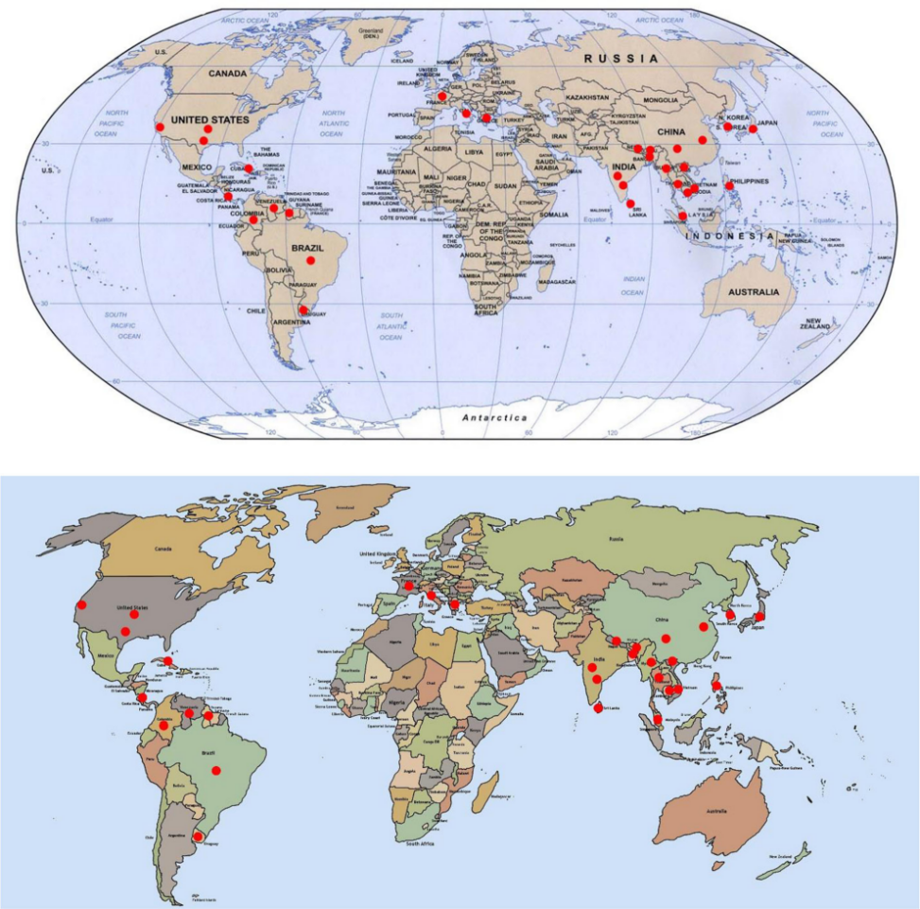

Figure 2 Global distribution of weedy rice. The red circles denote the regions where weedy rice has been reported (Nadir et al., 2017).

**2.2 Impact on rice cultivation**

The presence of weedy rice in rice fields can lead to significant yield losses due to its competitive nature. Weedy rice competes with cultivated rice for resources such as light, nutrients, and water, often resulting in reduced crop yields. Additionally, weedy rice can cause contamination of harvested rice, leading to economic losses. The introgression of weedy rice genes into cultivated rice can also result in the emergence of feral rice populations that possess both weedy and cultivated traits, further complicating management efforts (Zhang et al., 2018). The transfer of herbicide resistance from transgenic rice to weedy rice is another concern, as it can lead to the development of herbicide-resistant weedy rice populations, making control even more challenging (Zhang et al., 2003; Cromwell et al., 2005; Lu et al., 2014).

**2.3 Management strategies**

Managing weedy rice requires a multifaceted approach that includes both cultural and chemical control methods. Traditional transplanting methods have been effective in controlling weedy rice, but the shift to direct seeding has necessitated the development of new strategies. The use of herbicide-resistant rice varieties, such as those resistant to glufosinate, has been explored as a potential solution. However, the risk of gene flow from transgenic rice to weedy rice necessitates careful management to prevent the development of herbicide-resistant weedy rice populations (Zhang et al., 2003; Chen et al., 2004; Song et al., 2011; Lu et al., 2014). Strategies such as crop rotation, the use of multiple herbicides, and the development of dual herbicide-tolerant crops (Figure 3) are recommended to mitigate the risk of resistance development and ensure sustainable weed management (Gressel and Valverde, 2009; Fartyal et al., 2018). Additionally, the use of mitigation genes that render hybrids with weedy rice unfit to compete has been proposed as a way to contain herbicide resistance within the crop.

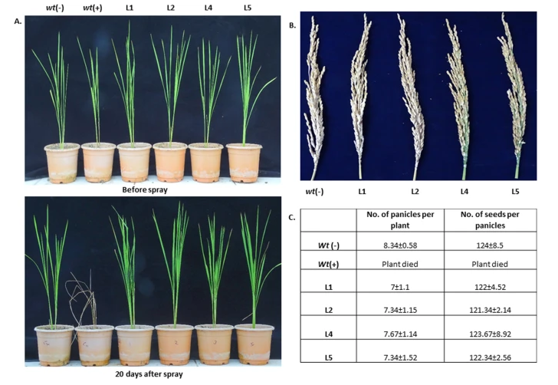

Figure 3. Analyzing the dual herbicide tolerance of transgenic plants (Adopted from Fartyal et al., 2018)

Image caption: (A) Transgenic plants were sprayed with 300 μM BM after 7 days of application of 2% basta. No phenological symptoms of leaf injury was recorded in transgenic lines, while the wt (+) plants died shortly even before the application of BM. (B) Effects of transgene integration and dual herbicide applications on the yield of transgenic lines. (C) Yield analysis of number of the seeds per panicle of transgenic (after herbicide application) and wt (−) plants. No significant differences were observed between the wt (+) and transgenic plants (Adopted from Fartyal et al., 2018)

**3 Mechanisms of Glufosinate Tolerance**

**3.1 Mode of action of glufosinate**

Glufosinate is a broad-spectrum herbicide that inhibits glutamine synthetase (GS), an enzyme critical for nitrogen metabolism in plants. By inhibiting GS, glufosinate causes an accumulation of ammonia in plant tissues, leading to cellular toxicity and plant death (James et al., 2018). The herbicide's effectiveness is due to its ability to disrupt the synthesis of glutamine from glutamate and ammonia, which is essential for plant growth and development (Bao et al., 2022).

**3.2 Genetic basis of tolerance**

The genetic basis of glufosinate tolerance in weedy rice and other crops often involves the introduction or overexpression of genes that encode for modified or additional copies of GS. For instance, in maize, the gene *ZmGHT1*, which encodes an aminotransferase, has been identified as a key player in conferring glufosinate tolerance. This gene likely participates in ammonia elimination involving GS activity, thereby reducing the toxic effects of glufosinate (Bao et al., 2022). Similarly, in transgenic rice, the overexpression of GS genes such as *OsGS1;1* and *OsGS2* has been shown to enhance tolerance to glufosinate by maintaining higher GS activity and lower ammonia levels (James et al., 2018). Additionally, the *bar* gene, which encodes phosphinothricin acetyltransferase, is commonly used in transgenic crops to confer glufosinate resistance by detoxifying the herbicide (Zhang et al., 2003; Yu et al., 2023).

**3.3 Physiological responses to glufosinate**

Physiological responses to glufosinate in tolerant plants include enhanced GS activity and reduced ammonia accumulation. For example, transgenic rice lines overexpressing *OsGS1;1* and *OsGS2* showed higher fresh weight, chlorophyll content, and relative water content under stress conditions, indicating improved physiological resilience (James et al., 2018). In maize, plants with the *ZmGHT1* gene exhibited lower ammonia content and higher GS activity after glufosinate treatment, suggesting a robust mechanism for ammonia detoxification (Bao et al., 2022). Furthermore, studies on weedy rice have shown that certain accessions exhibit reduced sensitivity to glufosinate, which may be due to inherent genetic variations that enhance their physiological tolerance (Shrestha et al., 2019).

Collectively, these mechanisms highlight the complex interplay between genetic modifications and physiological adaptations that enable certain plants to tolerate glufosinate, providing valuable insights for breeding and biotechnological interventions aimed at developing herbicide-resistant crops.

**4 Identification of Glufosinate-Tolerant Rice**

**4.1 Screening and selection techniques**

Screening and selection of glufosinate-tolerant rice involve several methodologies to ensure accurate identification and effective breeding. One common approach is the use of herbicide application to identify resistant individuals. For instance, in maize, a screening process involved spraying 854 inbred lines and 25,620 seedlings with glufosinate, identifying a single tolerant plant (Bao et al., 2022). Similarly, in rice, transgenic lines are often developed using gene transfer techniques such as particle bombardment, followed by selection using agents like bialaphos or hygromycin B to confirm resistance (Jiang et al., 2000; Kim et al., 2007). Field trials are also essential, where transgenic rice lines are grown alongside weedy rice to observe natural outcrossing and resistance transfer (Figure 4) (Zhang et al., 2003; Chen et al., 2004; Busconi et al., 2014).

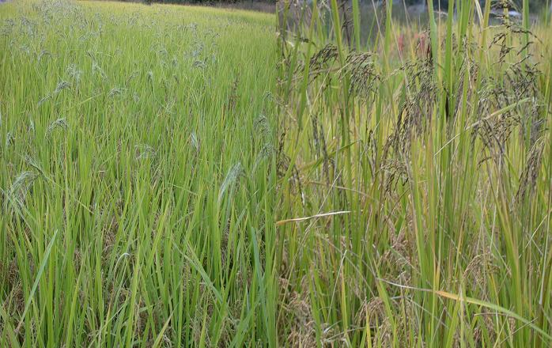

Figure 4 Field experiment of the crop-weedy mixture population, in which the weedy rice materilas (tall) were planted together with a glufosinate-tolerant transgenic rice (short) as a mimic mixture (Modified from Chen et al., 2004)

**4.2 Genotypic and phenotypic characterization**

Genotypic and phenotypic characterization of glufosinate-tolerant weedy rice is crucial for understanding the underlying genetic mechanisms and the expression of resistance traits. Molecular techniques such as Southern blot analysis and polymerase chain reaction (PCR) are employed to confirm the integration and expression of resistance genes like *pat* or *bar* in the rice genome (Jiang et al., 2000; Chen et al., 2004; Lu et al., 2014). Phenotypic traits such as plant height, maturity, seed dormancy, and seed production are evaluated to assess the impact of resistance genes on the overall fitness and agronomic performance of hybrids (Oard et al., 2000; Song et al., 2011). For example, hybrids between transgenic rice and weedy rice often exhibit traits like increased height and delayed maturity, which are indicative of successful gene transfer (Zhang et al., 2003; Zhang et al., 2018).

**4.3 Field studies and experimental evidence**

Field studies provide critical experimental evidence for the behavior and impact of glufosinate-tolerant weedy rice in real-world agricultural settings (Figure 5) (Chen et al., 2004). These studies often involve planting transgenic rice alongside weedy rice and monitoring gene flow, hybridization rates, and the persistence of resistance traits across generations. For instance, field trials in Louisiana and Arkansas evaluated the agronomic performance of F2 populations derived from transgenic rice and red rice, revealing significant differences in traits like plant height and maturity (Oard et al., 2000). Another study in China assessed gene flow from glufosinate-resistant rice to various rice cultivars and weedy rice, finding that gene flow frequencies varied significantly among different recipients and years (Lu et al., 2014). These field studies underscore the importance of comprehensive management strategies to mitigate the spread of herbicide resistance in weedy rice populations.

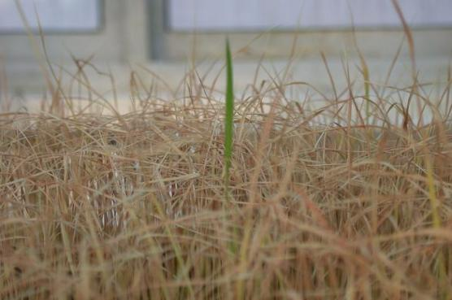

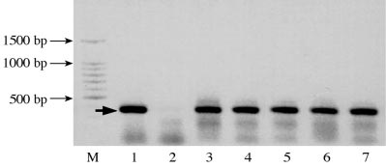

Figure 5 PCR detection of the *bar* gene in the surviving weedy rice seedlings that were resistant to the herbicide Basta (Modified from Chen et al., 2004). Lane 1, the transgenic rice line F5 with the *bar* gene; lane 2, weedy rice (bulk DNA sample of YW2257, YW2247 and YW1396); lanes 3-7, YW2257-HR (herbicide resistant) seedling-1, YW2257-HR seedling-2, YW2247-HR seedling-1, YW2247-HR seedling-2 and YW1396-HR seedling. M = DNA ladders .

**5 Breeding Potential of Glufosinate-Tolerant Weedy Rice**

**5.1 Genetic resources and germplasm**

The genetic resources and germplasm of weedy rice present a significant potential for breeding glufosinate-tolerant varieties. Weedy rice is known for its competitive traits such as rapid growth, high tillering, and enhanced nutrient uptake, which can be advantageous for crop improvement. Studies have shown that weedy rice accessions exhibit varying levels of tolerance to herbicides, including glufosinate, making them valuable genetic resources for developing herbicide-resistant rice varieties (Shrestha et al., 2019). Additionally, the introgression of weedy rice genes into transgenic rice has been observed, indicating the potential for gene flow and the creation of hybrid populations with desirable traits (Lu et al., 2014; Zhang et al., 2018).

**5.2 Breeding strategies and approaches**

Breeding strategies for glufosinate-tolerant rice involve both traditional and modern biotechnological approaches. One effective method is the transformation of elite rice lines using gene transfer techniques, such as particle bombardment, to introduce glufosinate resistance genes like *pat* or *bar* (Kim et al., 2007). This approach has been successfully applied to U.S. rice lines and photoperiod-sensitive genic male sterile (PGMS) lines, resulting in high transformation efficiency and stable integration of resistance genes (Jiang et al., 2000; Kim et al., 2007). Another strategy is the hybridization of transgenic glufosinate-resistant rice with weedy rice accessions, which has shown that hybrids can maintain high agronomic performance and herbicide resistance across multiple generations (Chen et al., 2004; Song et al., 2011). Furthermore, genetic analysis and fine mapping of resistance loci, such as *ZmGHT1* in maize, provide insights into the genetic mechanisms underlying herbicide tolerance, which can be applied to rice breeding programs (Bao et al., 2022).

**5.3 Integration into cultivated rice varieties**

Integrating glufosinate-tolerant traits into cultivated rice varieties requires careful management to mitigate the risks of gene flow and the evolution of resistant weedy populations. Field evaluations have demonstrated that hybrids between transgenic rice and weedy rice can exhibit traits such as increased height, extended flowering, and high seed shattering, which pose ecological risks (Zhang et al., 2003; Zhang et al., 2018). To address these challenges, breeding programs must incorporate strategies to control gene flow, such as the use of mitigation genes that render hybrids unfit to compete (Gressel and Valverde, 2009). Additionally, the development of dual herbicide-tolerant transgenic rice plants can provide sustainable weed management solutions by reducing the reliance on a single herbicide and preventing the evolution of resistant weeds (Fartyal et al., 2018). Effective integration of these traits into cultivated varieties will require ongoing research and field trials to ensure agronomic performance and environmental safety.

**6 Challenges in Breeding Glufosinate-Tolerant Rice**

**6.1 Gene flow and contamination risks**

Gene flow from glufosinate-resistant rice to weedy rice is a significant challenge due to the potential for creating herbicide-resistant weedy rice populations. Studies have shown that gene flow can occur at varying frequencies depending on the proximity and reproductive compatibility between transgenic rice and weedy rice. For instance, gene flow frequencies from glufosinate-resistant rice to weedy rice have been observed to range from 0.011% to 0.488% under different experimental conditions (Chen et al., 2004; Song et al., 2009; Lu et al., 2014; Sun et al., 2015; Nadir et al., 2017). The bidirectional gene flow between transgenic cultivated rice and weedy rice further complicates the issue, as it can lead to the introgression of weedy traits into hybrid rice, increasing the agro-ecological risks (Zhang et al., 2018). Additionally, the presence of transgenes in weedy rice populations can persist and spread, posing long-term contamination risks (Cao et al., 2009; Yook et al., 2020).

**6.2 Environmental and ecological concerns**

The environmental and ecological impacts of gene flow from glufosinate-resistant rice to weedy rice are profound. The hybrid progeny resulting from such gene flow often exhibit enhanced fitness and weediness traits, which can lead to more aggressive and resilient weedy rice populations (Olguin et al., 2009; Song et al., 2011; Zhang et al., 2018). These hybrids can outcompete native plant species, disrupt local ecosystems, and reduce biodiversity. Moreover, the increased fitness of hybrids, such as higher germination rates and greater vegetative and reproductive potential, can facilitate their persistence and spread in the environment (Cao et al., 2009; Yook et al., 2020). The potential for these hybrids to become dominant in agricultural fields and natural habitats raises significant ecological concerns.

**6.3 Regulatory and biosafety issues**

Regulatory and biosafety issues are critical challenges in the breeding of glufosinate-tolerant rice. The potential for gene flow and the resulting environmental risks necessitate stringent biosafety assessments and regulatory measures. Current regulations may not fully address the complexities of gene flow and the long-term impacts of transgenic crops on wild relatives and ecosystems (Zhang et al., 2003; Sun et al., 2015). Effective management strategies, including isolation distances and monitoring of transgenic rice variety and weedy rice populations, are essential to mitigate the risks. Additionally, the development of comprehensive biosafety guidelines that consider the specific ecological contexts and potential gene flow scenarios is crucial for the safe deployment of glufosinate-resistant rice varieties.

The challenges in breeding glufosinate-tolerant rice are multifaceted, involving gene flow and contamination risks, environmental and ecological concerns, and regulatory and biosafety issues. Addressing these challenges requires a holistic approach that integrates scientific research, regulatory frameworks, and effective management practices to ensure the safe and sustainable use of transgenic rice technologies.

**7 Advanced Techniques in Breeding Glufosinate-Tolerant Rice**

**7.1 Molecular breeding and marker-assisted selection**

Molecular breeding and marker-assisted selection (MAS) are pivotal in developing glufosinate-tolerant rice (Chen and Suh, 2015). These techniques involve the identification and utilization of specific genetic markers linked to desirable traits, such as herbicide tolerance. For instance, the development of herbicide-tolerant near-isogenic lines (NILs) in Basmati rice using marker-assisted backcross breeding (MABB) has been demonstrated successfully. In a study, a mutant allele of the acetohydroxy acid synthase (*AHAS*) gene, conferring tolerance to imidazolinone herbicides, was transferred into the genetic background of an elite Basmati variety, resulting in high-yielding, herbicide-tolerant lines (Grover et al., 2020). This approach can be adapted for glufosinate tolerance by identifying and utilizing markers linked to the *bar* or *pat* genes, which confer resistance to glufosinate.

**7.2 CRISPR/Cas9 and gene editing technologies**

CRISPR/Cas9 and other gene editing technologies have revolutionized plant breeding by enabling precise modifications at specific genomic loci (Romero and Gatica-Arias, 2019; Nascimento et al., 2023). These technologies have been effectively applied to create herbicide-tolerant rice varieties. For example, CRISPR/Cas9-mediated gene editing was used to create a novel herbicide-tolerance allele in the *OsALS* gene, resulting in a high level of herbicide tolerance in rice (Wang et al., 2020). Additionally, the CRISPR/Cas9 system has been employed to develop DNA-free genome editing methods, which reduce the risk of off-target effects and regulatory concerns associated with genetically modified organisms (Mishra et al., 2018; Toda et al., 2019; Ansari et al., 2020). These advancements highlight the potential of CRISPR/Cas9 in developing glufosinate-tolerant rice by targeting specific genes involved in herbicide resistance.

**7.3 Omics approaches (genomics, transcriptomics, proteomics)**

Omics approaches, including genomics, transcriptomics, and proteomics, provide comprehensive insights into the genetic and molecular mechanisms underlying herbicide tolerance. These techniques can identify key genes, regulatory networks, and metabolic pathways involved in glufosinate tolerance. For instance, advances in whole-genome sequencing and marker-assisted breeding strategies have significantly enhanced the ability to develop stress-tolerant rice varieties (Ganie et al., 2021). Furthermore, transcriptomic and proteomic analyses can elucidate the expression patterns and protein interactions associated with herbicide resistance, facilitating the identification of novel targets for breeding programs. Integrating omics data with traditional breeding and gene editing techniques can accelerate the development of glufosinate-tolerant rice.

In summary, the combination of molecular breeding, CRISPR/Cas9 gene editing, and omics approaches offers a robust framework for developing glufosinate-tolerant rice. These advanced techniques enable precise genetic modifications, comprehensive understanding of resistance mechanisms, and efficient selection of desirable traits, ultimately contributing to sustainable weed management in rice cultivation.

**8 Case Studies and Practical Applications**

**8.1 Successful breeding programs**

Several breeding programs have successfully developed glufosinate-tolerant rice varieties by integrating the *bar* gene, which confers resistance to the herbicide glufosinate. For instance, the commercial cultivars 'Gulfmont', 'IR72', and 'Koshihikari' were genetically engineered to express the *bar* gene, resulting in stable integration and expression of the transgene. Field trials demonstrated that these transgenic lines produced fertile seeds and exhibited resistance to glufosinate, with minimal impact on agronomic performance (Oard et al., 2004). Additionally, the development of dual herbicide-tolerant maize, which expresses both *cp4* *epsps* and *bar* genes, highlights the potential for creating crops with multiple herbicide resistances to delay the evolution of weed resistance (Yu et al., 2023).

**8.2 Field trials and yield performance**

Field trials have been conducted to evaluate the agronomic performance and yield of glufosinate-tolerant rice hybrids. Studies have shown that F1 hybrids between transgenic glufosinate-resistant rice lines and weedy rice accessions displayed heterosis in traits such as height, flag leaf area, and number of spikelets per panicle. These hybrids maintained similar agronomic performance to their weedy rice parents across multiple generations, indicating the potential for gene flow from transgenic rice to weedy rice under natural conditions (Song et al., 2011). Another study conducted field trials in Louisiana and Arkansas to assess the genetic and agronomic consequences of transferring glufosinate resistance from transgenic rice to “red rice”. The results indicated that transgenic populations exhibited similar plant vigor and density to non-transgenic populations, with no significant differences in seed dormancy and production (Oard et al., 2000).

**8.3 Adoption by farmers and agronomic benefits**

The adoption of glufosinate-tolerant rice by farmers can offer several agronomic benefits, including improved weed control and reduced crop losses due to weed competition. The successful integration of the *bar* gene into commercial rice cultivars has demonstrated the effectiveness of glufosinate in controlling weedy rice and other competitive weeds (Oard et al., 2004). However, the potential for gene flow from transgenic rice to weedy rice poses a significant challenge. Studies have shown that gene flow frequencies can vary based on environmental conditions and the genetic background of the rice varieties involved. For example, gene flow from glufosinate-resistant *japonica* rice to weedy rice was found to be higher than to improved rice cultivars, emphasizing the need for effective management strategies to prevent the evolution of resistant weedy rice populations (Lu et al., 2014; Nadir et al., 2017).

In conclusion, while the development and adoption of glufosinate-tolerant rice varieties offer promising agronomic benefits, careful consideration of gene flow risks and the implementation of robust management practices are essential to ensure the long-term sustainability of these technologies.

**9 Future Directions and Research Opportunities**

**9.1 Emerging trends and innovations**

The development of glufosinate-tolerant rice cultivars presents both opportunities and challenges in agricultural biotechnology. One emerging trend is the creation of dual herbicide-tolerant crops, which can significantly enhance weed management strategies. For instance, transgenic rice plants tolerant to both bensulfuron methyl and glufosinate have been developed, showing promising results in terms of herbicide tolerance without significant growth or yield penalties (Fartyal et al., 2018). This dual tolerance approach could be extended to other herbicides, providing a more robust solution to weed resistance.

Another innovation is the high-efficiency transformation techniques for U.S. rice lines, which have shown stable integration and expression of glufosinate resistance under field conditions (Jiang et al., 2000). These advancements in genetic transformation could facilitate the rapid development and deployment of herbicide-resistant rice varieties, thereby improving weed control and crop productivity.

**9.2 Addressing current research gaps**

Despite the progress made, several research gaps need to be addressed to fully harness the potential of glufosinate-tolerant rice. One critical area is the understanding of gene flow dynamics between transgenic rice and weedy rice. Studies have shown that gene flow can occur at varying frequencies, with weedy rice often exhibiting higher rates of transgene acquisition compared to cultivated rice (Chen et al., 2004; Lu et al., 2014; Nadir et al., 2017; Zhang et al., 2018). Further research is needed to quantify these rates under different environmental conditions and to develop strategies to mitigate unintended gene flow.

Additionally, the fitness and agronomic performance of hybrids between transgenic rice and weedy rice require more comprehensive evaluation. While some studies have indicated that hybrids do not exhibit increased fitness or seed fecundity (Zhang et al., 2003), others have shown that certain hybrid generations can possess higher composite fitness than their transgenic parents (Zhang et al., 2018). Understanding these fitness dynamics is crucial for developing effective management practices to prevent the spread of herbicide resistance in weedy rice.

**9.3 Long-term goals and perspectives**

In the long term, the goal is to develop sustainable weed management systems that minimize the risk of herbicide resistance while maintaining high crop yields. One promising strategy is the use of mitigation technologies that genetically link herbicide resistance genes with traits that render hybrids unfit to compete, such as non-shattering and dwarfism (Gressel and Valverde, 2009). This approach could help contain herbicide resistance within the crop and prevent the spread to weedy rice populations.

Moreover, continuous monitoring and evaluation of herbicide resistance in weedy rice populations are essential. Studies have shown that certain weedy rice accessions exhibit reduced sensitivity to herbicides like glyphosate and flumioxazin, highlighting the need for ongoing surveillance and adaptive management strategies (Shrestha et al., 2019). Integrating these practices with conventional weed management techniques could provide a holistic solution to the challenges posed by glufosinate-tolerant weedy rice.

In conclusion, while significant advancements have been made in the development of glufosinate-tolerant rice, addressing the current research gaps and focusing on long-term sustainable practices will be key to overcoming the challenges and fully realizing the potential of this technology.

**10 Concluding Remarks**

The breeding potential and challenges of glufosinate-tolerant rice have been extensively studied, revealing several critical insights. Firstly, the transfer of glufosinate resistance from transgenic rice to weedy rice occurs at low frequencies but poses significant ecological risks. Studies have shown that outcrossing rates between transgenic glufosinate-resistant rice and weedy rice can be as low as 0.3% to 0.488%. Despite the low frequency, the resulting hybrids can exhibit increased fitness and weediness traits, which complicates management strategies. Additionally, genetic analyses indicate that glufosinate resistance behaves as a single, dominant gene, which can be stably inherited across generations.

The findings underscore the necessity for robust management practices to mitigate the spread of glufosinate resistance in weedy rice populations. The bidirectional gene flow between transgenic and weedy rice highlights the potential for rapid emergence of herbicide-resistant weedy rice, which can outcompete cultivated varieties and reduce crop yields. Effective management strategies should include monitoring and controlling weedy rice populations, especially in fields planted with herbicide-resistant rice. Additionally, integrating multiple herbicide-tolerant crops and alternating herbicide use can help delay the evolution of resistant weeds. The development of dual herbicide-tolerant crops, such as those tolerant to both glufosinate and bensulfuron methyl, offers a promising approach for sustainable weed management.

The breeding of glufosinate-tolerant rice cultivars presents both opportunities and challenges. While the development of herbicide-tolerant crops can significantly enhance weed control and crop productivity, the potential for gene flow to weedy rice necessitates careful consideration and management. Future research should focus on understanding the ecological impacts of herbicide-resistant weedy rice and developing comprehensive management strategies to mitigate these risks. The integration of genetic, agronomic, and ecological approaches will be crucial in ensuring the sustainable use of herbicide-tolerant technologies in rice cultivation.

**Acknowledgments**

We extend our sincere thanks to two anonymous peer reviewers for their invaluable feedback on the initial draft of this paper, whose critical evaluations and constructive suggestions have greatly contributed to the improvement of our manuscript.

**Funding**

This work was supported by the grants from the Central Leading Local Science and Technology Development Project (grant no. 202207AA110010) and the Key and Major Science and Technology Projects of Yunnan (grant nos. 202202AE09002102, 202402AE090026-04).

**Conflict of Interest Disclosure**

The authors affirm that this research was conducted without any commercial or financial relationships that could be construed as a potential conflict of interest.

**References**

Ansari W., Chandanshive S., Bhatt V., Nadaf A., Vats S., Katara J., Sonah H., and Deshmukh R., 2020, Genome editing in cereals: approaches, applications and challenges, *International Journal of Molecular Sciences*, 21(11): 4040. <https://doi.org/10.3390/ijms21114040>

Bao J., Gao Y., Li Y., Wu S., Li J., Dong Z., and Wan X., 2022, Genetic analysis and fine mapping of *ZmGHT1* conferring glufosinate herbicide tolerance in maize (*Zea mays* L.), *International Journal of Molecular Sciences*, 23(19): 11481. <https://doi.org/10.3390/ijms231911481>

Busconi M., Baldi G., Lorenzoni C., and Fogher C., 2014, Gene flow from transgenic rice to red rice (*Oryza sativa* L.) in the field, *Plant Biology*, 16(1): 22-27. <https://doi.org/10.1111/plb.12021>

Cao Q., Xia H., Yang X., and Lu B., 2009, Performance of hybrids between weedy rice and insect-resistant transgenic rice under field experiments: implication for environmental biosafety assessment, *Journal of Integrative Plant Biology*, 51(12): 1138-1148. <https://doi.org/10.1111/j.1744-7909.2009.00877.x>

Chen, L.J., Lee, D.S., Song, Z.P., Suh, H.S., and Lu,B.R., 2004. Gene flow from cultivated rice (*Oryza sativa*) to its weedy and wild relatives. *Annals of Botany,* 93, 67-73. <https://doi.org/10.1093/aob/mch006>

Chen, L.J., & Suh, H.S., (ed.), 2015. Weedy rice—Origin and Dissemination. Yunnan Publishing Group Corporation, Yunnan Science and Technology Press, China. pp 234

Cromwell G., Henry B., Scott A., Gerngross M., Dušek D., and Fletcher D., 2005, Glufosinate herbicide-tolerant (LibertyLink) rice vs. conventional rice in diets for growing-finishing swine, *Journal of Animal Science*, 83(5): 1068-1074. <https://doi.org/10.2527/2005.8351068X>

Fartyal D., Fartyal D., Agarwal A., Agarwal A., James D., Borphukan B., Ram B., Ram B., Sheri V., Agrawal P., Achary V., and Reddy M., 2018, Developing dual herbicide tolerant transgenic rice plants for sustainable weed management, *Scientific Reports*, 8: 11598. <https://doi.org/10.1038/s41598-018-29554-9>

Ganie S., Wani S., Henry R., and Hensel G., 2021, Improving rice salt tolerance by precision breeding in a new era, *Current Opinion in Plant Biology*, 60: 101996. <https://doi.org/10.1016/j.pbi.2020.101996>

Gressel J., and Valverde B., 2009, A strategy to provide long-term control of weedy rice while mitigating herbicide resistance transgene flow, and its potential use for other crops with related weeds, *Pest Management Science*, 65(7): 723-731. <https://doi.org/10.1002/ps.1754>

Grover N., Kumar A., Yadav A., Krishnan S., Ellur R., Bhowmick P., Vinod K., Bollinedi H., Nagarajan M., Viswanathan C., Sevanthi A., Singh N., Mohapatra T., and Singh A., 2020, Marker assisted development and characterization of herbicide tolerant near isogenic lines of a mega Basmati rice variety, “Pusa Basmati 1121”, *Rice*, 13: 68. <https://doi.org/10.21203/rs.3.rs-32436/v1>

James D., Borphukan B., Fartyal D., Fartyal D., Ram B., Ram B., Singh J., Manna M., Sheri V., Panditi V., Yadav R., Achary V., and Reddy M., 2018, Concurrent overexpression of *OsGS1;1* and *OsGS2* genes in transgenic rice (*Oryza sativa* L.): impact on tolerance to abiotic stresses, *Frontiers in Plant Science*, 9: 786. <https://doi.org/10.3389/fpls.2018.00786>

Jiang J., Linscombe S., Wang J., and Oard J., 2000, High efficiency transformation of U.S. rice lines from mature seed-derived calli and segregation of glufosinate resistance under field conditions, *Crop Science*, 40: 1729-1741. <https://doi.org/10.2135/CROPSCI2000.4061729X>

Kim S.S., Jung,J.Y., Jeong, S.K., Lee, D.S., Chen L.J., and Suh,H.S., (2007). Use of herbicide-resistant genic male sterility in hybrid rice seed production. *Euphytica,* 156(7), 297-303

Lu Y., Burgos N., Wang W., and Yu L., 2014, Transgene flow from glufosinate-resistant rice to improved and weedy rice in China, *Rice Science*, 21: 271-281. <https://doi.org/10.1016/S1672-6308(13)60197-3>

Mishra R., Joshi R., and Zhao K., 2018, Genome editing in rice: recent advances, challenges, and future implications, *Frontiers in Plant Science*, 9: 1361. <https://doi.org/10.3389/fpls.2018.01361>

Nadir S., Xiong H.B., Zhu Q., Zhang X.L., Xu H.Y., Li J., Dongchen W.H., Henry D., Guo X.Q., Khan S., Suh H.S., Lee D.S., Chen L.J., 2017, Weedy rice in sustainable rice production. a review, *Agronomy for Sustainable Development*, 37(5), 1-14. <https://doi.org/10.1007/s13593-017-0456-4>

Nascimento F., Rocha A., Soares J., Mascarenhas M., Ferreira M., Lino L., Ramos A., Diniz L., Mendes T., Ferreira C., Santos-Serejo J., and Amorim E., 2023, Gene editing for plant resistance to abiotic factors: a systematic review, *Plants*, 12(2): 305. <https://doi.org/10.3390/plants12020305>

Oard J., Cohn M.A., Linscombe S., Gealy D., and Gravois K., 2000, Field evaluation of seed production, shattering, and dormancy in hybrid populations of transgenic rice (*Oryza sativa*) and the weed, red rice (*Oryza sativa*), *Plant Science*, 157(1): 13-22. <https://doi.org/10.1016/S0168-9452(00)00245-4>

Oard J., Linscombe S., Braverman M., Jodari F., Blouin D., Leech M., Kohli A., Vain P., Cooley J., and Christou P., 2004, Development, field evaluation, and agronomic performance of transgenic herbicide resistant rice, *Molecular Breeding*, 2: 359-368. <https://doi.org/10.1007/BF00437914>

Olguin E., Arrieta-Espinoza G., Lobo J., and Espinoza-Esquivel A., 2009, Assessment of gene flow from a herbicide-resistant indica rice (*Oryza sativa* L.) to the Costa Rican weedy rice (*Oryza sativa*) in tropical America: factors affecting hybridization rates and characterization of F1 hybrids, *Transgenic Research*, 18: 633-647. <https://doi.org/10.1007/s11248-009-9255-2>

Romero F., and Gatica-Arias A., 2019, CRISPR/Cas9: development and application in rice breeding, *Rice Science*, 26(5): 265-281. <https://doi.org/10.1016/j.rsci.2019.08.001>

Shrestha S., Sharma G., Burgos N., and Tseng T., 2019, Response of weedy rice (*Oryza* spp.) germplasm from Arkansas to glyphosate, glufosinate, and flumioxazin, *Weed Science*, 67: 303-310. <https://doi.org/10.1017/wsc.2018.92>

Shrestha S., Sharma G., Burgos N., and Tseng T., 2020, Competitive ability of weedy rice: toward breeding weed-suppressive rice cultivars, *Journal of Crop Improvement*, 34: 455-469. <https://doi.org/10.1080/15427528.2020.1733158>

Shrestha S., Sharma G., Stallworth S., Redoña E., and Tseng T., 2022, Exploring the genetic diversity among weedy rice accessions differing in herbicide tolerance and allelopathic potential, *Diversity*, 14: 44. <https://doi.org/10.20944/preprints202112.0157.v1>

Song X., Liu L., Wang Z., and Qiang S., 2009, Potential gene flow from transgenic rice (*Oryza sativa* L.) to different weedy rice (*Oryza sativa* f. *spontanea*) accessions based on reproductive compatibility, *Pest Management Science*, 65(8): 862-869. <https://doi.org/10.1002/ps.1766>

Song X., Wang Z., and Qiang S., 2011, Agronomic performance of F1, F2 and F3 hybrids between weedy rice and transgenic glufosinate-resistant rice, *Pest Management Science*, 67(8): 921-931. <https://doi.org/10.1002/ps.2132>

Sun G., Dai W., Cui R., Qiang S., and Song X., 2015, Gene flow from glufosinate-resistant transgenic hybrid rice Xiang 125S/Bar68-1 to weedy rice and cultivated rice under different experimental designs, *Euphytica*, 204: 211-227. <https://doi.org/10.1007/s10681-015-1370-y>

Toda E., Koiso N., Takebayashi A., Ichikawa M., Kiba T., Osakabe K., Osakabe Y., Sakakibara H., Kato N., and Okamoto T., 2019, An efficient DNA- and selectable-marker-free genome-editing system using zygotes in rice, *Nature Plants*, 5: 363-368. <https://doi.org/10.1038/s41477-019-0386-z>

Wang F., Xu Y., Li W., Chen Z., Wang J., Fan F., Tao Y., Jiang Y., Zhu Q., and Yang J., 2020, Creating a novel herbicide-tolerance *OsALS* allele using CRISPR/Cas9-mediated gene editing, *Crop Journal*, 9(2): 305-312. <https://doi.org/10.1016/j.cj.2020.06.001>

Yook M., Park H., Zhang C., Lim S., Jeong S., Chung Y., and Kim D., 2020, Environmental risk assessment of glufosinate-resistant soybean by pollen-mediated gene flow under field conditions in the region of the genetic origin, *The Science of the Total Environment*, 762: 143073. <https://doi.org/10.1016/j.scitotenv.2020.143073>

Yu X., Sun Y., Lin C., Wang P., Shen Z., and Zhao Y., 2023, Development of transgenic maize tolerant to both glyphosate and glufosinate, *Agronomy*, 13(1): 226. <https://doi.org/10.3390/agronomy13010226>

Zhang J., Kang Y., Valverde B., Dai W., Song X., and Qiang S., 2018, Feral rice from introgression of weedy rice genes into transgenic herbicide-resistant hybrid-rice progeny, *Journal of Experimental Botany*, 69: 3855-3865. <https://doi.org/10.1093/jxb/ery210>

Zhang N., Linscombe S., and Oard J., 2003, Out-crossing frequency and genetic analysis of hybrids between transgenic glufosinate herbicide-resistant rice and the weed, red rice, *Euphytica*, 130: 35-45. <https://doi.org/10.1023/A:1022371104679>