Research Article

**Functional Genomics of Key Traits in Dragon Fruit for Breeding Applications**

Zhen Li, Shaomin Yang, Xingzhu Feng

Hainan Institute of Biotechnology, Haikou, 570206, Hainan, China

*Corresponding author, xingzhu.feng@hibio.org

**Abstract**　Dragon fruit, belonging to the *Hylocereus* species, is gaining attention for its economic value and nutritional benefits, as well as its resilience to drought conditions. Recent advancements in functional genomics have opened new avenues for breeding applications aimed at enhancing key traits in dragon fruit. The characterization of genetic relationships among dragon fruit accessions using morphological traits and ISSR markers has revealed significant genetic diversity, which is crucial for breeding programs. The draft genome of *Hylocereus undatus* has provided insights into whole-genome duplication events and the co-localization of betacyanin biosynthetic genes, which are important for fruit coloration and antioxidant properties. Additionally, the evaluation of genetic variability in interspecific dragon fruit hybrids through morphological traits has identified promising candidates for breeding. These genomic resources and analyses are instrumental in developing improved dragon fruit varieties with enhanced traits such as drought resistance, fruit quality, and nutritional content. The integration of genomic data into breeding strategies promises to accelerate the development of superior dragon fruit cultivars, meeting both agricultural and consumer demands.

**Keywords** Dragon fruit; Functional genomics; Breeding applications; Genetic diversity; Betacyanin biosynthesis

**1 Introduction**

Dragon fruit, belonging to the *Hylocereus* species, holds significant importance in agriculture and economics due to its high nutritional value and adaptability to arid environments. This tropical fruit is not only a source of essential nutrients but also a valuable crop for agricultural industries, particularly in regions like China and Brazil where its cultivation is expanding (Zhang et al., 2020; Zheng et al., 2021). The economic value of dragon fruit is further enhanced by its drought tolerance, making it a resilient crop in the face of climate change (Tao et al., 2014).

Despite its economic potential, breeding dragon fruit presents several challenges and opportunities. The genetic diversity within dragon fruit species is substantial, as evidenced by the high polymorphism observed in genetic studies using morphological traits and ISSR markers (Tao et al., 2014). This diversity offers a rich resource for breeding programs aimed at improving traits such as fruit quality, yield, and stress resistance. However, the lack of commercial varieties and the need for selection of promising materials, especially in new cultivation areas like Brazil, highlight the challenges breeders face (De Castro Correia Da Silva et al., 2017).

Functional genomics plays a crucial role in overcoming these breeding challenges by enabling the identification and manipulation of key traits. The draft genome of *Hylocereus undatus*, for instance, provides insights into the genetic basis of important traits such as drought resistance and fruit flavor. The co-localization of betacyanin biosynthetic genes on a single chromosome suggests potential for enhancing pigment production through targeted breeding strategies. By leveraging genomic information, breeders can more effectively select for desirable traits, ultimately improving the quality and resilience of dragon fruit crops.

**2 Key Traits in Dragon Fruit**

**2.1 Fruit quality traits**

Dragon fruit, particularly *Hylocereus undatus*, is noted for its unique flavor profile, which is significantly influenced by its sugar content. The genome of *H. undatus* reveals an overrepresentation of fruit flavor-related functions in orthologous gene clusters, suggesting a genetic basis for its distinct taste. This genetic enrichment may contribute to the high sugar content and complex flavor profiles that are characteristic of dragon fruit, making it a desirable trait for breeding programs aimed at enhancing fruit quality (Tang et al., 2021; Zheng et al., 2021).

The vibrant coloration of dragon fruit pulp, particularly the red-violet hue, is primarily due to the presence of betacyanins. In *H. undatus*, genes involved in the betacyanin biosynthetic pathway are co-localized on a specific chromosomal region, which may enhance the efficiency of pigment production. This co-localization is a significant finding as it provides a potential target for genetic manipulation to improve or modify pulp coloration in breeding applications (Zheng et al., 2021).

Textural attributes and shelf life are critical quality traits for dragon fruit, affecting consumer preference and marketability. The genome of *H. undatus* has shown functional enrichment in carbohydrate and plant cell wall-related genes, which are crucial for maintaining fruit texture and extending shelf life. These genetic insights can be leveraged to develop dragon fruit varieties with improved textural qualities and longer shelf life, addressing key concerns in post-harvest handling and storage (Zheng et al., 2021).

**2.2 Stress resistance traits**

Dragon fruit exhibits remarkable tolerance to drought, a trait that is vital for its survival in arid environments. Genetic studies have identified significantly enriched orthologous gene clusters associated with drought resistance in *H. undatus*, highlighting the plant's evolutionary adaptations to water scarcity. This genetic information is invaluable for breeding programs focused on enhancing drought and salinity tolerance in dragon fruit, ensuring its resilience in changing climatic conditions (Iwata et al., 2016; Abirami et al., 2021).

Resistance to pathogens is a crucial trait for maintaining the health and productivity of dragon fruit plants. While specific genomic regions associated with pathogen resistance have not been detailed in the current data, the high genetic diversity observed among dragon fruit accessions suggests potential for selecting and breeding resistant varieties. This diversity, characterized by significant polymorphism in genetic markers, provides a rich resource for identifying and enhancing disease resistance traits (Muranty et al., 2015; Rifat et al., 2019).

Temperature adaptation is another critical trait for dragon fruit, enabling it to thrive in various climatic conditions. Although specific genomic insights into temperature adaptation mechanisms are not explicitly detailed, the overall genetic diversity and adaptability of dragon fruit suggest inherent mechanisms that allow it to cope with temperature fluctuations. This adaptability can be further explored and harnessed in breeding programs to develop varieties suited to diverse environmental conditions (Tao et al., 2014).

**2.3 Yield-related traits**

Flowering time and pollination biology are key determinants of yield in dragon fruit. The genetic diversity among dragon fruit hybrids, as evidenced by morphological and genetic marker analyses, indicates variability in flowering and pollination traits. This variability can be exploited to select for optimal flowering times and efficient pollination strategies, ultimately enhancing fruit yield (Kumar et al., 2012).

Fruit set and size are critical yield-related traits that directly impact the commercial value of dragon fruit. The genetic basis for these traits can be inferred from the high genetic variability observed in dragon fruit accessions. This variability provides a foundation for selecting and breeding varieties with improved fruit set and larger fruit size, contributing to higher overall yields (Minamikawa et al., 2017; Zhang et al., 2019).

Identifying genomic regions associated with high yield is essential for targeted breeding efforts. While specific regions have not been pinpointed in the current data, the comprehensive genomic resources available for *H. undatus*, including its annotated genome, offer a valuable tool for future research. These resources can facilitate the identification of yield-related genomic regions, enabling the development of high-yielding dragon fruit varieties (Kostick et al., 2023).

**3 Advances in Genomic Tools for Dragon Fruit Research**

**3.1 Whole genome sequencing and annotation**

Whole genome sequencing has significantly advanced our understanding of dragon fruit genetics, particularly with the sequencing of *Hylocereus undatus*, the white-fleshed dragon fruit. This chromosomal-level genome assembly revealed approximately 29 000 protein-coding genes, similar to other members of the Cactaceae family, such as *Carnegiea gigantea*. The sequencing efforts have uncovered a whole-genome duplication event in the last common ancestor of Cactaceae, followed by extensive genome rearrangements (Salgotra and Stewart, 2020). This genomic information is crucial for identifying genes associated with important traits such as drought resistance and fruit flavor, which are overrepresented in the orthologous gene clusters of *H. undatus* (Zheng et al., 2021; Xu and Wang, 2024).

**3.2 Transcriptomics and differential gene expression studies**

Transcriptomics has emerged as a powerful tool in dragon fruit research, enabling the study of gene expression patterns under various conditions. The availability of extensive OMICS datasets, including transcriptomics, has facilitated the identification of gene-to-trait associations, which are essential for understanding the genetic basis of performance traits in fruit trees. These studies help in pinpointing genes that are differentially expressed in response to environmental stresses or during different developmental stages, providing insights into the molecular mechanisms underlying these processes (Gouthu et al., 2022; Khokhar et al., 2023)。.

**3.3 CRISPR-Cas9 applications in dragon fruit breeding**

The application of CRISPR-Cas9 technology in dragon fruit breeding holds great promise for precision breeding. This genome-editing tool allows for targeted modifications in the dragon fruit genome, enabling the development of new cultivars with desirable traits such as improved stress resistance and enhanced nutritional content (Rai and Shekhawat, 2015). Although the fruit tree research community has been slow to fully embrace these technologies compared to staple crops, the potential for CRISPR-Cas9 to revolutionize dragon fruit breeding is significant. The technology's ability to create transgene-free edits through Ribonucleoprotein (RNP) delivery is particularly appealing, as it aligns with public preferences for sustainable and eco-friendly agricultural practices (Iwata et al., 2016; Minamikawa et al., 2017).

**4 Case Study**

**4.1 Floral development and reproductive challenges in *H. monacanthus* lines**

Since 2009, seedlings from five Hylocereus monacanthus androgenic lines have been cultivated under greenhouse conditions (Garcia et al., 2009a; Garcia et al., 2009b). These lines displayed suboptimal growth characteristics, including extremely slow vegetative development and an extended seedling stage lasting several years. Morphologically, the stems and spines of these plants resembled the donor species, but notable differences were observed in floral development (Nerd and Mizrahi, 2010).

Flower buds in these androgenic lines showed early abscission prior to blooming. Among the lines, two (007 and 011) initiated flower development in October 2013, with the remaining three lines following suit a year later (Figure 1A; Figure 1B). During the early stages of floral development, all five lines exhibited flower bud morphology similar to the donor species, characterized by green sepals with a red-purple margin (Figure 1A). However, aberrations became evident in the upper floral structures, including flattened and folded apical ends with inward-folded sepals exposing stigmas. Both pistils and anthers exhibited atypical deformities (Figure 1B; Figure 1C).

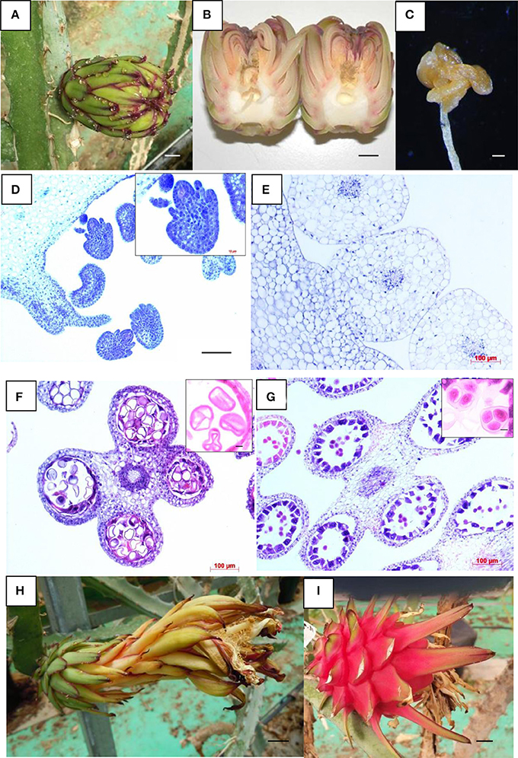

Figure 1 Reproductive parts of the diploid donor *H. monacanthus* and androgenic *H. monacanthus* lines (Adopted from Li et al., 2018)

Image caption: (A) Flower bud from the androgenic line 007, showing an atypical folded end (scale bar 1 cm). (B) Aborted open flower bud from the androgenic line 011 (scale bar 1 cm). (C) Deformed anther detached from an aborted flower bud of androgenic line 011 (scale bar 200 μm). (D–G) Histological sections of flower buds having the same length (6 cm), as follows: (D) Androgenic line 007 showing abnormal ovules (scale bar 100 μm), with a close-up of a shrunken ovule in the upper right-hand inset (scale bar 10 μm), (E) Well-developed ovules of the diploid donor (scale bar 100 μm), (F) Anther of the androgenic line 007 showing aborted tetrads, and a few uninucleate microspores with an atypical triangular shape (scale bar 100 μm), with a close-up of aborted pollen grains in the upper right-hand inset (scale bar 10 μm) (G) Anther of the diploid donor showing well-developed and viable tetrads (scale bar 100 μm), with a close-up of viable grains in the upper right-hand inset (scale bar 10 μm). (H) Anthesis in the androgenic line 011 (scale bar 1 cm), and (I) Mature fruit from line 011 (scale bar 1 cm) (Adopted from Li et al., 2018)

Most flower buds abscised before full bloom, preventing the assessment of pollen and ovule viability. Histological analysis of a 6 cm flower bud from line 007 revealed that the ovary contained significantly smaller, deformed, and shriveled ovules compared to the donor plant, which exhibited larger, typical plump ovules of spherical shape (Figure 1D; Figure1 E). Observations of anthers from line 007 further indicated marked degeneration, with the majority of pollen grains being sterile and exhibiting an abnormal triangular shape or wrinkled tapetal layers (Figure 1F). In contrast, the donor plant showed normal tetrads with a typical near-spherical shape (Figure 1G). Interestingly, line 011 successfully developed a single flower to full bloom in October 2016 (Figure 1H) and produced a fruit weighing 146.5 g (Figugre 1I). This weight was substantially lower than the average fruit weight of (355.0±90.4) g observed in the donor plants, highlighting potential limitations in the reproductive capacity of the androgenic lines (Li et al., 2018).

**4.2 Genomic and transcriptomic insights into betalain biosynthesis**

Recent genomic and transcriptomic studies have provided valuable insights into the biosynthesis of betalains in dragon fruit. The draft genome of *Hylocereus undatus* has revealed the co-localization of betacyanin biosynthetic genes on a specific chromosome region, suggesting a coordinated regulation of these genes that may enhance the efficiency of betalain production (Figure 2) (Zheng et al., 2021). Proteomic analyses have further identified key enzymes involved in the betalain biosynthesis pathway, such as polyphenol oxidase and DOPA dioxygenase, which are differentially expressed during the red pulp stage of *Hylocereus polyrhizus* (Tao et al., 2014). These findings underscore the complex regulatory networks governing betalain biosynthesis and highlight potential targets for genetic manipulation to enhance red pulp coloration. Understanding these molecular mechanisms is essential for developing breeding strategies that can optimize betalain content, thereby improving the nutritional and commercial value of dragon fruit.

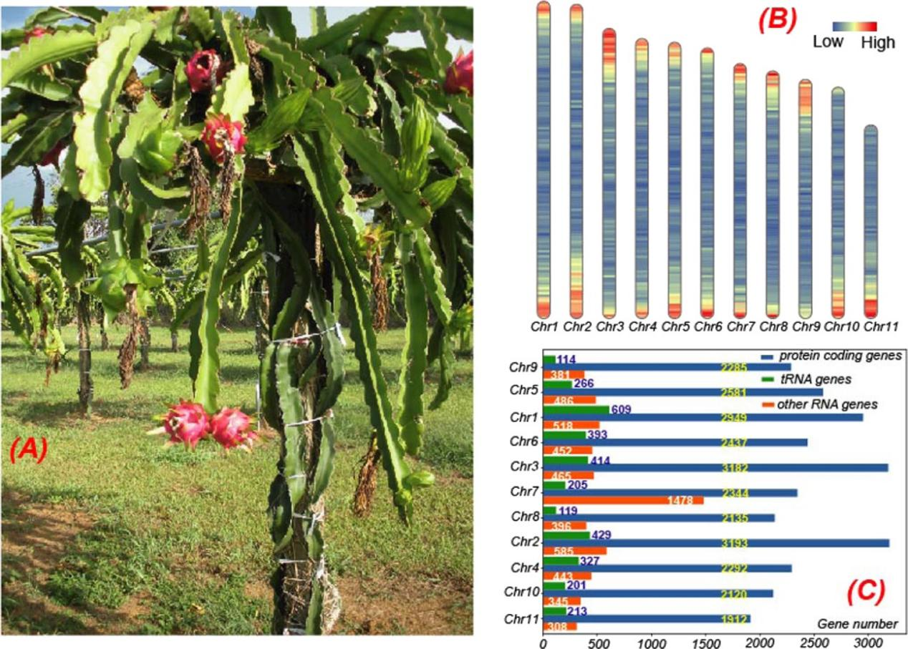

Figure 2 Gene distribution in the 11 longest scaffolds (pseudochromosomes) which account for 88.7% of the dragon fruit draft genome (Adopted from Zheng et al., 2021)

Image caption: Protein-coding genes, noncoding RNA gene, and tRNA genes resided in these scaffolds account for 87.8%, 72.6%, and 58.0% of all these genes, respectively. A A photo of the whole plant of Hylocereus undatus cultivar “David Bowie” from the USDA-ARS Tropical Agriculture Research Station in Mayaquez, Puerto Rico. B Protein-coding gene density of dragon fruit in the 11 longest scaffolds/pseudochromosomes with a window size 100,000 bp, which is plotted by Rldeogram111. C Distribution of protein-coding genes (blue), noncoding RNA genes (including rRNAs, orange), and tRNA genes (green) on the 11 longest scaffolds. The Chr7 (Scaffold 33675) has the most (1478) noncoding RNAs, including 1125 5S rRNAs. The mapping of scaffolds and pseudochromosomes is as follows: Chr1:Scaffold 33678, Chr2:Scaffold 19641, Chr3:Scaffold 33676, Chr4:Scaffold 10417, Chr5:Scaffold 33679, Chr6:Scaffold 33677, Chr7:Scaffold 33675, Chr8:Scaffold 33673, Chr9:Scaffold 33680, Chr10:Scaffold 3410, Chr11:Scaffold 2055 (Adopted from Zheng et al., 2021)

**4.3 Functional validation of candidate genes using CRISPR-Cas9**

The CRISPR-Cas9 system has emerged as a revolutionary tool for functional genomics, enabling precise editing of specific genes to validate their roles in key traits of dragon fruit. This technology leverages the complementarity of guide RNA (gRNA) to target specific DNA sequences, allowing the Cas9 enzyme to introduce double-stranded breaks at precise locations in the genome (Muranty et al., 2015). By employing CRISPR-Cas9, researchers can create targeted knockouts or modifications in candidate genes, facilitating the study of their functions in traits such as disease resistance, fruit quality, and stress tolerance (Tao et al., 2014). The application of CRISPR-Cas9 in dragon fruit involves designing gRNAs specific to genes of interest, followed by the delivery of the Cas9-gRNA complex into plant cells, often using traditional methods or advanced techniques like CRISPR ribonucleoproteins (RNPs) (De Castro Correia Da Silva et al., 2017). This approach not only accelerates the validation process but also enhances the precision of breeding programs by enabling the introduction of beneficial traits without altering other genetic characteristics.

**4.4 Implications for breeding programs**

The integration of CRISPR-Cas9 technology into dragon fruit breeding programs holds significant promise for the rapid development of new cultivars with enhanced traits. By enabling precise gene editing, CRISPR-Cas9 allows breeders to introduce desirable traits such as improved yield, enhanced nutritional content, and increased resistance to biotic and abiotic stresses directly into elite cultivars (Zheng et al., 2021; Kostick et al., 2023). This method circumvents the lengthy and resource-intensive processes associated with traditional breeding techniques, such as backcrossing and selection. Moreover, the ability to perform transgene-free genome editing through CRISPR-Cas9 can facilitate public acceptance of genetically modified crops, as it reduces concerns associated with transgenic modifications (Vassilev et al., 2006). The potential to manipulate consumer-friendly traits, such as fruit quality and stress tolerance, further underscores the transformative impact of CRISPR-Cas9 on breeding programs, paving the way for sustainable agricultural practices and improved crop resilience (Kostick et al., 2023).

**5 Challenges and Future Directions**

**5.1 Gaps in genomic resources for dragon fruit**

Despite the economic importance of dragon fruit, there are significant gaps in its genomic resources. The draft genome of *Hylocereus undatus* provides a foundational resource, yet it highlights the need for more comprehensive genomic data to fully understand the genetic basis of key traits such as drought resistance and fruit flavor (Zheng et al., 2021). The current genomic resources are limited, and there is a need for more extensive sequencing efforts and the development of high-density genetic maps to facilitate advanced breeding programs. Additionally, the lack of genomic resources in underutilized fruit crops, including dragon fruit, is a barrier to exploiting their full potential in breeding applications (Tchokponhoué et al., 2020).

**5.2 Integrating multi-omics approaches for trait analysis**

Integrating multi-omics approaches, such as genomics, transcriptomics, and metabolomics, can significantly enhance the understanding of complex traits in dragon fruit. The co-localization of betacyanin biosynthetic genes in the dragon fruit genome suggests that multi-omics approaches could elucidate the regulatory networks involved in pigment biosynthesis and other important traits (Zheng et al., 2021). By combining data from different omics layers, researchers can identify key regulatory genes and pathways, leading to more targeted breeding strategies (Salazar et al., 2017). This integration is crucial for dissecting polygenic traits and improving the efficiency of marker-assisted selection in dragon fruit breeding (Salazar et al., 2017).

**5.3 Climate-resilient breeding strategies**

Developing climate-resilient dragon fruit varieties is essential in the face of increasing environmental challenges. The genetic diversity observed in dragon fruit accessions, as revealed by morphological traits and ISSR markers, provides a valuable resource for breeding programs aimed at enhancing drought tolerance and other stress-related traits (Tao et al., 2014). Genomic selection and genome-assisted parental selection are promising strategies to accelerate the breeding of climate-resilient varieties by reducing the generation interval and increasing the accumulation of favorable alleles (Muranty et al., 2015). These strategies can help develop dragon fruit cultivars that are better adapted to changing climatic conditions, ensuring sustainable production and economic viability.

**6 Conclusions**

The study on the functional genomics of key traits in dragon fruit for breeding applications highlights significant advancements in the field of plant genomics and breeding. The integration of functional markers (FMs) and genomic resources has been pivotal in enhancing the precision and efficiency of breeding programs. These tools allow for the direct selection of genes associated with desirable phenotypic traits, thereby increasing the efficiency of developing new cultivars with improved agronomic traits and resistance to biotic and abiotic stresses.

Functional genomics offers practical applications in dragon fruit breeding by utilizing high-throughput sequencing and genome editing techniques. These methods facilitate the identification of genes linked to important horticultural traits, enabling breeders to develop cultivars with enhanced fruit quality, yield, and stress resistance. The use of marker-assisted selection (MAS) further supports the breeding process by providing reliable genetic markers that assist in selecting superior parent plants and progeny.

Looking forward, the prospects for developing sustainable and high-yielding dragon fruit cultivars are promising. Continued research and investment in genomic resources, particularly for underutilized fruit crops, will be crucial. By expanding genomic databases and improving infrastructure, especially in lesser-developed regions, the potential for breeding resilient and productive dragon fruit varieties can be fully realized. This will not only contribute to global food security but also support the economic growth of regions where dragon fruit is a key agricultural product.

**Acknowledgments**

The author sincerely thanks Dr. Green for carefully reviewing the initial draft of the manuscript and providing detailed revision suggestions. The author also extends deep gratitude to the two anonymous peer reviewers for their valuable comments and suggestions on the initial draft of this study.

**Conflict of Interest Disclosure**

The authors affirm that this research was conducted without any commercial or financial relationships that could be construed as a potential conflict of interest.

**References**

Abirami, K.; Swain, S.; Baskaran, V.; Venkatesan, K.; Sakthivel, K.; Bommayasamy, N. Distinguishing three Dragon fruit (Hylocereus spp.) species grown in Andaman and Nicobar Islands of India using morphological, biochemical and molecular traits. Sci. Rep. 2021, 11, 1–14.

Attar Ş H, Gündeşli M A, Urün I, et al. Nutritional analysis of red-purple and white-fleshed pitaya (Hylocereus) species[J]. Molecules, 2022, 27(3): 808.

De Castro Correia Da Silva, A., Sabião, R., Chiamolera, F., Segantini, D., & Martins, A. (2017). Morphological traits as tool to verify genetic variability of interspecific dragon fruit hybrids. Revista Brasileira De Fruticultura, 39. https://doi.org/10.1590/0100-29452017168.

Garcia, R. B., Cisneros, A., Schneider, B., and Tel-Zur, N. (2009a). Gynogenesis in the vine cacti Hylocereus and Selenicereus (Cactaceae). Plant Cell Rep. 28, 719–726. doi: 10.1007/s00299-009-0687-1

Garcia, R. B., Schneider, B., and Tel-Zur, N. (2009b). Androgenesis in the vine cacti Selenicereus and Hylocereus (Cactaceae). Plant Cell Tissue Organ Cult. 96, 191–199. doi: 10.1007/s11240-008-9475-9

Gouthu, S., Mandelli, C., Eubanks, B., & Deluc, L. (2022). Transgene-free genome editing and RNAi ectopic application in fruit trees: Potential and limitations. Frontiers in Plant Science, 13. https://doi.org/10.3389/fpls.2022.979742.

Iwata, H., Minamikawa, M., Kajiya-Kanegae, H., Ishimori, M., & Hayashi, T. (2016). Genomics-assisted breeding in fruit trees. Breeding Science, 66, 100 - 115. https://doi.org/10.1270/jsbbs.66.100.

Khokhar A A, Hui L, Khan D, et al. Comprehensive characterization of SBP genes revealed their role under multifactorial stress combinations in dragon fruit (Selenicereus undatus L.)[J]. Plant Stress, 2023, 10: 100294.

Kostick, S., Bernardo, R., & Luby, J. (2023). Genomewide selection for fruit quality traits in apple: breeding insights gained from prediction and postdiction. Horticulture Research, 10. https://doi.org/10.1093/hr/uhad088.

Kumar, S., Chagné, D., Bink, M., Volz, R., Whitworth, C., & Carlisle, C. (2012). Genomic Selection for Fruit Quality Traits in Apple (Malus×domestica Borkh.). PLoS One, 7. https://doi.org/10.1371/journal.pone.0036674.

Kumar, S., Hilario, E., Deng, C., & Molloy, C. (2020). Turbocharging introgression breeding of perennial fruit crops: a case study on apple. Horticulture Research, 7. https://doi.org/10.1038/s41438-020-0270-z.

Li D, Arroyave Martinez M F, Shaked R, et al. Homozygote depression in gamete-derived dragon-fruit (Hylocereus) lines[J]. Frontiers in plant science, 2018, 8: 2142.

Minamikawa, M., Nonaka, K., Kaminuma, E., Kajiya-Kanegae, H., Onogi, A., Goto, S., Yoshioka, T., Imai, A., Hamada, H., Hayashi, T., Matsumoto, S., Katayose, Y., Toyoda, A., Fujiyama, A., Nakamura, Y., Shimizu, T., & Iwata, H. (2017). Genome-wide association study and genomic prediction in citrus: Potential of genomics-assisted breeding for fruit quality traits. Scientific Reports, 7. https://doi.org/10.1038/s41598-017-05100-x.

Muranty, H., Troggio, M., Sadok, I., Rifaï, M., Auwerkerken, A., Banchi, E., Velasco, R., Stevanato, P., Van De Weg, W., Di Guardo, M., Kumar, S., Laurens, F., & Bink, M. (2015). Accuracy and responses of genomic selection on key traits in apple breeding. Horticulture Research, 2. https://doi.org/10.1038/hortres.2015.60.

Nerd, A., and Mizrahi, Y. (2010). “Reproductive biology of cactus fruit crops,” in Horticultural Reviews, Vol. 18, ed J. Janick (Oxford: John Wiley & Sons, Inc.), 321–346.

Rai, M., & Shekhawat, N. (2015). Genomic resources in fruit plants: an assessment of current status. Critical Reviews in Biotechnology, 35, 438 - 447. https://doi.org/10.3109/07388551.2014.898127.

Rifat T, Khan K, Islam M S. Genetic diversity in dragon fruit (Hylocereus sp) germplasms revealed by RAPD marker[J]. JAPS: Journal of Animal & Plant Sciences, 2019, 29(3).

Salazar, J., Pacheco, I., Shinya, P., Zapata, P., Silva, C., Aradhya, M., Velasco, D., Ruiz, D., Martínez-Gómez, P., & Infante, R. (2017). Genotyping by Sequencing for SNP-Based Linkage Analysis and Identification of QTLs Linked to Fruit Quality Traits in Japanese Plum (Prunus salicina Lindl.). Frontiers in Plant Science, 8. https://doi.org/10.3389/fpls.2017.00476.

Salgotra, R., & Stewart, C. (2020). Functional Markers for Precision Plant Breeding. International Journal of Molecular Sciences, 21. https://doi.org/10.3390/ijms21134792.

Tang, W.; Li, W.; Yang, Y.; Lin, X.; Wang, L.; Li, C.; Yang, R. Phenolic compounds profile and antioxidant capacity of pitahaya fruit peel from two red-skinned species (Hylocereus polyrhizus and Hylocereus undatus). Foods 2021, 10, 1183.

Tao, J., Qiao, G., Wen, X., Gao, G., Liu, T., Zhijun, P., Yongqiang, C., Chen, N., Yan, F., & Zhang, B. (2014). Characterization of genetic relationship of dragon fruit accessions (*Hylocereus* spp.) by morphological traits and ISSR markers. Scientia Horticulturae, 170, 82-88. https://doi.org/10.1016/J.SCIENTA.2014.03.006.

Tchokponhoué, D., Achigan-Dako, E., N’Danikou, S., Nyadanu, D., Kahane, R., Houéto, J., Hotegni, N., Odindo, A., & Sibiya, J. (2020). Phenotypic variation, functional traits repeatability and core collection inference in Synsepalum dulcificum (Schumach & Thonn.) Daniell reveals the Dahomey Gap as a centre of diversity. Scientific Reports, 10. https://doi.org/10.1038/s41598-020-76103-4.

Vassilev, D., Nenov, A., Atanassov, A., Dimov, G., & Getov, L. (2006). Application of bioinformatics in fruit plant breeding. Journal of fruit and ornamental plant research, 14, 145-162.

Xu J.G., and Wang Z.Z., 2024, Genetic study of pigment synthesis and related genes in dragon fruit, International Journal of Horticulture, 14(5): 297-309 (doi: 10.5376/ijh.2024.14.0031)

Zhang, L., Hu, J., Han, X., Li, J., Gao, Y., Richards, C., Zhang, C., Tian, Y., Liu, G., Gul, H., Wang, D., Tian, Y., Yang, C., Meng, M., Yuan, G., Kang, G., Wu, Y., Wang, K., Zhang, H., Wang, D., & Cong, P. (2019). A high-quality apple genome assembly reveals the association of a retrotransposon and red fruit colour. Nature Communications, 10. https://doi.org/10.1038/s41467-019-09518-x.

Zhang, X., Zhao, Y., Ren, Y., Wang, Y., & Yuan, Z. (2020). Fruit Breeding in Regard to Color and Seed Hardness: A Genomic View from Pomegranate. Agronomy. https://doi.org/10.3390/agronomy10070991.

Zheng, J., Meinhardt, L., Goenaga, R., Zhang, D., & Yin, Y. (2021). The chromosome-level genome of dragon fruit reveals whole-genome duplication and chromosomal co-localization of betacyanin biosynthetic genes. Horticulture Research, 8. <https://doi.org/10.1038/s41438-021-00501-6.>

**Disclaimer/Publisher's Note**

The statements, opinions, and data contained in all publications are solely those of the individual authors and contributors and do not represent the views of the publishing house and/or its editors. The publisher and/or its editors disclaim all responsibility for any harm or damage to persons or property that may result from the application of ideas, methods, instructions, or products discussed in the content. Publisher remains neutral with regard to jurisdictional claims in published maps and institutional affiliations.