Research Insight

**Frontiers in Loquat Genetic Improvement: Identification and Application of Key Genes**

Xuming Lv, Yeping Han *

Institute of Life Sciences, Jiyang Colloge of Zhejiang A&F University, Zhuji, 311800, Zhejiang, China

*Corresponding author, yeping.han@jicat.org

**Abstract**This study reviews the latest progress in genetic improvement of loquat (Eriobotrya japonica), with a focus on analyzing key genomics and molecular breeding strategies. Research has pointed out that the limited genetic diversity, self incompatibility, and susceptibility to diseases of loquat severely restrict breeding work. With the rapid development of genome sequencing, transcriptomics, and proteomics, key genes affecting loquat fruit quality, stress resistance, and agricultural traits have gradually been revealed, such as differentially expressed genes involved in carbohydrate metabolism and hormone signaling pathways, as well as SWEET and MADS box gene families. Functional genomics methods and gene editing technologies such as CRISPR Cas have shown great potential in precision breeding, but currently still face challenges such as low transformation efficiency. Meanwhile, the application of molecular markers such as SNPs and SSRs has significantly accelerated the breeding of high-quality varieties. Case studies have shown that wild loquat germplasm resources have important value in improving disease resistance and growth vitality, especially the hybrid vigor exhibited by triploid loquat. Future research should focus on the application of emerging genomic tools, global collaboration, and sustainable breeding strategies to develop high-quality and stress resistant loquat varieties that meet market demand. This article emphasizes the necessity of integrating traditional breeding and molecular breeding methods, providing scientific basis and practical suggestions for loquat breeding.

**Keywords**Loquat genetic improvement; Key genes identification; Molecular breeding; Functional genomics; CRISPR-Cas technology

**1 Introduction**

Loquat (*Eriobotrya japonica* Lindl.) is a significant fruit crop within the Rosaceae family, valued for its unique flavor and nutritional benefits. It is cultivated extensively in subtropical regions, contributing to both local economies and global horticultural diversity (Jing et al., 2022; Yan et al., 2024). The fruit's appeal lies in its rich phenolic content and antioxidant properties, which have been shown to vary significantly among different cultivars (Ferreres et al., 2009). This diversity not only enhances its market value but also offers potential health benefits, making loquat an important crop in horticulture (Zhang et al., 2023).

Despite its importance, loquat breeding faces several challenges. One major issue is the limited genetic diversity within cultivated varieties, which can hinder the development of new cultivars with improved traits (Soriano et al., 2005). Additionally, loquat exhibits gametophytic self-incompatibility, complicating breeding efforts and necessitating careful selection of compatible pollen donors (Wang et al., 2017). Furthermore, diseases such as leaf spot caused by Alternaria species pose significant threats to loquat cultivation, impacting yield and fruit quality (Yan et al., 2024). These challenges underscore the need for advanced breeding techniques and genetic studies to enhance loquat production and resilience (Gisbert et al., 2009a).

This study focuses on the latest progress in genetic improvement of loquat, particularly by identifying and utilizing genes that play a key role in loquat development and domestication. It explores recent achievements in genome research, including the discovery of potential genes related to fruit size and growth, as well as the analysis of important gene families such as SAUR and MADS box to reveal the molecular mechanisms behind loquat characteristics. At the same time, we also focus on the genetic diversity of wild loquat germplasm resources, emphasizing their importance in strengthening breeding projects, committed to promoting loquat variety improvement, addressing current challenges in horticultural production, and exploring new paths for future development.

## 2 Genomic Resources for Loquat

### 2.1 Progress in genome sequencing

The advancement in genome sequencing has significantly contributed to the understanding of loquat (*Eriobotrya japonica*) genetics. The first high-quality chromosome-level genome assembly of wild loquat has been generated, revealing 45,791 predicted protein-coding genes. This assembly has provided insights into the genomic evolution and domestication of loquat, showing a recent whole-genome duplication event prior to its divergence from a common ancestor shared with apple and pear (Jing et al., 2022). Additionally, genome resequencing has distinguished loquat germplasms into wild and cultivated groups, highlighting the genetic diversity and selective sweeps related to fruit quality and size during domestication (Jing et al., 2022).

### 2.2 Transcriptomics and proteomics

Transcriptomic and proteomic analyses have been pivotal in identifying key genes and metabolic pathways involved in loquat fruit development and ripening. High-throughput RNA-seq has identified thousands of differentially expressed genes (DEGs) across various metabolic pathways, including carbohydrate metabolism and hormone signaling, which are crucial for fruit development (Song et al., 2016). Furthermore, a comprehensive analysis of expressed sequence tags (ESTs) from a normalized full-length cDNA library has revealed significant functional genes related to loquat fruit development, such as ethylene receptors and cell wall expansin genes (Song et al., 2018). Proteomic studies have also highlighted the role of differentially accumulated proteins in starch and sucrose metabolism during flower development (Jing et al., 2020).

### 2.3 Comparative genomics

Comparative genomics has provided valuable insights into the genetic relationships and evolutionary history of loquat. Analysis has shown that loquat shares a common ancestor with other members of the Rosaceae family, such as apple and pear, and has undergone a whole-genome duplication event (Jing et al., 2022). This comparative approach has also been used to identify quantitative trait loci (QTLs) associated with important traits in other crops, which can be applied to loquat for genetic improvement (Shariatipour et al., 2021). Additionally, the identification of single nucleotide polymorphisms (SNPs) from transcriptome sequences has facilitated genetic diversity analyses and marker-assisted selection breeding in loquat (Li et al., 2015).

## 3 Identification of Key Genes

### 3.1 Genes controlling agronomic traits

In loquat, several genes have been identified that play crucial roles in controlling agronomic traits such as fruit size, flesh color, and development. The genome assembly of wild loquat has revealed key differentially expressed genes (DEGs) involved in carbohydrate metabolism and plant hormone signal transduction, which are significantly regulated during fruit development in cultivated loquats (Table 1) (Jing et al., 2022). Additionally, the MADS-box gene family, particularly the ABCDE model homologs, has been associated with flower and fruit development, indicating their potential role in agronomic trait regulation (Li et al., 2023). Furthermore, quantitative PCR (qPCR) techniques have been developed to genotype polyploid loquats, allowing for the identification of flesh color genotypes, which is a key agronomic trait (Wang et al., 2021).

Table 1 Summary statistics of wild loquat genome assembly and annotation (Adopted from Jing et al., 2022)

|  |  |
| --- | --- |
| Assembly feature | Value |
| Assembly size | 783.7 Mb |
| Number of scaffolds | 230 |
| Length of largest scaffolds | 52.8 Mb |
| Scaffold N50 size | 41.8 Mb |
| Number of contigs | 526 |
| Length of largest contig | 16.9 Mb |
| Contig N50 size | 3.9 Mb |
| GC content | 37.76% |
| Sequences anchored to chromosomes | 99.88% |
| CEGMA complete percentage in assembly | 98.03% |
| BUSCO complete percentage in assembly | 98.27% |
| Gene number | 45 791 |
| Average gene length | 3 315.7 bp |
| Average coding sequence length | 1 246.6 bp |

### 3.2 Genes involved in stress responses

Loquat plants have developed various genetic mechanisms to respond to environmental stresses. The SWEET gene family, identified in loquat, plays a significant role in sugar transport and is involved in various physiological processes, including stress responses (Li et al., 2022). The expression patterns of EjSWEET genes in different tissues suggest their potential roles in plant development and stress adaptation. Moreover, the circadian clock genes in loquat, such as EjLHY, EjTOC1, and EjGIGANTEA, have been linked to heterosis and stress resistance, indicating their involvement in stress response mechanisms (Liu et al., 2019).

### 3.3 Genes regulating nutritional and quality traits

The nutritional and quality traits of loquat are regulated by a complex network of genes. The genome-wide analysis of loquat has identified DEGs involved in flavonoid and carotenoid biosynthesis, which are crucial for fruit quality and nutritional value (Jing et al., 2022). The MADS-box genes, particularly those involved in fruit expansion, such as EjMADS24/46/49/55/61/67/77/86, have been identified as key regulators of fruit quality traits (Li et al., 2023). Additionally, the expression of SWEET genes, particularly EjSWEET1, EjSWEET3, and EjSWEET16, is higher in ripened fruits, suggesting their role in sugar accumulation and quality trait regulation (Li et al., 2022).

## 4 Functional Genomics Approaches

### 4.1 Gene validation techniques

Gene validation is a critical step in functional genomics, allowing researchers to confirm the roles of specific genes in loquat genetic improvement. Techniques such as TILLING (Targeting Induced Local Lesions IN Genomes), targeted insertional mutagenesis, gene silencing, gene targeting, and genome editing are employed to validate gene functions. These methods enable the detection of genetic changes through gene knock-down, knock-up, and knock-out strategies, providing insights into gene activity patterns and functional redundancy (Kumar et al., 2024). The use of next-generation sequencing (NGS) has further facilitated the identification and mapping of causal mutations, enhancing the resolution of quantitative trait loci (QTL) and assisting in determining functional causative variations in genes (Sahu et al., 2020).

### 4.2 Omics integration for trait discovery

Integrating various omics approaches, such as genomics, transcriptomics, and metabolomics, is essential for discovering traits in loquat. Large-scale transcriptome and metabolome analyses have been conducted to identify differentially expressed genes (DEGs) and differentially accumulated metabolites (DAMs) in loquat during fruit development. These analyses have revealed significant regulation of genes involved in carbohydrate metabolism, plant hormone signal transduction, flavonoid biosynthesis, and carotenoid biosynthesis in cultivated loquats compared to their wild counterparts (Jing et al., 2022). The integration of these omics data provides a comprehensive understanding of the molecular mechanisms underlying trait development and domestication in loquat.

### 4.3 Phenotyping for functional studies

Phenotyping is a fundamental component of functional genomics, providing the observable characteristics that result from gene expression. In loquat, phenotyping involves assessing traits such as fruit quality, size, and flesh color, which are influenced by genetic factors identified through genomic and transcriptomic analyses (Jing et al., 2022). The use of high-throughput phenotyping techniques, combined with genetic mapping and allele frequency estimation, allows for the identification of heritable phenotypes and linked genetic markers, facilitating the discovery of novel genetic targets for crop improvement (Kumar et al., 2024). These phenotypic assessments are crucial for validating gene functions and understanding the biological processes that contribute to desirable traits in loquat.

## 5 Genetic Transformation in Loquat

### 5.1 Methods for gene introduction

Genetic transformation in loquat (*Eriobotrya japonica*) involves several methods for introducing new genes into the plant genome. One common approach is the use of Agrobacterium-mediated transformation, which exploits the natural ability of Agrobacterium tumefaciens to transfer DNA to plant cells. This method has been widely used in various Rosaceae species, including loquat, due to its efficiency in stable gene integration (Gisbert et al., 2009b). Another method involves the use of biolistic or particle bombardment techniques, which physically introduce DNA into plant cells by shooting microscopic particles coated with DNA into the plant tissue. This method is particularly useful for species that are recalcitrant to Agrobacterium-mediated transformation (Gisbert et al., 2009b; Zhao, 2024).

### 5.2 Applications of CRISPR-Cas systems

The CRISPR-Cas system has emerged as a powerful tool for precise genome editing in plants, including loquat. This technology allows for targeted modifications of specific genes, enabling the development of loquat varieties with improved traits such as disease resistance, fruit quality, and stress tolerance. The application of CRISPR-Cas in loquat is still in its early stages, but it holds significant promise for accelerating breeding programs and enhancing genetic improvement efforts (Song et al., 2016; Jing et al., 2022). The ability to precisely edit genes involved in key metabolic pathways could lead to breakthroughs in loquat breeding, particularly in enhancing fruit development and ripening processes (Song et al., 2016).

### 5.3 Challenges and solutions in loquat transformation

Transforming loquat presents several challenges, including low transformation efficiency and difficulties in regenerating transformed plants. These challenges are often due to the complex genetic makeup and recalcitrant nature of loquat tissues to in vitro culture conditions (Gisbert et al., 2009b). To overcome these obstacles, researchers are exploring the optimization of transformation protocols, such as improving tissue culture techniques and selecting more responsive explant types. Additionally, the use of advanced molecular tools like CRISPR-Cas systems can help bypass some of the limitations associated with traditional transformation methods by allowing for more precise and efficient gene editing (Song et al., 2016; Jing et al., 2022). Another solution involves the use of polyploidy manipulation, which has shown potential in improving genetic diversity and transformation success rates in loquat breeding programs (Wang et al., 2021).

## 6 Molecular Markers in Loquat Breeding

### 6.1 Marker development

The development of molecular markers has significantly advanced loquat breeding by providing tools for genetic analysis and cultivar identification. Single nucleotide polymorphism (SNP) markers have been identified from transcriptome sequences of loquat cultivars, offering a high-resolution tool for genetic studies. These SNPs are instrumental in cultivar identification and genetic diversity analyses, which are crucial for marker-assisted selection breeding in loquat (Li et al., 2015). Additionally, random amplified polymorphic DNA (RAPD) markers have been used to fingerprint loquat cultivars, aiding in the management of germplasm resources and the estimation of genetic similarity among cultivars (Vilanova et al., 2004). Furthermore, microsatellite markers, or simple sequence repeats (SSRs), have been developed from loquat genomic libraries, providing a robust method for assessing genetic diversity and facilitating genetic studies (Gisbert et al., 2009a).

### 6.2 QTL mapping for key traits

Quantitative trait loci (QTL) mapping in loquat has been facilitated by the development of genetic linkage maps using AFLP and SSR markers. These maps have been constructed for different loquat cultivars, such as 'Algerie' and 'Zaozhong-6', and have been used to map traits like self-incompatibility, which is crucial for breeding programs (Gisbert et al., 2009a). The transferability of SSR markers from related species in the Rosaceae family, such as apple and pear, has enhanced the mapping efforts in loquat, allowing for the identification of key genomic regions associated with important agronomic traits (Gisbert et al., 2009a).

### 6.3 Marker-assisted selection

Marker-assisted selection (MAS) in loquat breeding leverages molecular markers to accelerate the selection of desirable traits. The use of SNPs and SSRs has enabled the identification of genetic markers linked to traits such as fruit quality, size, and flesh color, which are critical for improving loquat cultivars (Figure 1) (Li et al., 2015; Wang et al., 2021). The integration of these markers into breeding programs allows for the efficient selection of superior genotypes, reducing the time and resources required for traditional breeding methods. The development of high-density genetic linkage maps and the identification of QTLs further support the application of MAS in loquat breeding, providing a framework for the systematic improvement of this fruit species (Gisbert et al., 2009a; Guo-Lu, 2013).

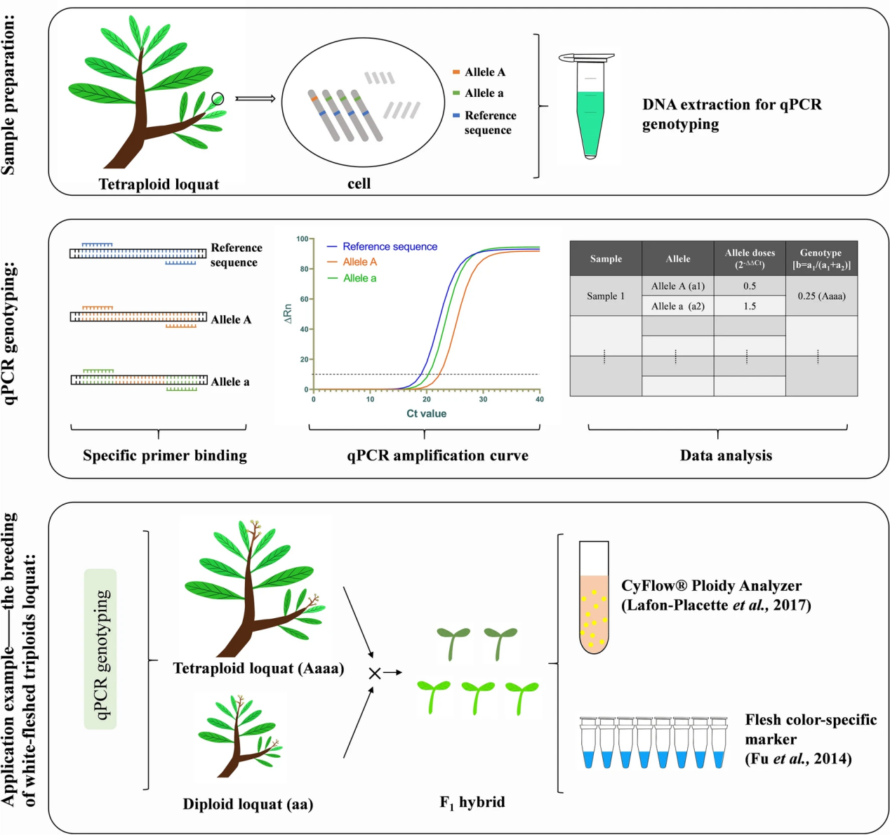

Figure 1 Schematic flew diagram of qPCR genotyping. DNA of loquat leaves was extracted for qPCR genotyping. qPCR genotyping was amplified by allele-specific primers, and the relative copy number of each allele was calculated by 2−ΔΔCt method, and then parameter b [b = a1/(a1 + a2); 0 ≤ b ≤ 1] was calculated to determine the genotype of the tested material. We can select tetraploids of the appropriate genotype as backbone parents according to the breeding goal. More genetic information was obtained by MAS and ploidy analysis (Adopted from Wang et al., 2021)

## 7 Case Study Sharing

### 7.1 Genetic improvement for disease resistance

The genetic improvement of loquat for disease resistance has been significantly advanced through the study of genetic diversity and the identification of key genes. Research has shown that wild loquat populations, particularly those from Guizhou Province in China, offer a rich genetic resource for breeding disease-resistant varieties. These populations exhibit a high level of genetic diversity, which is crucial for developing cultivars with enhanced resistance to diseases (Wu et al., 2014). Additionally, the heterosis observed in triploid loquats, which includes improved disease resistance, suggests that manipulating ploidy levels can be an effective strategy for enhancing disease resistance in loquat breeding programs (Liu et al., 2019).

### 7.2 Enhancing fruit quality traits

Enhancing fruit quality traits in loquat has been a major focus of genetic improvement efforts. The identification of differentially expressed genes (DEGs) involved in carbohydrate metabolism, hormone signaling, and cell-wall degradation has provided insights into the genetic basis of fruit development and ripening (Song et al., 2016). Moreover, the genome-wide characterization of the SWEET gene family has highlighted their role in sugar transport and accumulation, which are critical for improving fruit sweetness and overall quality (Figure 2) (Li et al., 2022). The development of genotyping techniques, such as quantitative PCR, has also facilitated the selection of desirable traits like flesh color in polyploid loquats, further contributing to the enhancement of fruit quality (Wang et al., 2021).

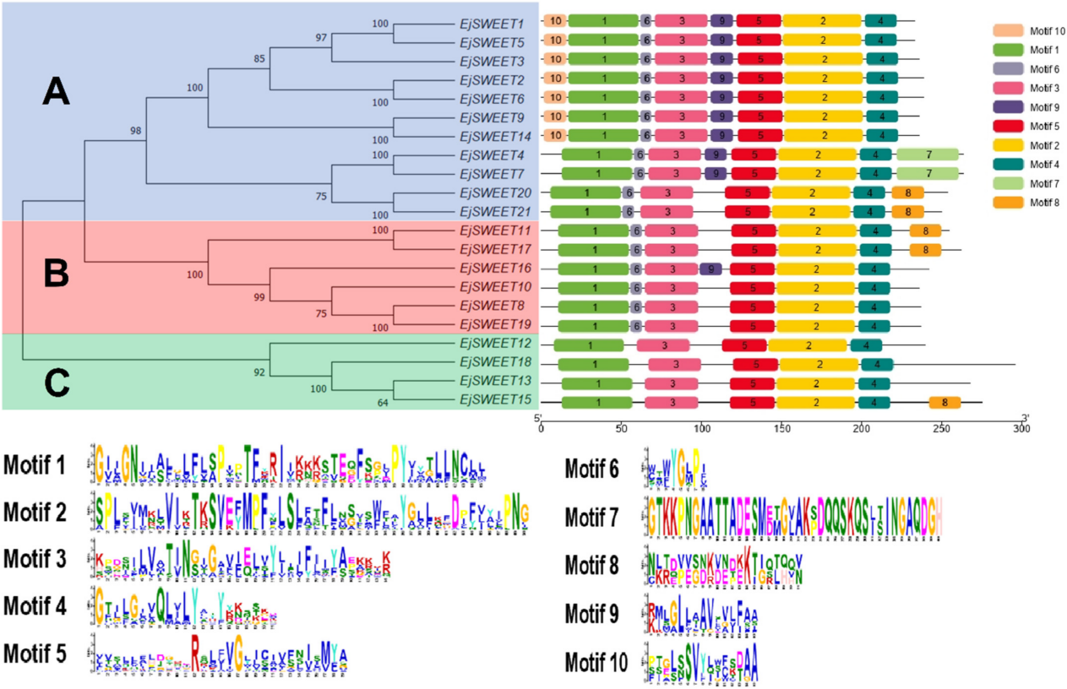

Figure 2 Phylogenetic relationship and conserved motif analysis of EjSWEET genes (Adopted from Li et al., 2022)

### 7.3 Comprehensive multi-trait improvement

Comprehensive multi-trait improvement in loquat involves the integration of various genetic resources and techniques to enhance multiple desirable traits simultaneously. The use of single nucleotide polymorphism (SNP) markers has enabled the evaluation of genetic diversity and the identification of key genetic markers for traits such as fruit size, color, and quality (Li et al., 2015). Additionally, the genome assembly and resequencing of wild loquat have provided valuable insights into the genomic evolution and domestication processes, which are essential for targeted breeding strategies (Jing et al., 2022). The identification of MADS-box genes associated with flower and fruit development further supports the potential for multi-trait improvement by targeting genes involved in both reproductive and vegetative growth (Li et al., 2023).

## 8 Future Directions

### 8.1 Emerging tools and technologies

The future of loquat genetic improvement is poised to benefit significantly from emerging tools and technologies. The development of high-quality genome assemblies and resequencing efforts have already provided valuable insights into the genomic evolution and domestication of loquat, offering a foundation for future genetic studies (Jing et al., 2022). The use of next-generation sequencing technologies has facilitated the identification of single nucleotide polymorphisms (SNPs), which are crucial for genetic diversity analyses and marker-assisted selection breeding (Li et al., 2015). Additionally, the application of quantitative PCR (qPCR) for genotyping polyploid plants, such as triploid loquats, represents a promising tool for breeding programs focused on specific traits like flesh color (Wang et al., 2021). The integration of these advanced genomic tools will enhance the precision and efficiency of loquat breeding efforts.

### 8.2 Collaboration and resource sharing

Collaboration and resource sharing are essential for advancing loquat genetic improvement. The establishment of comprehensive genomic databases, such as those containing expressed sequence tags (ESTs) and full-length cDNA libraries, provides a rich resource for researchers worldwide (Song et al., 2018). Sharing these resources can facilitate the identification of novel genes and the understanding of complex traits, such as fruit development and ripening (Song et al., 2016). Furthermore, international collaborations can leverage diverse genetic resources, such as those found in wild loquat populations, to enhance the genetic base of cultivated varieties (Wu et al., 2014). By fostering a collaborative environment, researchers can accelerate the development of improved loquat cultivars.

### 8.3 Vision for sustainable loquat breeding

The vision for sustainable loquat breeding involves integrating genetic insights with ecological and economic considerations. The identification of key genes involved in fruit development, such as those in the MADS-box gene family, can inform breeding strategies aimed at improving fruit quality and yield (Li et al., 2023). Additionally, understanding the genetic basis of traits like sugar transport and hormone signaling can lead to the development of loquat varieties that are more resilient to environmental stresses (Li et al., 2022). Sustainable breeding practices will also benefit from the exploitation of quantitative trait loci (QTLs) to enhance complex traits, ensuring that new cultivars meet the demands of both producers and consumers (Kumar et al., 2017). By aligning genetic improvement with sustainability goals, the loquat industry can achieve long-term success and resilience.

## 9 Concluding Remarks

Recent advancements in loquat genetic improvement have been significant, particularly with the development of genomic resources and the identification of key genes involved in fruit development and quality. The high-quality genome assembly of wild loquat has provided insights into the genomic evolution and domestication processes, revealing key differentially expressed genes (DEGs) and metabolites involved in fruit quality traits such as carbohydrate metabolism and hormone signaling. Additionally, the identification of genic SNP markers has enhanced our understanding of genetic diversity and cultivar identification, which are crucial for molecular breeding. The characterization of the SWEET gene family and MADS-box genes has further elucidated their roles in sugar transport and flower and fruit development, respectively, offering new targets for genetic improvement.

Case studies have highlighted the importance of genetic diversity and the potential of wild loquat as a genetic resource for breeding. The genetic diversity analysis of loquat in Guizhou Province demonstrated the presence of distinct gene pools, emphasizing the value of wild relatives in breeding programs. The successful application of quantitative PCR for genotyping polyploid loquats has shown the feasibility of using advanced molecular techniques for breeding purposes, particularly in manipulating traits like flesh color. Moreover, the study of triploid loquats has revealed the potential of heterosis in improving growth vigor and disease resistance, linked to altered circadian rhythms.

To further advance loquat genetic improvement, there is a need for continued exploration and utilization of genomic resources. Researchers should focus on integrating genomic data with traditional breeding methods to enhance the efficiency of selecting desirable traits. The development of more comprehensive genomic tools and databases will facilitate the identification of additional key genes and pathways involved in loquat fruit development and quality. Collaborative efforts between researchers, breeders, and industry stakeholders are essential to translate these genetic insights into practical applications, ultimately leading to the development of superior loquat cultivars with improved fruit quality and resilience.

**Acknowledgments**

Thank you to the project team for the careful guidance and strong support. Your professional insights and valuable suggestions have played a crucial role in the smooth progress of this research.

**Conflict of Interest Disclosure**

The authors affirm that this research was conducted without any commercial or financial relationships that could be construed as a potential conflict of interest.

**References**

Ferreres, F., Gomes, D., Valentão, P., Gonçalves, R., Pio, R., Chagas, E., Seabra, R., & Andrade, P. (2009). Improved loquat (*Eriobotrya japonica* Lindl.) cultivars: Variation of phenolics and antioxidative potential. Food Chemistry, 114, 1019-1027. https://doi.org/10.1016/J.FOODCHEM.2008.10.065

Gisbert, A., Lopez-Capuz, I., Soriano, J., Llácer, G., Romero, C., & Badenes, M. (2009b). Development of microsatellite markers from loquat, *Eriobotrya japonica* (Thunb.) Lindl.. Molecular Ecology Resources, 9. https://doi.org/10.1111/j.1755-0998.2008.02211.x

Gisbert, A., Martínez-Calvo, J., Llácer, G., Badenes, M., & Romero, C. (2009a). Development of two loquat [*Eriobotrya japonica* (Thunb.) Lindl.] linkage maps based on AFLPs and SSR markers from different Rosaceae species. Molecular Breeding, 23, 523-538. https://doi.org/10.1007/s11032-008-9253-8

Guo-Lu, L. (2013). Progresses on application of DNA molecular markers in loquat. Journal of Fruit Science

Jing, D., Chen, W., Hu, R., Zhang, Y., Xia, Y., Wang, S., He, Q., Guo, Q., & Liang, G. (2020). An Integrative Analysis of Transcriptome, Proteome and Hormones Reveals Key Differentially Expressed Genes and Metabolic Pathways Involved in Flower Development in Loquat. International Journal of Molecular Sciences, 21. https://doi.org/10.3390/ijms21145107

Jing, D., Liu, X., He, Q., Dang, J., Hu, R., Xia, Y., Wu, D., Wang, S., Zhang, Y., Xia, Q., Zhang, C., Yu, Y., Guo, Q., & Liang, G. (2022). Genome assembly of wild loquat (*Eriobotrya japonica*) and resequencing provide new insights into the genomic evolution and fruit domestication in loquat. Horticulture Research, 10. https://doi.org/10.1093/hr/uhac265

Kumar, J., Gupta, D., Gupta, S., Dubey, S., Gupta, P., & Kumar, S. (2017). Quantitative trait loci from identification to exploitation for crop improvement. Plant Cell Reports, 36, 1187 - 1213. https://doi.org/10.1007/s00299-017-2127-y

Kumar, S., Singh, A., Bist, C., & Sharma, M. (2024). Advancements in genetic techniques and functional genomics for enhancing crop traits and agricultural sustainability.. Briefings in functional genomics. https://doi.org/10.1093/bfgp/elae017

Li, B., Ali, M., Guo, T., Alam, S., Gull, S., Iftikhar, J., Yousef, A., Mosa, W., & Chen, F. (2022). Genome-Wide Identification, In Silico Analysis and Expression Profiling of SWEET Gene Family in Loquat (*Eriobotrya japonica* Lindl.). Agriculture. https://doi.org/10.3390/agriculture12091312

Li, W., Liu, X., Zhao, C., Wu, W., Jiang, Y., Su, W., Lin, S., Yang, X., & Peng, Z. (2023). Genome-Wide Characterization of MADS-box Genes Identifies Candidates Associated with Flower and Fruit Development in Loquat (*Eriobotrya japonica* Lindl.). Agronomy. https://doi.org/10.3390/agronomy13112709

Li, X., Xu, H., Feng, J., Zhou, X., & Chen, J. (2015). Mining of genic SNPs and diversity evaluation of landraces in loquat. Scientia Horticulturae, 195, 82-88. https://doi.org/10.1016/J.SCIENTA.2015.08.040

Liu, C., Liu, T., Ohlson, E., Wang, L., Wu, D., Guo, Q., Timko, M., & Liang, G. (2019). Loquat (*Eriobotrya japonica* (Thunb.) circadian clock gene cloning and heterosis studies of artificial triploid loquat. Scientia Horticulturae. https://doi.org/10.1016/J.SCIENTA.2018.10.068

Sahu, P., Sao, R., Mondal, S., Vishwakarma, G., Gupta, S., Kumar, V., Singh, S., Sharma, D., & Das, B. (2020). Next Generation Sequencing Based Forward Genetic Approaches for Identification and Mapping of Causal Mutations in Crop Plants: A Comprehensive Review. Plants, 9. https://doi.org/10.3390/plants9101355

Shariatipour, N., Heidari, B., Tahmasebi, A., & Richards, C. (2021). Comparative Genomic Analysis of Quantitative Trait Loci Associated With Micronutrient Contents, Grain Quality, and Agronomic Traits in Wheat (Triticum aestivum L.). Frontiers in Plant Science, 12. https://doi.org/10.3389/fpls.2021.709817

Song, H., Yuan, W., Wang, W., Hu, W., Wang, X., Diao, E., Wu, J., & Liu, L. (2018). Transcription and Characterization Analysis of Expressed Sequence Tags from a Normalized Full-Length cDNA Library of Loquat Fruit at Different Developmental Stages.

Song, H., Zhao, X., Hu, W., Wang, X., Shen, T., & Yang, L. (2016). Comparative Transcriptional Analysis of Loquat Fruit Identifies Major Signal Networks Involved in Fruit Development and Ripening Process. International Journal of Molecular Sciences, 17. https://doi.org/10.3390/ijms17111837

Soriano, J., Romero, C., Vilanova, S., Llácer, G., & Badenes, M. (2005). Genetic diversity of loquat germplasm (*Eriobotrya japonica* (Thunb) Lindl) assessed by SSR markers.. Genome, 48 1, 108-14 . https://doi.org/10.1139/G04-101

Vilanova, S., Badenes, M., Martínez-Calvo, J., & Llácer, G. (2004). Analysis of loquat germplasm (*Eriobotrya japonica* Lindl) by RAPD molecular markers. Euphytica, 121, 25-29. https://doi.org/10.1023/A:1012051207948

Wang, H., Dang, J., Wu, D., Xie, Z., Yan, S., Luo, J., Guo, Q., & Liang, G. (2021). Genotyping of polyploid plants using quantitative PCR: application in the breeding of white-fleshed triploid loquats (*Eriobotrya japonica*). Plant Methods, 17. https://doi.org/10.1186/s13007-021-00792-9

Wang, S., Wang, Q., Zhang, Y., Qie, H., & Wang, H. (2017). Identification of two new S-RNases and molecular S-genotyping of twenty loquat cutivars [*Eriobotrya japonica* (Thunb.) Lindl.]. Scientia Horticulturae, 218, 48-55. https://doi.org/10.1016/J.SCIENTA.2017.02.002

Wu, D., Fan, W., He, Q., Guo, Q., Spano, A., Wang, Y., Timko, M., & Liang, G. (2014). Genetic Diversity of Loquat [*Eriobotrya japonica* (Thunb.) Lindl.] Native to Guizhou Province (China) and Its Potential in the Genetic Improvement of Domesticated Cultivars. Plant Molecular Biology Reporter, 33, 952 - 961. https://doi.org/10.1007/s11105-014-0809-y

Yan, S., Yu, P., Liang, G., Zhang, D., Timko, M., Guo, Q., & Wu, D. (2024). Three Alternaria Species, Including a New Species, Causing Leaf Spot Disease of Loquat (*Eriobotrya japonica*) in China.. Plant disease. https://doi.org/10.1094/PDIS-07-23-1368-RE

Zhang, K., Zhou, J., Song, P., Li, X., Peng, X., Huang, Y., , Q., Liang, D., & Deng, Q. (2023). Dynamic Changes of Phenolic Composition, Antioxidant Capacity, and Gene Expression in ‘Snow White’ Loquat (*Eriobotrya japonica* Lindl.) Fruit throughout Development and Ripening. International Journal of Molecular Sciences, 25. https://doi.org/10.3390/ijms25010080

Zhao X.Y., 2024, Study of post-harvest preservation techniques for loquat and its application in reducing post-harvest losses, Bioscience Methods, 15(5): 207-215 (doi: 10.5376/bm.2024.15.0021)