Comprehensive Review

**Ecological Factors Influencing Tea Yield: A Comprehensive Review**

Yufen Wang, Chunyu Li, Xiaocheng Wang *

Cuixi Academy of Biotechnology, Zhuji, 311800, Zhejiang, China

* Corresponding author, xiaocheng.wang@cuixi.org

**Abstract** Tea (*Camellia sinensis*) is one of the most economically and culturally significant crops worldwide. Tea yield is influenced by various ecological factors, including climate, soil characteristics, biotic factors, and agronomic practices. This review systematically examines the key ecological factors affecting tea yield and explores the potential impacts of climate change on tea production. Findings indicate that temperature, precipitation, light intensity, and extreme weather events (e.g., droughts and frosts) significantly affect tea yield and quality. Soil acidity, organic matter content, and microbial communities determine the health and productivity of tea plantations. Furthermore, pest management, crop competition, and agronomic practices, such as pruning, shade management, and fertilization, interact with environmental factors to shape sustainable tea production. To address challenges posed by climate change and resource limitations, this study highlights adaptive strategies and future research directions, including precision agriculture, ecological tea gardens, and the breeding of stress-tolerant tea varieties. These insights provide a scientific foundation for optimizing tea cultivation and ensuring resilience against future environmental challenges.

**Keywords** Tea yield; Climate change; Ecological tea gardens; Precision agriculture; Agronomic practices; Climate adaptability

**1 Introduction**

Tea, derived from the *Camellia sinensis* plant, is a globally significant crop, both economically and culturally. As the second most consumed beverage worldwide, tea production plays a crucial role in the economies of over 50 countries, particularly in Asia and Africa (Hajiboland, 2017; Ahmed et al., 2018). The increasing global demand for tea, driven by its health-promoting properties, underscores its importance as a staple agricultural product (Hajiboland, 2017).

Despite its significance, maximizing tea yield presents several challenges. Environmental factors such as climate change, soil conditions, and water availability significantly impact tea production. Climate change, in particular, poses a threat by altering temperature and precipitation patterns, which can adversely affect both the yield and quality of tea (Dutta et al., 2010; Duncan et al., 2016; Jayasinghe and Kumar, 2021). Additionally, the use of chemical fertilizers and pesticides, while aimed at increasing yield, can lead to environmental degradation and health risks, prompting a shift towards more sustainable practices (Hajiboland, 2017; Xie et al., 2018).

This study investigates the ecological factors influencing tea yield, focusing on the interaction between environmental conditions and agricultural practices. It seeks to identify key challenges and propose strategies to optimize tea production in the context of ecological and climate change, aiming to support future research and guide sustainable management practices in tea cultivation.

**2 Climatic Factors**

**2.1 Temperature: optimal ranges and seasonal variability**

Temperature plays a crucial role in determining tea yield, with optimal ranges varying across different regions. In Assam, India, it was found that tea yield decreases when monthly average temperatures exceed 26.6°C, indicating that warmer temperatures can negatively impact tea production (Duncan et al., 2016). Similarly, in South India, temperature variability was identified as a significant factor affecting tea yield uncertainty, more so than rainfall variability (Raj et al., 2019). In Sri Lanka, maximum temperatures showed a positive relationship with tea yield, while minimum temperatures had a negative long-term impact, suggesting that both extremes of temperature can influence tea production differently (Edirisinghe et al., 2024).

Seasonal temperature variations also affect tea yield. In the Dooars region of India, higher temperatures during summer and monsoon seasons were detrimental to tea yield, whereas warmer winter temperatures were beneficial (Mallik and Ghosh, 2021). This highlights the importance of understanding seasonal temperature patterns to optimize tea production. In Kenya, rising maximum temperatures in March and warming trends in traditionally cooler months like May have been observed, which could alter the growing conditions for tea (Sitienei et al., 2017).

**2.2 Rainfall and moisture: impact on growth and yield**

Rainfall and moisture levels are critical for tea cultivation, as tea is predominantly a rain-fed crop. In Bangladesh, excessive rainfall was found to erode topsoil and wash away nutrients, negatively impacting tea yield (Rahman et al., 2024). Conversely, in Sri Lanka, rainfall was positively correlated with tea yield, indicating that adequate precipitation is essential for optimal growth (Edirisinghe et al., 2024). In Kenya, soil moisture dynamics, influenced by rainfall, were significant in determining tea yield variability, with predictions suggesting that future increases in soil moisture could offset some negative impacts of rising temperatures (Rigden et al., 2020).

Precipitation variability, particularly intensity, has been shown to negatively affect tea yield in Assam, India, emphasizing the need for consistent rainfall patterns (Duncan et al., 2016). In the Dooars region, sporadic and excessive rainfall during monsoon months was detrimental to tea yield, highlighting the challenges posed by unpredictable weather patterns (Mallik and Ghosh, 2021). These findings underscore the importance of managing water resources and developing strategies to mitigate the adverse effects of rainfall variability on tea production.

**2.3 Light intensity and photoperiod: effects on photosynthesis**

Light intensity and photoperiod are vital for photosynthesis, directly impacting tea yield. While specific studies on light intensity's impact on tea yield are limited, it is known that adequate sunlight is necessary for photosynthesis, which drives growth and productivity. In general, changes in light factors due to climate change can influence the concentrations of secondary metabolites in tea, affecting both yield and quality (Ahmed et al., 2019).

The interplay between light intensity and other climatic factors, such as temperature and rainfall, can further complicate the effects on tea yield. For instance, in regions where cloud cover is prevalent, reduced light intensity could limit photosynthesis, thereby affecting growth. Understanding the balance between light availability and other environmental conditions is crucial for optimizing tea production and ensuring high-quality yields.

**2.4 Climatic extremes: droughts, frosts, and heatwaves**

Climatic extremes such as droughts, frosts, and heatwaves pose significant challenges to tea cultivation. In Assam, India, drought intensity was found not to affect tea yield significantly, but precipitation variability did, indicating that while droughts may not always directly impact yield, they can exacerbate other climatic stresses (Duncan et al., 2016). In Bangladesh, prolonged droughts negatively impacted tea production, highlighting the vulnerability of tea crops to water scarcity (Rahman et al., 2024).

Heatwaves and frosts can also have detrimental effects on tea yield. In Kenya, rising temperatures are expected to decrease tea yields by up to 10% by 2040-2070, although increased soil moisture could mitigate some losses (Rigden et al., 2020). Frosts, while less frequently discussed, can damage tea plants, particularly in regions where they are not common. Developing adaptive strategies to cope with these extremes, such as improving soil moisture conservation and selecting frost-resistant cultivars, is essential for sustaining tea production in the face of climate change.

**3 Soil Characteristics**

**3.1 Soil types suitable for tea cultivation**

Tea cultivation thrives in specific soil types that provide the necessary conditions for optimal growth. The ideal soils for tea are typically acidic, with a pH range of 4.0 to 5.5, which supports the unique nutrient requirements of tea plants, particularly their tolerance and even preference for aluminum (Al) in the soil (Ding et al., 2021). In regions like India and China, tea is often grown in soils with varying textures; for instance, Chinese tea soils tend to be fine-textured with silt clay, while Indian soils are more coarse with sandy clay loam (Thapa et al., 2022). These soil types are crucial as they influence the availability of nutrients and the overall health of the tea plants.

The physical properties of the soil, such as bulk density and porosity, also play a significant role in tea cultivation. In China, tea soils have been found to have higher bulk density and lower total porosity compared to Indian soils, which can affect root penetration and water retention (Thapa et al., 2022). Additionally, volcanic ash soils, like those in southern Kyushu, Japan, are known for their unique properties that enhance moisture retention and permeability, making them suitable for tea cultivation (Maehara et al., 1965). These soils also benefit from the accumulation of organic residues, which improve the cation exchange capacity and nutrient availability.

**3.2 pH and nutrient availability**

The pH of the soil is a critical factor in tea cultivation, as it directly affects nutrient availability and plant health. Tea plants prefer acidic soils, with an optimal pH range of 4.5 to 5.5, which supports their unique nutrient uptake mechanisms (Yan et al., 2020; Ding et al., 2021). In China, a significant portion of tea-growing soils have been found to be too acidic, with pH levels below 4.5, which can hinder growth unless managed properly (Yan et al., 2020). The acidity of the soil is often exacerbated by the use of chemical fertilizers, which can lead to further soil degradation.

Nutrient availability in tea soils is influenced by the soil's chemical properties, including the presence of essential elements like nitrogen (N), phosphorus (P), and potassium (K). Studies in India have shown that tea soils are generally rich in plant-available potassium, which is crucial for tea yield (Karak et al., 2015). However, the availability of other nutrients can vary significantly, necessitating balanced fertilization practices to maintain soil fertility and support sustainable tea production (Karak et al., 2015; Malakar et al., 2022). The use of organic fertilizers has been shown to improve soil pH and enhance the availability of nutrients, thereby supporting better tea growth (Li et al., 2022).

**3.3 Organic matter content and soil structure**

Organic matter content is vital for maintaining soil structure and fertility in tea plantations. The presence of organic matter enhances the soil's ability to retain moisture and nutrients, which are essential for the growth of tea plants. In regions like Southwest China, long-term tea cultivation has been shown to increase the content of soil organic carbon (SOC) and humic substances, which improve the quality of soil humus and enhance nutrient cycling (He et al., 2021). This increase in organic matter is beneficial for maintaining the structure and fertility of tea plantation soils.

The structure of the soil is also influenced by the accumulation of organic residues, which can improve the cation exchange capacity and nutrient availability. In volcanic ash soils, for example, the accumulation of organic matter in the surface layer has been observed, which contributes to better soil structure and fertility (Maehara et al., 1965). The integration of organic and inorganic fertilizers can further enhance soil organo-mineral associations, supporting the sequestration of soil organic matter and improving soil fertility (Li et al., 2022). These practices are crucial for sustaining the productivity and health of tea plantations over the long term.

**3.4 Role of microbial communities in soil health**

Microbial communities play a crucial role in maintaining soil health and fertility in tea plantations. These communities are involved in the decomposition of organic matter, nutrient cycling, and the suppression of soil-borne diseases. The presence of diverse microbial populations can enhance the availability of nutrients like nitrogen and phosphorus, which are essential for tea plant growth (Ruan et al., 2023). In degraded soils, the selection of tea plant varieties with high nutrient efficiency can influence microbial activity and improve soil health by reducing nutrient heterogeneity and soil acidification (Figure 1).

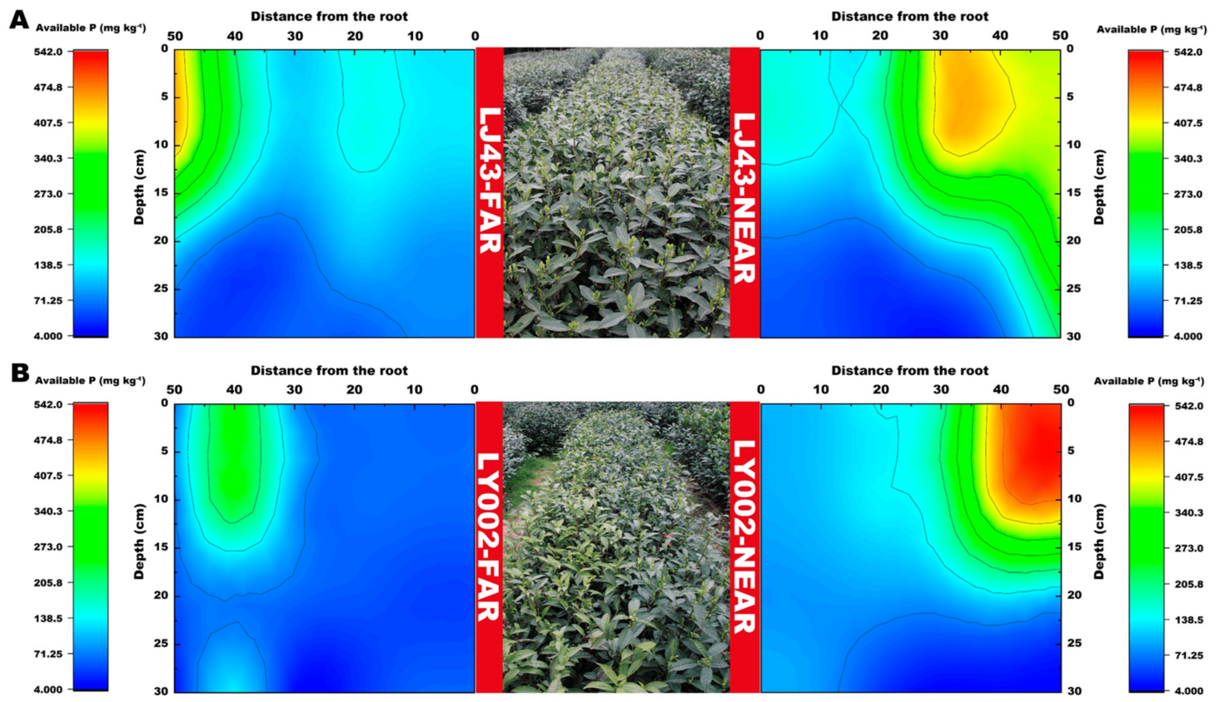

Figure 1 Variation in soil available P content related to LJ43 and LY002 with different treatments (Adopted from Ruan et al., 2023)

Image caption: (A): LJ43; (B): LY002. Data show the mean ± standard deviation (n = 3). The fertilization zone is located at the right-most side (i.e., 50 cm distance to LJ43-near or LY002-near main roots). Regarding the tea plants near the fertilization belts (LJ43-near or LY002-near), the fertilization belt was 50 cm distance from main roots of the tea plants; regarding the tea plants far from the fertilization belts (LJ43-far or LY002-far), the fertilization belt was 100 cm distance from the main roots of the tea plants (Adopted from Ruan et al., 2023)

The interaction between microbial communities and soil organic matter is also significant in enhancing soil fertility. Organic fertilization practices have been shown to support microbial activity, leading to improved soil structure and nutrient availability (Li et al., 2022). These practices can increase the concentration of beneficial soil microbes, which contribute to the stabilization of soil organic matter and the overall health of the soil ecosystem. By fostering a healthy microbial community, tea plantations can achieve sustainable soil management and improved crop yields.

**4 Biotic Factors**

**4.1 Pest and disease management: impacts on yield**

Pest and disease management is crucial for maintaining tea yield, as various pests and diseases can significantly impact the productivity of tea plantations. Insect pests such as the tea green leafhopper and various mites are known to cause substantial yield losses if not properly managed. Integrated Pest Management (IPM) strategies, which include biological control measures, have been widely adopted to mitigate these impacts. For instance, in China, over 1100 species of natural enemies, including viruses, fungi, parasitoids, and predators, have been documented in tea ecosystems, providing effective control of arthropod pests with reduced chemical pesticide usage (Hazarika et al., 2009; Yè et al., 2014). The use of nanopesticides is also emerging as a promising approach, offering more effective and safer pest control options (Deka et al., 2021).

Fungal diseases, such as blister blight, pose another significant threat to tea yield. These diseases can severely affect the quality and quantity of harvestable shoots. Management strategies include the use of fungicides, microbial biocontrol agents, and the development of resistant cultivars to mitigate damage (Sen et al., 2020; Pandey et al., 2021; Liu, 2024). However, the overuse of chemical pesticides can lead to phytotoxicity and undesirable residues, prompting a shift towards more sustainable practices like microbial biocontrol and integrated disease management (Sen et al., 2020). Understanding the genetic variability of pathogens and the economic impact of diseases is essential for developing effective management strategies, especially as climate change alters disease dynamics (Pandey et al., 2021).

**4.2 Role of pollinators and other beneficial organisms**

Pollinators and other beneficial organisms play a vital role in enhancing tea yield by promoting plant health and reducing pest populations. Predacious mites, for example, have been shown to positively impact tea leaf yield in Kenya. The presence of these mites, particularly from the Phytoseiidae family, correlates with increased leaf yield, especially when combined with factors like high altitude and NPK-fertilizer application (Mutisya et al., 2018). This highlights the importance of maintaining a balanced ecosystem within tea plantations to support beneficial organisms.

Moreover, the use of cover crops can influence the abundance of beneficial predators like the mite *Anystis baccarum*, which preys on the tea green leafhopper. Intercropping with specific cover crops has been shown to increase the abundance of these predatory mites, thereby enhancing their suppressive effect on pest populations (Chen et al., 2019). This approach not only supports pest control but also contributes to the overall health and productivity of the tea plantation ecosystem.

**4.3 Competition with weeds and other plants**

Weeds and other competing plants can significantly affect tea yield by competing for resources such as nutrients, water, and light. Effective weed management is therefore essential to ensure optimal growth conditions for tea plants. Traditional methods of weed control, such as manual weeding and the use of herbicides, are commonly employed, but these can have environmental and economic drawbacks.

The integration of cover crops offers a sustainable alternative by suppressing weed growth while simultaneously enhancing soil health and supporting beneficial organisms. For instance, intercropping with cover crops has been shown to influence the abundance of predatory mites, which can indirectly benefit tea yield by controlling pest populations (Chen et al., 2019). This approach not only reduces the need for chemical herbicides but also promotes a more resilient agro-ecosystem, ultimately supporting higher tea yields.

**5 Agronomic Practices and Environmental Interactions**

Agronomic practices play a crucial role in determining tea yield and quality, interacting significantly with environmental factors. In Northeast India, the stagnation of tea yields has been attributed to a combination of plant age, environmental conditions such as rainfall and soil organic carbon, and management practices including the application of NPK fertilizers and pruning methods (Dutta et al., 2010). Similarly, in Eastern Africa, the use of nitrogenous fertilizers and the timing of plucking intervals have been shown to influence soil organic carbon and pH, which in turn affect tea yields (Ombori et al., 2020). These findings highlight the importance of optimizing agronomic practices to suit specific environmental conditions to enhance tea production.

In Vietnam, the shift from conventional to agroecological management practices has demonstrated improvements in soil health and economic returns, despite a slight reduction in tea yields (Le et al., 2023). This suggests that sustainable agronomic practices can mitigate environmental degradation while maintaining economic viability. The interaction between agronomic practices and environmental factors is complex, requiring a nuanced understanding to optimize tea production sustainably.

**5.1 Pruning and plucking methods**

Pruning is a critical agronomic practice that influences tea plant growth and yield. Studies have shown that pruning can enhance tea yield by promoting the growth of new shoots, although it may reduce the accumulation of quality-related compounds such as polyphenols and flavonoids in tea leaves (Figure 2) (Zhang et al., 2023a; 2023b). This reduction in quality is linked to changes in the rhizosphere soil microbial community and metabolic pathways, which are altered by pruning activities (Zhang et al., 2023a). Therefore, while pruning is beneficial for yield, it necessitates careful management to balance yield and quality.

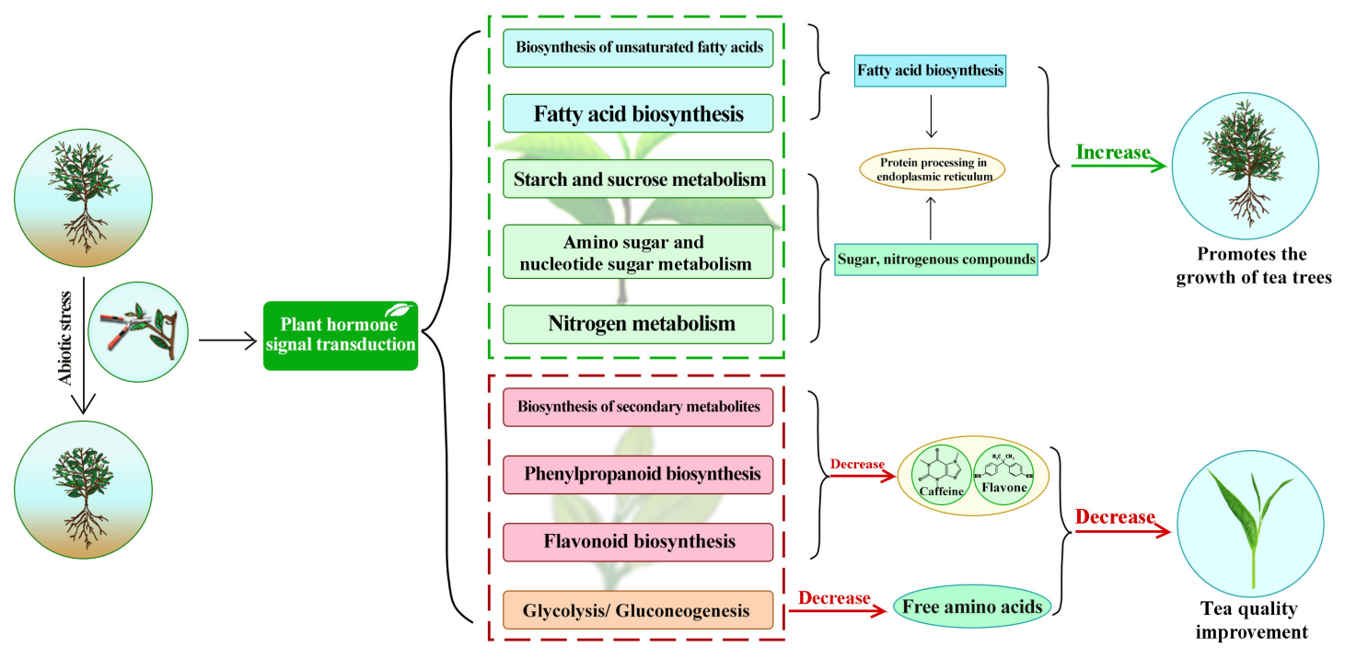

Figure 2 Transcriptome mechanism analysis of effects of pruning on growth and quality of tea plants (Adopted from Zhang et al., 2023b)

Plucking intervals also significantly impact tea yield and quality. In Kenya, variations in plucking intervals have been shown to affect tea yields, with shorter intervals generally leading to higher yields (Owuor et al., 2009). However, the optimal plucking interval can vary depending on the geographical location and specific environmental conditions, indicating the need for location-specific agronomic recommendations (Dufitumukiza et al., 2020). These findings underscore the importance of tailoring pruning and plucking practices to local conditions to maximize both yield and quality.

**5.2 Shade management and agroforestry systems**

Shade management and agroforestry systems are integral to sustainable tea cultivation, influencing both microclimatic conditions and soil health. In Northern Vietnam, agroecological management practices, which often include shade management, have been shown to improve soil organic matter and biological activity, contributing to better soil health and potentially enhancing tea quality (Le et al., 2023). These systems can mitigate the adverse effects of environmental stressors such as high temperatures and water scarcity, which are becoming more prevalent due to climate change (Ahmed et al., 2019).

The integration of shade trees in tea plantations can also enhance biodiversity and provide additional ecosystem services, such as carbon sequestration and habitat for beneficial organisms. However, the implementation of such systems requires careful planning to ensure that the benefits outweigh any potential trade-offs, such as competition for resources between tea plants and shade trees. Overall, shade management and agroforestry systems offer promising strategies for enhancing the sustainability of tea production in the face of environmental challenges.

**5.3 Fertilization practices and their environmental impacts**

Fertilization practices are pivotal in maintaining tea yields but can have significant environmental impacts if not managed properly. Excessive use of nitrogen fertilizers, common in many tea-growing regions, can lead to soil acidification, nutrient leaching, and greenhouse gas emissions (Rebello et al., 2022). In Eastern Africa, the application of nitrogenous fertilizers has been shown to increase soil organic carbon but also lower soil pH, which can negatively impact long-term tea productivity (Ombori et al., 2020).

To mitigate these environmental impacts, sustainable nitrogen management practices, such as the use of organic fertilizers, controlled-release fertilizers, and nitrification inhibitors, have been recommended (Rebello et al., 2022). These practices can reduce nitrogen loading and its associated environmental impacts while maintaining or even enhancing tea yields. However, the adoption of these practices is often hindered by financial and knowledge barriers, highlighting the need for targeted education and support for tea farmers.

**5.4 Irrigation strategies in response to environmental stress**

Irrigation strategies are crucial for managing environmental stress in tea plantations, particularly in regions prone to water scarcity. Climate change has exacerbated water stress in many tea-growing areas, necessitating the development of efficient irrigation practices to ensure consistent tea yields (Ahmed et al., 2019). In regions like Rwanda, where tea is grown in diverse agro-ecosystems, irrigation strategies must be tailored to the specific needs of highland and lowland areas to optimize water use and enhance productivity (Dufitumukiza et al., 2020).

Efficient irrigation practices can help mitigate the effects of drought and other environmental stressors, ensuring that tea plants receive adequate water for optimal growth. These strategies, combined with other agronomic practices such as shade management and fertilization, can enhance the resilience of tea plantations to environmental changes. As climate change continues to impact tea-growing regions, the development and implementation of adaptive irrigation strategies will be essential for sustainable tea production.

**6 Ecosystem Services and Climate Change**

**6.1 Role of tea plantations in carbon sequestration**

Tea plantations play a significant role in carbon sequestration, acting as potential carbon sinks that can mitigate climate change impacts. The integration of tea plants with shade trees in agroforestry systems enhances carbon storage both above and below ground. Studies have shown that the total vegetation carbon stock, which includes shade trees, tea bushes, and litter biomass, increases with the age of the tea agroforestry systems (TAFS). This increase can be as high as 25% in systems older than 20 years compared to younger ones, indicating the potential of TAFS to contribute to climate change mitigation strategies such as the Clean Development Mechanisms (CDM) and REDD+ initiatives under the United Nations Framework Convention on Climate Change (UNFCCC) (Kalita et al., 2020). Additionally, tea gardens, due to their extensive area and the presence of shade trees, are capable of storing significant quantities of atmospheric CO2, further underscoring their role as effective carbon sinks (Chettri and Ghosh, 2024).

The carbon sequestration potential of tea plantations is not only beneficial for climate change mitigation but also provides economic incentives. The economic benefits derived from the carbon storage capabilities of tea gardens can support local economies, particularly in regions heavily reliant on tea production. This dual benefit of ecological and economic gains makes tea plantations a valuable component in the global effort to combat climate change (Chettri and Ghosh, 2024).

**6.2 Biodiversity in tea ecosystems**

Biodiversity within tea ecosystems is crucial for maintaining ecological balance and enhancing the resilience of tea plantations against climate change. The construction of ecological tea gardens, as seen in Fuzhou, China, aims to achieve a synergy between tea production and ecological conservation. These gardens have been shown to transform traditional tea gardens into more ecologically sustainable systems, promoting biodiversity and improving ecosystem services such as soil retention and climate regulation (Wang et al., 2023a). The presence of diverse plant species and the integration of agroforestry practices contribute to a more resilient ecosystem capable of withstanding environmental stresses.

Moreover, biodiversity conservation is a key adaptive strategy employed by tea growers to mitigate the adverse effects of climate change. In Assam, India, tea growers have adopted measures such as afforestation and the creation of wind barriers to preserve biodiversity and protect tea plantations from climate-induced challenges. These strategies not only enhance the ecological health of tea ecosystems but also support sustainable tea production in the face of changing climatic conditions (Baruah and Handique, 2021).

**6.3 Adaptive strategies for climate resilience**

Adaptive strategies are essential for enhancing the resilience of tea plantations to climate change. In Kenya, the tea industry has adopted a multi-targeted approach to address climate-driven stresses, including the development of climate-compatible tea cultivars through genetic modeling and breeding programs. These efforts aim to improve the tolerance of tea plants to biotic and abiotic stresses, ensuring optimal performance under varying climatic conditions (Muoki et al., 2020). Additionally, physiological and biochemical responses such as stomatal closure and the accumulation of osmolytes are leveraged to support the breeding of resilient tea cultivars.

In Assam, India, tea growers have implemented various adaptive measures to combat climate change, including rainwater harvesting, irrigation, and soil mulching. These practices help mitigate the impacts of prolonged droughts, excessive precipitation, and temperature extremes, which are common challenges faced by tea plantations due to climate change. Furthermore, the gradual replacement of synthetic fertilizers with organic alternatives and the cultivation of climate-tolerant cultivars are part of the future strategies aimed at enhancing the sustainability and resilience of tea production (Baruah and Handique, 2021). These adaptive strategies are crucial for maintaining tea yield and quality in the face of ongoing climate change challenges.

**7 Regional Case Studies**

**7.1 Ecological challenges and yield in Chinese tea-producing regions**

In China, tea production is significantly influenced by ecological factors, particularly the dynamics of the East Asian Monsoon. Changes in monsoon patterns, such as delayed retreat dates, have been shown to negatively impact tea yields. A 1% increase in the monsoon retreat date can lead to a reduction in tea yield by approximately 0.481% to 0.535%. Additionally, excessive rainfall during the monsoon period is associated with decreased yields, highlighting the need for adaptive management strategies to mitigate these effects (Boehm et al., 2016). Furthermore, the construction of ecological tea gardens in regions like Fuzhou has been explored as a means to balance tea production with environmental protection. These gardens aim to enhance ecosystem services, such as soil retention and climate regulation, while maintaining high tea yields (Figure 3) (Wang et al., 2023).

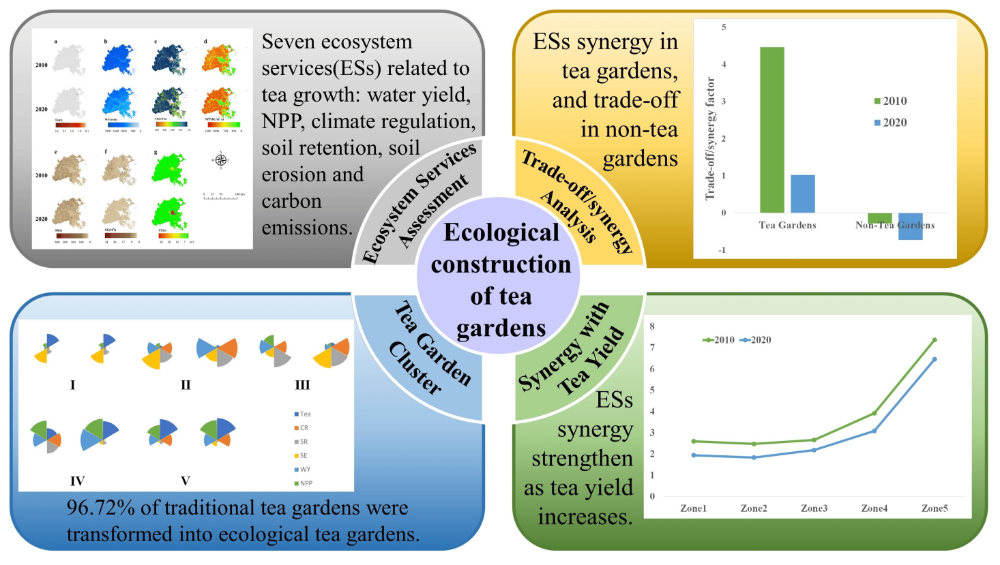

Figure 3 Ecological construction and ecosystem services synergy of tea gardens (Adapted from Wang et al., 2023)

The use of organic fertilizers and reduced pesticide applications in Chinese tea plantations, such as those in Zhejiang Province, has shown promise in improving soil health and tea quality. Replacing chemical fertilizers with organic alternatives can mitigate soil acidification and nutrient deficiencies, leading to improved tea yields and quality (Xie et al., 2018). This approach not only supports sustainable agricultural practices but also addresses the environmental challenges posed by traditional farming methods. Overall, the integration of ecological management practices in Chinese tea-producing regions is crucial for sustaining tea yields amidst changing climatic conditions.

**7.2 Indian tea plantations: balancing tradition and environmental pressures**

In India, particularly in the northeastern regions, tea plantations face the challenge of balancing traditional cultivation practices with environmental pressures. Tea yield in these areas is influenced by a combination of plant age, environmental factors such as rainfall and soil organic carbon, and management practices like fertilizer application and pruning. The stagnation of tea yields in recent years has prompted studies to identify key factors affecting productivity. For instance, rainfall has a significant correlation with tea yield, while plant age negatively impacts it (Dutta et al., 2010). Effective management practices, including the use of nitrogen fertilizers, have been shown to positively influence yields, highlighting the importance of adaptive strategies in maintaining productivity.

Climate variability poses additional challenges to Indian tea plantations. In Assam, for example, rising temperatures and precipitation variability have been identified as critical factors affecting tea yield. Warmer monthly average temperatures above 26.6°C have a negative impact on productivity, while precipitation intensity also adversely affects yields (Duncan et al., 2016). These findings underscore the need for interventions to reduce the sensitivity of tea plantations to climatic changes, ensuring the sustainability of tea production in the face of environmental pressures.

**7.3 Tea production in Kenya: thriving under unique climatic conditions**

Kenya, as the third-largest tea producer globally, benefits from unique climatic conditions that support tea production. The country's tea yield is closely linked to soil moisture and temperature dynamics, with satellite-derived observations showing a strong correlation between these factors and yield variability. Despite the challenges posed by rising temperatures, projections suggest that increases in soil moisture could offset potential yield losses, resulting in a relatively modest decrease in yields by 2040-2070 (Rigden et al., 2020). This highlights the importance of soil moisture conservation strategies in maintaining tea productivity under changing climatic conditions.

Adaptation strategies in Kenyan tea plantations focus on enhancing resilience to climate change. By improving soil moisture retention and implementing advanced planning measures, tea producers can mitigate the adverse effects of temperature increases and ensure sustainable yields (Rigden et al., 2020). These efforts are crucial for maintaining Kenya's position as a leading tea producer and for supporting the livelihoods of those dependent on the tea industry.

**7.4 Comparative analysis of ecological factors in major tea-producing regions**

A comparative analysis of ecological factors across major tea-producing regions reveals diverse challenges and adaptation strategies. In China, the focus is on managing monsoon dynamics and promoting ecological tea gardens to balance production with environmental sustainability (Boehm et al., 2016; Wang et al., 2023a). In India, traditional practices are being adapted to address climate variability and improve yield through effective management of environmental and agronomic factors (Dutta et al., 2010; Duncan et al., 2016). Meanwhile, Kenya's approach emphasizes soil moisture conservation to counteract the effects of rising temperatures, ensuring continued productivity (Rigden et al., 2020).

**8 Emerging Research and Technological Innovations**

**8.1 Advances in precision agriculture for tea cultivation**

Precision agriculture is revolutionizing tea cultivation by integrating advanced technologies to enhance productivity and sustainability. The use of information and communication technology (ICT) in tea cultivation is becoming increasingly prevalent, allowing for more precise management of resources and improved decision-making processes. ICT tools are utilized in various stages of tea cultivation, including land preparation, pest control, and nutrient management, which are crucial for optimizing yield and quality (Paul et al., 2018). Additionally, machine learning techniques are being employed to evaluate the suitability of land for tea cultivation, ensuring that resources are allocated efficiently and sustainably. For instance, a study in Xinming Township, China, utilized machine learning models to assess land suitability, which aids in making informed decisions about land use and cultivation practices (Xing et al., 2022).

Furthermore, the integration of computer vision and machine learning in the tea industry has led to the development of vision-based harvesting equipment and disease detection methods. These technologies enable more efficient and accurate identification of tea buds and detection of common diseases, which are essential for maintaining high-quality tea production. Despite the current limitations, such as the need for more comprehensive applications, the ongoing advancements in sensor technologies and artificial intelligence are paving the way for more intelligent and sustainable tea garden management (Wang et al., 2023b).

**8.2 Use of remote sensing and AI in monitoring ecological factors**

Remote sensing and artificial intelligence (AI) are playing pivotal roles in monitoring ecological factors that influence tea yield. These technologies provide valuable insights into environmental conditions, enabling tea growers to adapt to changing climates and optimize their cultivation practices. The application of remote sensing allows for the continuous monitoring of large tea plantations, providing data on soil moisture, temperature, and other critical factors that affect tea growth (Wang et al., 2023b). This data-driven approach helps in making timely decisions to mitigate adverse effects caused by environmental stresses.

AI, particularly machine learning, is being used to analyze complex datasets obtained from remote sensing technologies. This analysis helps in predicting the impact of various ecological factors on tea yield and quality. For example, machine learning models have been developed to evaluate the suitability of different areas for tea cultivation based on climate, soil, and terrain factors, ensuring that tea is grown in the most favorable conditions (Xing et al., 2022). These innovations not only enhance the efficiency of tea production but also contribute to the sustainability of the tea industry by reducing the environmental footprint.

**8.3 Breeding for resilience to environmental stresses**

Breeding tea plants for resilience to environmental stresses is a critical area of research aimed at ensuring the sustainability of tea cultivation in the face of climate change. Advances in genomics and biotechnology have facilitated the identification of genes responsible for stress tolerance, enabling the development of tea varieties that can withstand adverse conditions such as drought, high temperatures, and heavy rainfall (Xia et al., 2020). These efforts are crucial for maintaining tea yield and quality, especially in regions that are highly susceptible to climate variability.

The use of multi-omics technologies has further enhanced our understanding of the molecular mechanisms underlying stress responses in tea plants. By integrating genomics, transcriptomics, and metabolomics, researchers can identify key pathways and genes involved in stress tolerance, paving the way for the development of more resilient tea varieties (Zhang et al., 2020). This approach not only aids in breeding programs but also provides insights into the evolutionary adaptations of tea plants, contributing to the long-term sustainability of tea cultivation.

**9 Conclusion and Future Perspectives**

This study underscores the intricate relationship between ecological factors and tea production, emphasizing the profound impact of environmental conditions on tea yield and quality. Climate change stands out as a critical determinant, with alterations in seasonality, water availability, and temperature variability significantly influencing the production of secondary metabolites that are essential for tea quality. Other factors, including plant age, soil characteristics, and management practices such as fertilizer application, also play a pivotal role in shaping tea yield. The development of ecological tea gardens has demonstrated potential in harmonizing tea production with environmental sustainability, fostering synergies in ecosystem services.

To promote sustainable tea cultivation, adopting adaptive management strategies is imperative. Key measures include optimizing water utilization, aligning planting schedules with shifting seasonal patterns, and transitioning to organic farming practices to reduce reliance on chemical inputs. The integration of ecological tea gardens can bolster resilience by enhancing biodiversity and improving soil health. Furthermore, substituting chemical fertilizers and pesticides with organic alternatives can preserve tea yield and quality while mitigating environmental impacts.

Future research priorities should address the direct effects of elevated carbon dioxide levels on tea quality, a critical knowledge gap. Additionally, studies should investigate the combined effects of multiple environmental factors under real-world scenarios to better understand their synergistic or antagonistic impacts on tea systems. Developing ensemble modeling techniques to predict climate suitability for tea cultivation will be essential for strategic long-term planning. Finally, exploring the socioeconomic impacts of climate change on tea-producing communities is crucial for formulating policies that support sustainable livelihoods and ensure the resilience of the tea industry.

**Acknowledgments**

The authors thank Mrs. Tang for providing resources and support for this research.

**Conflict of Interest Disclosure**

The authors affirm that this research was conducted without any commercial or financial relationships that could be construed as a potential conflict of interest.

**References**

Ahmed, S., Griffin, T., Cash, S., Han, W., Matyas, C., Long, C., Orians, C., Stepp, J., Robbat, A., & Xue, D., 2018. Global Climate Change, Ecological Stress, and Tea Production. , pp. 1-23. <https://doi.org/10.1007/978-981-13-2140-5_1>

Ahmed, S., Griffin, T., Kraner, D., Schaffner, K., Sharma, D., Hazel, M., Leitch, A., Orians, C., Han, W., Stepp, J., Robbat, A., Matyas, C., Long, C., Xue, D., Houser, R., & Cash, S., 2019. Environmental Factors Variably Impact Tea Secondary Metabolites in the Context of Climate Change. Frontiers in Plant Science, 10. <https://doi.org/10.3389/fpls.2019.00939>

Baruah, P., & Handique, G., 2021. Perception of climate change and adaptation strategies in tea plantations of Assam, India. Environmental Monitoring and Assessment, 193. <https://doi.org/10.1007/s10661-021-08937-y>

Boehm, R., Cash, S., Anderson, B., Ahmed, S., Griffin, T., Robbat, A., Stepp, J., Han, W., Hazel, M., & Orians, C., 2016. Association between Empirically Estimated Monsoon Dynamics and Other Weather Factors and Historical Tea Yields in China: Results from a Yield Response Model. Climate, 4, pp. 20. <https://doi.org/10.3390/CLI4020020>

Chen, L., Yuan, P., Pozsgai, G., Chen, P., Zhu, H., & You, M., 2019. The impact of cover crops on the predatory mite Anystis baccarum (Acari, Anystidae) and the leafhopper pest Empoasca onukii (Hemiptera, Cicadellidae) in a tea plantation.. Pest management science. <https://doi.org/10.1002/ps.5489>

Chettri, V., & Ghosh, C., 2024. Tea Gardens, A Potential Carbon-sink for Climate Change Mitigation. Current Agriculture Research Journal. <https://doi.org/10.12944/carj.11.3.01>

Deka, B., Babu, A., Baruah, C., & Barthakur, M., 2021. Nanopesticides: A Systematic Review of Their Prospects With Special Reference to Tea Pest Management. Frontiers in Nutrition, 8. <https://doi.org/10.3389/fnut.2021.686131>

Ding, Z., Shi, Y., Li, G., Harberd, N., & Zheng, S., 2021. Tease out the future: How tea research might enable crop breeding for acid soil tolerance. Plant Communications, 2. <https://doi.org/10.1016/j.xplc.2021.100182>

Dufitumukiza, W., Owuor, P., Bigirimana, J., Akingeneye, A., & Murenzi, B., 2020. Influence of Nitrogenous Fertilizer Rates and Plucking Intervals on Tea in Peatland and Highland Ultisol Soils of Rwanda: 1 Tea Yields. International Journal of Tea Science. <https://doi.org/10.20425/IJTS1516>

Duncan, J., Saikia, S., Gupta, N., & Biggs, E., 2016. Observing climate impacts on tea yield in Assam, India. Applied Geography, 77, pp. 64-71. <https://doi.org/10.1016/J.APGEOG.2016.10.004>

Dutta, R., Stein, A., Smaling, E., Bhagat, R., & Hazarika, M., 2010. Effects of Plant Age and Environmental and Management Factors on Tea Yield in Northeast India. Agronomy Journal, 102, pp. 1290-1301. <https://doi.org/10.2134/AGRONJ2010.0091>

Edirisinghe, J., Ranjan, H., Herath, H., Mudalige, U., Wijeratne, M., Kuruppu, V., Jayathilake, C., Wijesuriya, W., Somarathna, K., Karunaratne, S., Jayawardana, S., Gunathilaka, D., & Balasooriya, D., 2024. Impact of climate on tea yield: an empirical investigation from Sri Lanka. Journal of the National Science Foundation of Sri Lanka. <https://doi.org/10.4038/jnsfsr.v52i2.11762>

Hajiboland, R., 2017. Environmental and nutritional requirements for tea cultivation. Folia Horticulturae, 29, pp. 199 - 220. <https://doi.org/10.1515/fhort-2017-0019>

Hazarika, L., Bhuyan, M., & Hazarika, B., 2009. Insect pests of tea and their management.. Annual review of entomology, 54, pp. 267-84 . <https://doi.org/10.1146/annurev.ento.53.103106.093359>

He, S., Zheng, Z., & Renhuan, Z., 2021. Long-term tea plantation effects on composition and stabilization of soil organic matter in Southwest China. Catena, 199, pp. 105132. <https://doi.org/10.1016/J.CATENA.2020.105132>

Jayasinghe, S., & Kumar, L., 2021. Potential Impact of the Current and Future Climate on the Yield, Quality, and Climate Suitability for Tea [*Camellia sinensis* (L.) O. Kuntze]: A Systematic Review. Agronomy, 11, pp. 619. <https://doi.org/10.3390/AGRONOMY11040619>

Kalita, R., Das, A., Sileshi, G., & Nath, A., 2020. Ecosystem carbon stocks in different aged tea agroforestry systems: implications for regional ecosystem management. Tropical Ecology, 61, pp. 203 - 214. <https://doi.org/10.1007/s42965-020-00084-8>

Karak, T., Paul, R., Boruah, R., Sonar, I., Bordoloi, B., Dutta, A., & Borkotoky, B., 2015. Major Soil Chemical Properties of the Major Tea-Growing Areas in India. Pedosphere, 25, pp. 316-328. <https://doi.org/10.1016/S1002-0160(15)60016-9>

Le, V., Herrmann, L., Bräu, L., & Lesueur, D., 2023. Sustainable green tea production through agroecological management and land conversion practices for restoring soil health, crop productivity and economic efficiency: Evidence from Northern Vietnam. Soil Use and Management, 39, pp. 1185 - 1204. <https://doi.org/10.1111/sum.12885>

Li, H., Hu, Z., Wan, Q., Mu, B., Li, G., & Yang, Y., 2022. Integrated Application of Inorganic and Organic Fertilizer Enhances Soil Organo-Mineral Associations and Nutrients in Tea Garden Soil. Agronomy. <https://doi.org/10.3390/agronomy12061330>

Liu C.C., 2024, Interaction between tea tree root probiotics and tea yellowing disease, Journal of Tea Science Research, 14(1): 10-18 (doi: 10.5376/jtsr.2024.14.0002)

Maehara, M., Hiramine, S., Hirata, M., & Ezaki, S., 1965. Studies on the Volcanic Ash Tea Soils (Part 1). Chagyo Kenkyu Hokoku (Tea Research Journal), 1965, pp. 102-112. <https://doi.org/10.5979/CHA.1965.24_102>

Malakar, H., Timsina, G., Dutta, J., Borgohain, A., Deka, D., Babu, A., Paul, R., Yeasin, M., Rahman, F., Panja, S., & Karak, T., 2022. Sick or rich: Assessing the selected soil properties and fertility status across the tea-growing region of Dooars, West Bengal, India. Frontiers in Plant Science, 13. <https://doi.org/10.3389/fpls.2022.1017145>

Mallik, P., & Ghosh, T., 2021. Impact of climate on tea production: a study of the Dooars region in India. Theoretical and Applied Climatology, 147, pp. 559-573. <https://doi.org/10.1007/s00704-021-03848-x>

Muoki, C., Maritim, T., Oluoch, W., Kamunya, S., & Bore, J., 2020. Combating Climate Change in the Kenyan Tea Industry. Frontiers in Plant Science, 11. <https://doi.org/10.3389/fpls.2020.00339>

Mutisya, D., Banhawy, E., & Cheramgoi, E., 2018. Positive Yield Impact of Predacious Mites in Tea Production Areas of Kenya. Sustainable Agriculture Research, 7, pp. 1. <https://doi.org/10.5539/SAR.V7N3P1>

Ombori, R., Owuor, P., Kamau, D., Kwach, B., Dufitumukiza, W., & Msomba, S., 2020. Nitrogenous Fertilizer Rates and Plucking Intervals Effects on Soil Organic Carbon, pH and Tea Yields and Their Relationships in Eastern Africa Tea Growing Regions. International Journal of Tea Science. <https://doi.org/10.20425/IJTS1513>

Owuor, P., Kamau, D., & Jondiko, E., 2009. Responses of clonal tea to location of production and plucking intervals. Food Chemistry, 115, pp. 290-296. <https://doi.org/10.1016/J.FOODCHEM.2008.11.073>

Pandey, A., Sinniah, G., Babu, A., & Tanti, A., 2021. How the Global Tea Industry Copes up with Fungal Diseases-Challenges and Opportunities.. Plant disease. <https://doi.org/10.1094/PDIS-09-20-1945-FE>

Paul, P., Chatterjee, A., Ganguly, J., & Ghosh, M., 2018. Information and Communication Technology and Information: Their Role in Tea Cultivation and Marketing in the Context of Developing Countries-A Theorotical Approach. , 5.

Rahman, M., Islam, M., Hossain, M., & Ali, M., 2024. Statistical Association between Temperature-Rainfall and Tea Yield at Sylhet Malnicherra Tea Estate: An Empirical Analysis. SSRN Electronic Journal. <https://doi.org/10.2139/ssrn.4887718>

Raj, E., Ramesh, K., Rajkumar, R., & Tejada, M., 2019. Modelling the impact of agrometeorological variables on regional tea yield variability in South Indian tea-growing regions: 1981-2015. Cogent Food & Agriculture, 5. <https://doi.org/10.1080/23311932.2019.1581457>

Rebello, R., Burgess, P., & Girkin, N., 2022. Identifying Sustainable Nitrogen Management Practices for Tea Plantations. Nitrogen. <https://doi.org/10.3390/nitrogen3010003>

Rigden, A., Ongoma, V., & Huybers, P., 2020. Kenyan tea is made with heat and water: how will climate change influence its yield?. Environmental Research Letters, 15. <https://doi.org/10.1088/1748-9326/ab70be>

Ruan, L., Li, X., Song, Y., Li, J., & Palansooriya, K., 2023. Effects of Tea Plant Varieties with High- and Low-Nutrient Efficiency on Nutrients in Degraded Soil. Plants, 12. <https://doi.org/10.3390/plants12040905>

Sen, S., Rai, M., Das, D., Chandra, S., & Acharya, K., 2020. Blister blight a threatened problem in tea industry: A review. Journal of King Saud University - Science, 32, pp. 3265-3272. <https://doi.org/10.1016/J.JKSUS.2020.09.008>

Sitienei, B., Juma, S., & Opere, E., 2017. On the Use of Regression Models to Predict Tea Crop Yield Responses to Climate Change: A Case of Nandi East, Sub-County of Nandi County, Kenya. Climate, 5, pp. 54. <https://doi.org/10.3390/CLI5030054>

Thapa, M., Gurung, S., & He, B., 2022. The Effects of Tea Plantation Upon the Soil Properties Based Upon the Comparative Study of India and China: A Meta – Analysis. Journal of Agriculture and Crops. <https://doi.org/10.32861/jac.84.309.322>

Wang, C., Zhao, M., Xu, Y., Zhao, Y., & Zhang, X., 2023a. Ecosystem Service Synergies Promote Ecological Tea Gardens: A Case Study in Fuzhou, China. Remote. Sens., 15, pp. 540. <https://doi.org/10.3390/rs15020540>

Wang, H., Gu, J., & Wang, M., 2023b. A review on the application of computer vision and machine learning in the tea industry. , 7. <https://doi.org/10.3389/fsufs.2023.1172543>

Wang, Y., Yao, Z., Pan, Z., Wang, R., Yan, G., Liu, C., Su, Y., Zheng, X., & Butterbach‐Bahl, K., 2020. Tea-planted soils as global hotspots for N2O emissions from croplands. Environmental Research Letters, 15. <https://doi.org/10.1088/1748-9326/aba5b2>

Xia, E., Tong, W., Wu, Q., Wei, S., Zhao, J., Zhang, Z., Wei, C., & Wan, X., 2020. Tea plant genomics: achievements, challenges and perspectives. Horticulture Research, 7. <https://doi.org/10.1038/s41438-019-0225-4>

Xie, S., Feng, H., Yang, F., Zhao, Z., Hu, X., Wei, C., Liang, T., Li, H., & Geng, Y., 2018. Does dual reduction in chemical fertilizer and pesticides improve nutrient loss and tea yield and quality? A pilot study in a green tea garden in Shaoxing, Zhejiang Province, China. Environmental Science and Pollution Research, 26, pp. 2464-2476. <https://doi.org/10.1007/s11356-018-3732-1>

Xing, W., Zhou, C., Li, J., Wang, W., He, J., Tu, Y., Cao, X., & Zhang, Y., 2022. Suitability Evaluation of Tea Cultivation Using Machine Learning Technique at Town and Village Scales. Agronomy. <https://doi.org/10.3390/agronomy12092010>

Yan, P., Wu, L., Wang, D., Fu, J., Shen, C., Li, X., Zhang, L., Zhang, L., Fan, L., & Wenyan, H., 2020. Soil acidification in Chinese tea plantations.. The Science of the total environment, 715, pp. 136963 . <https://doi.org/10.1016/j.scitotenv.2020.136963>

Yè, G., Xiao, Q., Chen, M., Chen, X., Yuan, Z., Stanley, D., & Hu, C., 2014. Tea Biological control of insect and mite pests in China. Biological Control, 68, pp. 73-91. <https://doi.org/10.1016/J.BIOCONTROL.2013.06.013>

Zhang, C., Wang, M., Gao, X., Zhou, F., Shen, C., & Liu, Z., 2020. Multi-omics research in albino tea plants: Past, present, and future. Scientia Horticulturae, 261, pp. 108943. <https://doi.org/10.1016/j.scienta.2019.108943>

Zhang, Q., Zhang, Y., Wang, Y., Lin, S., Chen, M., Cheng, P., Ye, J., Miao, P., Jia, X., & Wang, H., 2023a. Effects of pruning on tea tree growth, tea quality, and rhizosphere soil microbial community. Microbiology Spectrum, 11. <https://doi.org/10.1128/spectrum.01601-23>

Zhang, Q., Zhang, Y., Wang, Y., Zou, J., Lin, S., Chen, M., Miao, P., Jia, X., Cheng, P., Pang, X., Ye, J., & Wang, H., 2023b. Transcriptomic Analysis of the Effect of Pruning on Growth, Quality, and Yield of Wuyi Rock Tea. Plants, 12. <https://doi.org/10.3390/plants12203625>