Feature Review

**CRISPR/Cas9-Mediated Trait Improvement in Kiwifruit: Current Progress and Future Directions**

Wenfang Wang *

Institute of Life Sciences, Jiyang Colloge of Zhejiang A&F University, Zhuji, 311800, Zhejiang, China

* Corresponding author, wenfang.wang@jicat.org

**Abstract**Kiwifruit is a globally significant economic and nutritional crop, but its breeding faces numerous challenges, including the need for improvements in yield, quality, and stress resistance traits. In recent years, the application of CRISPR/Cas9 technology in crop genetic improvement has demonstrated immense potential, providing a novel technical pathway for optimizing kiwifruit traits. This review systematically summarizes the research progress on key traits and their genetic basis in kiwifruit, with a focus on the application of CRISPR/Cas9 technology in kiwifruit breeding, including functional studies of key trait-related genes and case studies on trait improvement through gene editing. The study explores the technical bottlenecks of CRISPR/Cas9 technology in kiwifruit, such as off-target effects, editing efficiency, and genetic stability, and summarizes methods for improving editing efficiency and the prospects of applying novel Cas variants. Additionally, this review integrates the latest achievements in multi-omics studies, elucidating the role of genomics, transcriptomics, and epigenomics data in precision gene editing and proposing strategies for integrating gene editing with traditional breeding approaches. This review provides a comprehensive theoretical foundation for the research and application of CRISPR/Cas9 technology in kiwifruit, offering practical guidance for developing high-quality kiwifruit varieties with enhanced market competitiveness.

**Keywords**Kiwifruit; CRISPR/Cas9; Gene Editing; Trait Improvement; Multi-omics Integration; Breeding Strategy

**1 Introduction**

Kiwifruit, belonging to the *Actinidia genus*, is a crop of significant economic and nutritional value globally. Originating from China, it has become a staple in countries like New Zealand, Italy, and Chile due to its rich content of vitamins C, E, and K, which contribute to its high nutritional profile (Zhou et al., 2020). The expansion of kiwifruit cultivation has been driven by the development of new cultivars and improved agricultural practices, making it a vital component of the global fruit market.

Despite its economic importance, kiwifruit breeding faces several challenges. Traditional breeding methods are often time-consuming and inefficient, particularly in addressing traits such as disease resistance, fruit quality, and plant architecture (Fizikova et al., 2021). The long juvenile phase and dioecious nature of kiwifruit further complicate breeding efforts, necessitating innovative approaches to accelerate the development of improved varieties.

CRISPR/Cas9 technology offers a promising solution for precise genetic improvement in kiwifruit. This genome-editing tool allows for targeted mutagenesis, enabling the modification of specific genes to enhance desirable traits such as reduced plant dormancy, improved fruit quality, and altered plant architecture (Nazir et al., 2024). The technology's ability to create transgene-free modifications also addresses regulatory concerns, facilitating broader acceptance and application in crop improvement.

This study explored the use of CRISPR / Cas 9 technology for improving the key kiwi traits (e. g., flowering time, plant structure, and fruit quality). By using this advanced genome editing tool, studies overcome the limitations of traditional breeding methods and accelerate the development of high quality kiwi varieties. The results will provide important contributions to the field of improvement of fruit crops and provide insights into the integration of modern genetic technologies in breeding programs.

**2 Key Traits of Kiwifruit and Their Genetic Basis**

**2.1 Overview of key traits in kiwifruit**

Kiwifruit, belonging to the genus Actinidia, is valued for several key traits including yield, fruit quality, and disease resistance. Yield is influenced by factors such as flowering duration and fruit weight, which have shown high heritability, indicating potential for genetic improvement through selection. Fruit quality is characterized by attributes like vitamin C content, soluble solids, and fruit weight, with significant genetic variation observed among different kiwifruit germplasms. Disease resistance, although less frequently highlighted, is crucial for maintaining healthy crops and ensuring consistent yield and quality (Scaglione et al., 2015).

**2.2 Advances in kiwifruit genomics and the identification of regulatory genes**

Recent advances in kiwifruit genomics have significantly enhanced our understanding of its genetic makeup. The draft genome of *Actinidia chinensis* has been sequenced, revealing important insights into its genetic structure, including ancient hexaploidization and recent whole-genome duplication events that have contributed to the diversification of genes regulating key traits like vitamin C and flavonoid metabolism (Liao et al., 2019). Genome-wide association studies (GWAS) have identified SNP markers associated with important traits, facilitating molecular breeding efforts4. Additionally, transcriptome analyses have identified key genes involved in anthocyanin biosynthesis, which are crucial for fruit coloration (Figure 1) (Liao et al., 2021a).

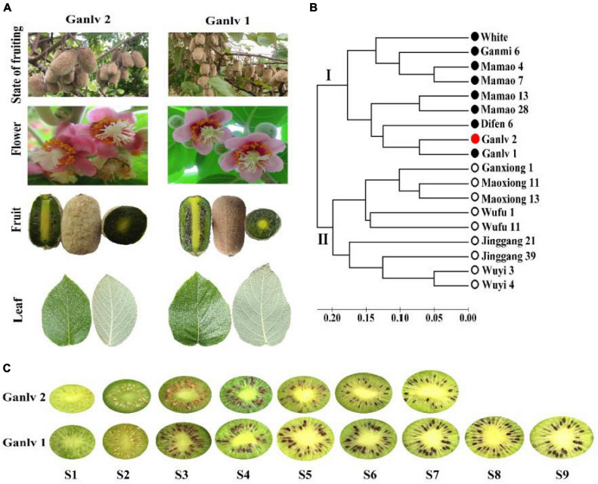

Figure 1 Analysis of key regulatory genes for key metabolites in kiwifruit (Adopted from Liao et al., 2021a)

Image Caption: Test materials (A) ‘Ganlv 1’ and ‘Ganlv 2’ had similar botanical traits and flowering stages; (B) Simple sequence repetition (SSR) technology was used for genetic similarity coefficient analysis, and the genetic similarity coefficient value of test materials was less than 0.08, the bar at the bottom is the bar of genetic similarity coefficient, the solid circle represents the female germplasm, the hollow circle represents the male germplasm, and ‘Ganlv 2’ was marked in red; (C) Fruit developmental stages and sampling time points of ‘Ganlv 2’ and ‘Ganlv 1’, the early mature germplasm ‘Ganlv 2’ had reached the commercial harvested standard at S7 (Adopted from Liao et al., 2021a)

**2.3 Impact of genomic complexity on genetic improvement of kiwifruit**

The genomic complexity of kiwifruit, characterized by polyploidy and extensive genetic diversity, presents both challenges and opportunities for genetic improvement. The presence of multiple whole-genome duplication events complicates the genetic landscape, making it challenging to pinpoint specific genes responsible for desirable traits (Liao et al., 2021b). However, this complexity also provides a rich genetic resource for breeding programs, allowing for the incorporation of diverse traits through techniques like marker-assisted selection and interspecific hybridization. The development of linkage maps and identification of sex-determining chromosomes further aid in the efficient selection and breeding of kiwifruit varieties (Lee et al., 2020).

**3 Application of CRISPR/Cas9 Technology in Kiwifruit Improvement**

**3.1 Overview of CRISPR/Cas9 principles and applications**

CRISPR/Cas9 technology is a revolutionary tool for genome editing that allows for precise modifications at specific genomic loci. It involves the use of a guide RNA (gRNA) to direct the Cas9 protein to a specific DNA sequence, where it introduces double-strand breaks. This system has been widely adopted in various crops, including kiwifruit, due to its simplicity, efficiency, and versatility (Varkonyi-Gasic et al., 2018). The technology has been applied to improve agronomic traits, enhance nutritional value, and develop disease-resistant varieties in fruit crops.

**3.2 Functional validation and editing of key trait-related genes using CRISPR**

In kiwifruit, CRISPR/Cas9 has been used to target and edit genes associated with important traits. For instance, the AcPDS gene, involved in carotenoid biosynthesis, was successfully edited using a paired-sgRNA/Cas9 system, resulting in a high mutagenesis frequency and the induction of an albino phenotype in kiwifruit plantlets (Keul et al., 2022). Additionally, the AcBFT2 gene, which regulates plant dormancy, was targeted to produce an evergrowing phenotype without affecting flowering, demonstrating the potential for climate adaptation (Herath et al., 2022).

**3.3 Case studies: improving fruit quality in kiwifruit through CRISPR technology**

CRISPR/Cas9 has been instrumental in enhancing fruit quality traits in kiwifruit. By targeting genes involved in fruit ripening and bioactive compound synthesis, researchers have been able to modify fruit texture, color, and nutritional content. For example, the manipulation of genes like *Lycopene desaturase* (PDS) and *Pectate lyases* (PL) has shown promise in improving fruit quality and extending shelf life (Zhou et al., 2020). These advancements highlight the potential of CRISPR technology to meet consumer demands for high-quality fruit.

**3.4 Gene editing research on disease resistance and stress tolerance traits**

Research on CRISPR/Cas9 in kiwifruit has also focused on enhancing disease resistance and stress tolerance. By editing genes associated with these traits, such as those involved in plant architecture and flowering time, kiwifruit can be made more resilient to environmental stresses and pathogens. This approach not only improves crop yield and quality but also reduces the need for chemical inputs, contributing to sustainable agriculture (Wang et al., 2018).

**4 Technical Optimization and Application Challenges**

**4.1 Key technical challenges in applying CRISPR to kiwifruit**

Applying CRISPR/Cas9 technology to kiwifruit presents several technical challenges. One major issue is the optimization of the CRISPR system for high efficiency in this specific species. The editing capability can vary significantly depending on the combination of synthetic guide RNA (sgRNA) and Cas9 protein expression devices used. For instance, the development of a paired-sgRNA/Cas9 system has shown promise in increasing mutagenesis frequency, but it requires careful optimization to achieve desired results in kiwifruit (Liu et al., 2021). Additionally, the delivery of CRISPR constructs into kiwifruit cells and ensuring stable integration and expression remain significant hurdles (Wang et al., 2024).

**4.2 Off-target effects and issues with gene editing efficiency**

Off-target effects are a critical concern in CRISPR/Cas9 applications, as unintended edits can lead to undesirable traits or affect plant health. In kiwifruit, the specificity of the CRISPR system must be finely tuned to minimize these effects. The efficiency of gene editing is also variable, with some systems like the polycistronic tRNA-sgRNA cassette (PTG) showing higher efficiency compared to traditional CRISPR/Cas9 systems (Xu et al., 2020). However, achieving consistent and high editing efficiency across different genetic backgrounds and target sites remains a challenge.

**4.3 Genetic stability and heritability after kiwifruit gene editing**

Ensuring genetic stability and heritability of edited traits in kiwifruit is crucial for the practical application of CRISPR technology. Edited traits must be stably inherited across generations to be useful in breeding programs. Studies have shown that while CRISPR/Cas9 can induce desired mutations, the stability and heritability of these changes can vary, necessitating further research to understand and control these aspects. The potential for large chromosomal deletions, as observed in some CRISPR applications, also raises concerns about genetic stability (Kaur et al., 2020).

**4.4 Methods to improve editing efficiency and applications of novel cas variants**

To improve editing efficiency, researchers are exploring various strategies, including the use of novel Cas variants and advanced delivery methods. The PTG/Cas9 system, for example, has demonstrated a tenfold increase in mutagenesis frequency compared to traditional systems, suggesting that alternative sgRNA expression devices can significantly enhance efficiency (Wan et al., 2021). Additionally, novel Cas variants with improved specificity and reduced off-target effects are being developed, which could further enhance the precision and applicability of CRISPR in kiwifruit. Heat treatment and other environmental manipulations have also been proposed to increase editing efficiency.

**5 Role of Multi-omics Integration in Kiwifruit Trait Improvement**

**5.1 Integration of genomics, transcriptomics, and epigenomics data**

The integration of genomics, transcriptomics, and epigenomics data is pivotal in understanding the complex biological processes that govern kiwifruit traits. Genomics provides the foundational genetic information, while transcriptomics offers insights into gene expression patterns under various conditions. Epigenomics adds another layer by revealing modifications that affect gene activity without altering the DNA sequence (Yang et al., 2021). Together, these omics approaches enable a comprehensive understanding of the regulatory mechanisms involved in kiwifruit development and trait expression. The integration of these datasets can lead to the identification of key regulatory genes and pathways that are crucial for trait improvement (Chao et al., 2023).

**5.2 Construction and application of regulatory networks for key traits**

Constructing regulatory networks involves mapping the interactions between genes, proteins, and metabolites that influence key traits in kiwifruit. By utilizing multi-omics data, researchers can build detailed models that depict these interactions, providing insights into the molecular basis of traits such as fruit ripening, flavor, and nutritional content (Mahmood et al., 2022). These networks can be used to predict how changes in one part of the network might affect the overall phenotype, thus guiding targeted interventions for trait enhancement. The application of such networks is crucial for developing new kiwifruit varieties with improved qualities (Figure 2) (Shu et al., 2023).

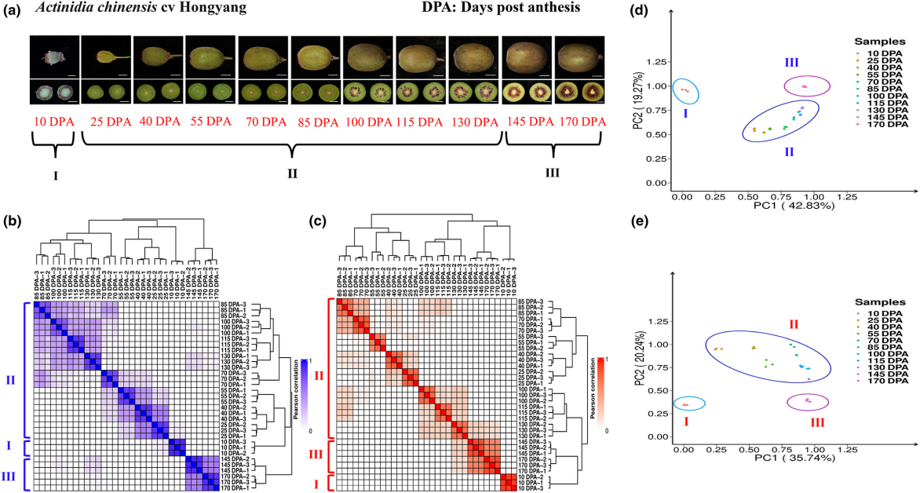

Figure 2 Summary of metabolome and transcriptome datasets for the construction of kiwi metabolic regulatory network (Adopted from Shu et al., 2023)

**5.3 Data-driven precision gene editing and trait optimization**

Data-driven approaches in precision gene editing, such as CRISPR/Cas9, are revolutionizing kiwifruit trait optimization. By leveraging multi-omics data, researchers can identify specific genes or regulatory elements that are prime targets for editing to achieve desired traits. This precision allows for the modification of specific traits without affecting other important characteristics, leading to more efficient breeding programs. The integration of omics data ensures that gene editing is informed by a comprehensive understanding of the genetic and molecular landscape, thereby enhancing the success rate of trait improvement efforts1 (Tian et al., 2021).

**6 Future Directions for CRISPR/Cas9 in Kiwifruit Breeding**

**6.1 Integration of gene editing with traditional breeding strategies**

The integration of CRISPR/Cas9 with traditional breeding strategies offers a promising avenue for enhancing kiwifruit breeding programs. By combining the precision of gene editing with the genetic diversity available in traditional breeding, it is possible to accelerate the development of superior kiwifruit varieties. This approach can help incorporate beneficial traits more efficiently, such as disease resistance and improved fruit quality, while maintaining the genetic diversity necessary for long-term crop resilience (Sardar, 2023).

**6.2 Development of gene-editing platforms for multi-trait improvement**

Advancements in CRISPR/Cas9 technology have led to the development of platforms capable of targeting multiple traits simultaneously. This multiplex genome editing approach can significantly enhance the efficiency of breeding programs by allowing the simultaneous modification of several genes associated with desirable traits, such as yield, stress resistance, and fruit quality. The use of optimized sgRNA/Cas9 systems has already shown promise in achieving high-efficiency editing in kiwifruit, paving the way for multi-trait improvement (Pimentel and Fortes, 2020).

**6.3 Potential of gene-editing technology to enhance breeding efficiency and economic benefits**

CRISPR/Cas9 technology holds the potential to greatly enhance breeding efficiency by reducing the time and resources required to develop new kiwifruit cultivars (Ahmad et al., 2020). The ability to precisely edit genes associated with key agronomic traits can lead to faster development of varieties that meet market demands and environmental challenges. This can result in significant economic benefits by increasing yield, reducing losses due to pests and diseases, and improving fruit quality, thereby enhancing the competitiveness of kiwifruit in the global market1.

**6.4 Expanding applications of crispr/cas9 in kiwifruit quality enhancement and stress resistance improvement**

The application of CRISPR/Cas9 in kiwifruit is expanding beyond basic trait improvement to include enhancements in fruit quality and stress resistance. By targeting genes involved in nutrient content, flavor, and shelf life, CRISPR/Cas9 can help develop kiwifruit varieties that offer superior quality. Additionally, editing genes related to stress responses can improve the plant's resilience to biotic and abiotic stresses, ensuring stable production under varying environmental conditions (De Mori et al., 2020).

**7 Data Integration and Collaborative Mechanisms**

**7.1 Importance of data sharing in kiwifruit genomic research**

Data sharing is crucial in kiwifruit genomic research as it facilitates the rapid dissemination of findings and accelerates the pace of discovery. The CRISPR/Cas9 system has been applied to various fruit crops, including kiwifruit, to improve traits such as disease resistance and fruit quality (Liu et al., 2023). Sharing genomic data allows researchers to build upon each other's work, reducing redundancy and fostering innovation. It also enables the integration of diverse datasets, which can lead to more comprehensive insights into the genetic basis of important traits.

**7.2 Role of international collaboration in the development and application of gene-editing technology**

International collaboration plays a pivotal role in advancing gene-editing technologies like CRISPR/Cas9. By pooling resources and expertise, researchers can overcome technical challenges and accelerate the development of new applications. For instance, the optimization of CRISPR/Cas9 systems for specific crops, such as kiwifruit, benefits from collaborative efforts that bring together diverse scientific perspectives and methodologies. Such collaborations also facilitate the exchange of knowledge and technology, which is essential for the global advancement of agricultural biotechnology (Ho et al., 2020).

**7.3 Necessity of building an open-access kiwifruit genetic resource database**

An open-access kiwifruit genetic resource database is essential for supporting ongoing research and development efforts. This database would serve as a centralized repository for genetic information, including gene sequences and phenotypic data, which are critical for CRISPR/Cas9-mediated trait improvement (Arora and Narula, 2017). By providing researchers with easy access to comprehensive genetic resources, such a database would enhance the efficiency of breeding programs and enable more precise gene-editing interventions. It would also promote transparency and reproducibility in research, fostering a collaborative scientific community (Huang, 2024).

**8 Concluding Remarks**

CRISPR/Cas9 technology has significantly advanced the genetic improvement of kiwifruit by enabling precise genome editing. This technology has been successfully applied to modify key genes associated with important traits such as disease resistance, plant architecture, and fruit quality. For instance, the use of CRISPR/Cas9 has led to the development of kiwifruit with reduced susceptibility to diseases and improved fruit yield and quality. The optimization of CRISPR/Cas9 systems, such as the paired-sgRNA/Cas9 system, has further enhanced editing efficiency, allowing for more effective trait improvement in kiwifruit.

The future of gene-editing research in kiwifruit looks promising, with potential advancements in transgene-free genome editing and the de novo domestication of wild relatives. These approaches could lead to the development of new kiwifruit cultivars with enhanced traits such as increased resistance to environmental stressors and improved nutritional content. Additionally, the integration of CRISPR/Cas9 with other emerging technologies, such as base editing, could further expand the scope of genetic modifications possible in kiwifruit. Future breeding strategies may focus on multiplex genome editing to simultaneously target multiple traits, thereby accelerating the development of superior kiwifruit varieties.

This study underscores the transformative impact of CRISPR/Cas9 technology on the genetic improvement of kiwifruit, offering a powerful tool for addressing key challenges in kiwifruit cultivation. By enabling precise and efficient genetic modifications, CRISPR/Cas9 facilitates the development of kiwifruit varieties with enhanced agronomic traits, which can lead to increased productivity and economic benefits for the kiwifruit industry. The advancements in gene-editing techniques also hold the potential to improve the sustainability of kiwifruit production by reducing reliance on chemical inputs and enhancing resilience to climate change. Overall, this study highlights the critical role of CRISPR/Cas9 in driving innovation and growth in the kiwifruit sector.

**Acknowledgments**

The author thanks the scientific research projects and funding institutions for funding this study and providing the necessary resource support for the research.

**Conflict of Interest Disclosure**

The author affirms that this research was conducted without any commercial or financial relationships that could be construed as a potential conflict of interest.

**References**

Ahmad S., Wei, X., Sheng, Z., Hu, P., and Tang, S. (2020). CRISPR/Cas9 for development of disease resistance in plants: recent progress, limitations and future prospects.. Briefings in functional genomics. https://doi.org/10.1093/bfgp/elz041

Arora, L., and Narula, A. (2017). Gene Editing and Crop Improvement Using CRISPR-Cas9 System. Frontiers in Plant Science, 8. https://doi.org/10.3389/fpls.2017.01932

Chao H., Zhang, S., Hu, Y., Ni, Q., Xin, S., Zhao, L., Ivanisenko, V., Orlov, Y., and Chen, M. (2023). Integrating omics databases for enhanced crop breeding. Journal of Integrative Bioinformatics, 20. https://doi.org/10.1515/jib-2023-0012.

De Mori G., Zaina, G., Franco-Orozco, B., Testolin, R., De Paoli, E., and Cipriani, G. (2020). Targeted Mutagenesis of the Female-Suppressor SyGI Gene in Tetraploid Kiwifruit by CRISPR/CAS9. Plants, 10. <https://doi.org/10.3390/plants10010062>

Fizikova A., Tikhonova, N., Ukhatova, Y., Ivanov, R., and Khlestkina, E. (2021). Applications of CRISPR/Cas9 System in Vegetatively Propagated Fruit and Berry Crops. Agronomy. <https://doi.org/10.3390/agronomy11091849>

Herath D., Voogd, C., Mayo-Smith, M., Yang, B., Allan, A., Putterill, J., and Varkonyi-Gasic, E. (2022). CRISPR‐Cas9‐mediated mutagenesis of kiwifruit BFT genes results in an evergrowing but not early flowering phenotype. Plant Biotechnology Journal, 20, 2064 - 2076. <https://doi.org/10.1111/pbi.13888>

Ho J., Zhao, M., Wojcik, S., Taiaroa, G., Butler, M., and Poulter, R. (2020). The application of the CRISPR-Cas9 system in Pseudomonas syringae pv. actinidiae.. Journal of medical microbiology. <https://doi.org/10.1099/jmm.0.001124>

Huang B.F., 2024, A Comprehensive analysis of genomic advances and CRISPR/Cas9 applications in kiwifruit (*Actinidia chinensis Planch*.), International Journal of Horticulture, 14(5): 319-332 https://doi.org/10.5376/ijh.2024.14.0033

Kaur N., Awasthi, P., and Tiwari, S. (2020). Fruit crops improvement using CRISPR/Cas9 system. , 131-145. <https://doi.org/10.1016/b978-0-12-818140-9.00012-x>

Keul A., Farkas, A., Carpa, R., Dobrotă, C., and Iordache, D. (2022). Development of smart fruit crops by genome editing. Turkish Journal of Agriculture and Forestry. <https://doi.org/10.55730/1300-011x.2965>

Lee M., Kim, H., Rhee, H., Kwack, Y., 무디얀셀라지, 헤., and Kim, J. (2020). Evaluation of the Genetic Resources of Kiwifruit with Multivariate Analysis. Korean Journal of Horticultural Science and Technology. <https://doi.org/10.7235/HORT.20200053>

Liao G., Li, Z., Huang, C., Zhong, M., Tao, J., Qu, X., Chen, L., and Xu, X. (2019). Genetic diversity of inner quality and SSR association analysis of wild kiwifruit (Actinidia eriantha). Scientia Horticulturae. <https://doi.org/10.1016/J.SCIENTA.2019.01.021>

Liao G., Liu, Q., Xu, X., He, Y., Li, Y., Wang, H., Ye, B., Huang, C., Zhong, M., and Jia, D. (2021a). Metabolome and Transcriptome Reveal Novel Formation Mechanism of Early Mature Trait in Kiwifruit (Actinidia eriantha). Frontiers in Plant Science, 12. <https://doi.org/10.3389/fpls.2021.760496>

Liao G., Zhong, M., Jiang, Z., Tao, J., Jia, D., Qu, X., Huang, C., Liu, Q., and Xu, X. (2021b). Genome-Wide Association Studies Provide Insights into the Genetic Determination of Flower and Leaf Traits of Actinidia eriantha. Frontiers in Plant Science, 12. <https://doi.org/10.3389/fpls.2021.730890>

Liu B., Song, W., Wang, L., Wu, Y., Xu, X., Niu, X., Huang, S., Liu, Y., and Tang, W. (2023). dCas9-BE3 and dCas12a-BE3 Systems Mediated Base Editing in Kiwifruit Canker Causal Agent Pseudomonas syringae pv. actinidiae. International Journal of Molecular Sciences, 24. <https://doi.org/10.3390/ijms24054597>

Liu Q., Yang, F., Zhang, J., Liu, H., Rahman, S., Islam, S., , W., and She, M. (2021). Application of CRISPR/Cas9 in Crop Quality Improvement. International Journal of Molecular Sciences, 22. <https://doi.org/10.3390/ijms22084206>

Mahmood U., Li, X., Fan, Y., Chang, W., Niu, Y., Li, J., Qu, C., and Lu, K. (2022). Multi-omics revolution to promote plant breeding efficiency. Frontiers in Plant Science, 13. <https://doi.org/10.3389/fpls.2022.1062952>

Nazir M., Lou, J., Wang, Y., Zou, S., and Huang, H. (2024). Kiwifruit in the Omics Age: Advances in Genomics, Breeding, and Beyond. Plants, 13. <https://doi.org/10.3390/plants13152156>

Pimentel D., and Fortes, A. (2020). Targeted genome editing using CRISPR-Cas9: Applications in fruit quality and stress resilience., 199-207. <https://doi.org/10.1016/b978-0-12-818581-0.00012-7>

Sardar, A. (2023). Genetic amelioration of fruit and vegetable crops to increase biotic and abiotic stress resistance through CRISPR Genome Editing. Frontiers in Plant Science, 14. <https://doi.org/10.3389/fpls.2023.1260102>

Scaglione D., Fornasiero, A., Pinto, C., Cattonaro, F., Spadotto, A., Infante, R., Meneses, C., Messina, R., Lain, O., Cipriani, G., and Testolin, R. (2015). A RAD-based linkage map of kiwifruit (Actinidia chinensis Pl.) as a tool to improve the genome assembly and to scan the genomic region of the gender determinant for the marker-assisted breeding. Tree Genetics and Genomes, 11. <https://doi.org/10.1007/s11295-015-0941-3>

Shu P., Zhang, Z., Wu, Y., Chen, Y., Li, K., Deng, H., Zhang, J., Zhang, X., Wang, J., Liu, Z., Xie, Y., Du, K., Li, M., Bouzayen, M., Hong, Y., Zhang, Y., and Liu, M. (2023). A comprehensive metabolic map reveals major quality regulations in red flesh kiwifruit (*Actinidia chinensis*).. The New phytologist. <https://doi.org/10.1111/nph.18840>

Tian X., Zhu, L., Yang, N., Song, J., Zhao, H., Zhang, J.F., and Li, M. (2021). Proteomics and Metabolomics Reveal the Regulatory Pathways of Ripening and Quality in Post-Harvest Kiwifruits.. Journal of agricultural and food chemistry. <https://doi.org/10.1021/acs.jafc.0c05492>

Varkonyi-Gasic E., Wang, T., Voogd, C., Jeon, S., Drummond, R., Gleave, A., and Allan, A. (2018). Mutagenesis of kiwifruit CENTRORADIALIS‐like genes transforms a climbing woody perennial with long juvenility and axillary flowering into a compact plant with rapid terminal flowering. Plant Biotechnology Journal, 17, 869 - 880. <https://doi.org/10.1111/pbi.13021>

Wan L., Wang, Z., Tang, M., Hong, D., Sun, Y., Ren, J., Zhang, N., and Zeng, H. (2021). CRISPR-Cas9 Gene Editing for Fruit and Vegetable Crops: Strategies and Prospects. Horticulturae. <https://doi.org/10.3390/HORTICULTURAE7070193>

Wang X., Li Y.W., Liu F.P., Dong W.B., Liang L.Y., Chen D.K., Li H.L., and Liao H.H., 2024, Developing citrus germplasm resistant to Asian citrus psyllid using CRISPR/Cas9 gene editing technology: recent advances and challenges, International Journal of Horticulture, 14(3): 142-155 https://doi.org/10.5376/ijh.2024.14.0016

Wang Z., Wang, S., Li, D., Zhang, Q., Li, L., Zhong, C., Liu, Y., and Huang, H. (2018). Optimized paired‐sgRNA/Cas9 cloning and expression cassette triggers high‐efficiency multiplex genome editing in kiwifruit. Plant Biotechnology Journal, 16, 1424 - 1433. https://doi.org/10.1111/pbi.12884

Xu X., Yuan, Y., Feng, B., and Deng, W. (2020). CRISPR/Cas9-mediated gene-editing technology in fruit quality improvement. Food Quality and Safety. <https://doi.org/10.1093/fqsafe/fyaa028>

Yang Y., Saand, M., Huang, L., Abdelaal, W., Zhang, J., Wu, Y., Li, J., Sirohi, M., and Wang, F. (2021). Applications of Multi-Omics Technologies for Crop Improvement. Frontiers in Plant Science, 12. <https://doi.org/10.3389/fpls.2021.563953>

Zhou J., Li, D., Wang, G., Wang, F., Kunjal, M., Joldersma, D., and Liu, Z. (2020). Application and future perspective of CRISPR/Cas9 genome editing in fruit crops.. Journal of integrative plant biology. <https://doi.org/10.1111/jipb.12793>

**Disclaimer/Publisher’s Note**

The statements, opinions, and data contained in all publications are solely those of the individual authors and contributors and do not represent the views of the publishing house and/or its editors. The publisher and/or its editors disclaim all responsibility for any harm or damage to persons or property that may result from the application of ideas, methods, instructions, or products discussed in the content. Publisher remains neutral with regard to jurisdictional claims in published maps and institutional affiliations.