Case Study

**Case Study on Precision Viticulture: Implementing Technology for High Yields and Sustainability**

Shaomin Yang, Xingzhu Feng, Dandan Huang *

Hainan Institute of Biotechnology, Haikou, 570206, Hainan, China

* Corresponding author, dandan.huang@hibio.org

**Abstract**Precision viticulture, utilizing modern equipment and data-driven methods, provides a viable pathway to enhance yield, improve fruit quality, and achieve agricultural sustainability. This study summarizes the implementation process of precision viticulture technologies and analyzes their contributions to high yield and sustainability through case studies. The core technologies of precision viticulture include remote sensing and drones, sensor networks, Geographic Information Systems (GIS), and machine learning data analytics. Specific case studies demonstrate that a French winery significantly increased grape yield through precision irrigation; an Italian vineyard used AI to predict diseases and apply pesticides precisely, reducing chemical inputs; an Australian vineyard reduced irrigation water usage by 50% using sensor networks; and a California vineyard optimized harvest timing with remote sensing to enhance fruit sugar content. The study reveals that these technologies not only improve resource utilization efficiency but also reduce the use of fertilizers and pesticides, mitigate environmental impacts, and offer effective support for addressing climate change. Precision viticulture plays a vital role in achieving high yields and sustainability, providing practical references for the digital transformation of agriculture.

**Keywords**Grapes; Precision viticulture; High yield; Sustainable agriculture; Artificial intelligence

# 1 Introduction

Grape cultivation holds significant economic and agricultural importance globally, as grapes are one of the most widely grown commercial fruit crops and a key component of the wine industry (Ozdemir et al., 2017). The demand for high-quality grapes has driven the adoption of innovative agricultural practices, such as precision viticulture, which leverages advanced technologies to enhance production efficiency and sustainability (Spachos and Gregori, 2019).

Precision agriculture technology, particularly precision viticulture, plays a crucial role in modern grape cultivation. It involves the use of technologies like GPS, remote sensing, and IoT to monitor and manage vineyard variability, thereby improving grape quality and yield while minimizing environmental impacts (Ozdemir et al., 2017; Pero et al., 2024). These technologies enable site-specific management practices, such as variable rate irrigation and nutrient application, which have been shown to reduce greenhouse gas emissions and improve resource use efficiency (Balafoutis et al., 2017; Pereyra et al., 2022).

Traditional grape cultivation methods face several challenges, including the impacts of climate change and resource waste. Water scarcity, exacerbated by climate change, threatens the economic viability of grape production, necessitating efficient water management strategies (Finco et al., 2022). Additionally, conventional practices often lead to resource inefficiencies and increased environmental footprints, highlighting the need for more sustainable approaches (Balafoutis et al., 2017; Marcu et al., 2022).

This study will analyze relevant case studies to summarize the implementation process of precision grape cultivation techniques and explore their effectiveness in improving yield and achieving sustainability. This research provides insights for researchers on how precision grape cultivation addresses the challenges faced by traditional methods and promotes the sustainable development of the grape industry.

## 2 Concept and Principles of Precision Viticulture

### 2.1 Definition of precision viticulture

Precision viticulture (PV) is a specialized branch of precision agriculture that focuses on optimizing vineyard management through the use of advanced technologies. These technologies include the Internet of Things (IoT), machine learning, and various sensing devices, which enable the collection of high-resolution data on meteorological and soil conditions (Figure 1). This data is crucial for making informed decisions that enhance land productivity and crop quality (Matese and Gennaro, 2015; Pero et al., 2024). The integration of remote and proximal sensing technologies, such as satellites and unmanned aerial vehicles (UAVs), further supports efficient vineyard management by providing detailed insights into spatial variability and vine health (Spachos and Gregori, 2019; Mucalo et al., 2024).

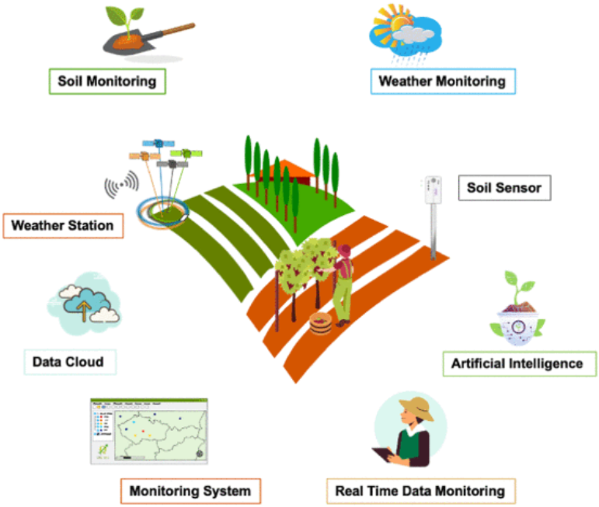

Figure 1 PA ecosystem (Adopted from Pero et al., 2024)

Data-driven decision support systems (DSS) play a pivotal role in precision viticulture by analyzing vast amounts of data collected from various sources. These systems help viticulturists make informed decisions regarding vineyard management practices, such as irrigation, fertilization, and pest control, thereby improving both the economic and environmental sustainability of vineyards (Ammoniaci et al., 2021). The use of advanced analytics and machine learning algorithms enhances the ability to predict and respond to vineyard conditions, ultimately leading to more precise and effective management strategies (Santesteban, 2019; Ferro and Catania, 2023).

### 2.2 Key principles

Precision viticulture emphasizes the importance of site-specific management practices, such as variable-rate fertilization and irrigation, which are tailored to the unique conditions of each vineyard zone. This approach not only improves grape quality and yield but also minimizes environmental impacts by reducing the use of water, fertilizers, and pesticides (Balafoutis et al., 2017; Finco et al., 2022). The integration of wireless sensor networks and smart UAVs allows for real-time monitoring and precise application of inputs, optimizing resource use and enhancing vineyard sustainability (Spachos and Gregori, 2019).

A fundamental principle of precision viticulture is the recognition and management of spatial and temporal variability within vineyards. By delineating zones of differential treatment based on detailed data analysis, viticulturists can apply site-specific management practices that address the unique needs of each area. This approach not only improves vineyard productivity but also ensures that resources are used efficiently and sustainably (Arnó et al., 2009; Mucalo et al., 2024).

### 2.3 Technological framework

A closed-loop management model is essential for the effective implementation of precision viticulture. This model involves continuous data collection, analysis, and feedback, enabling viticulturists to make timely and informed decisions. Technologies such as variable-rate machines, robotics, and DSS are integral to this framework, providing the tools necessary for precise vineyard management (Ammoniaci et al., 2021). By leveraging these technologies, viticulturists can enhance the sustainability and efficiency of their operations, ultimately leading to higher yields and improved grape quality (Matese and Gennaro, 2015; Ferro and Catania, 2023).

## 3 Core Technologies in Precision Viticulture

### 3.1 Remote sensing and drone technology

Remote sensing and drone technology are pivotal in monitoring vineyard health and growth dynamics. Unmanned Aerial Systems (UASs) and satellites provide high-resolution imagery that helps in assessing vine health, water content, and overall vigor through various vegetation indices (Hall et al., 2002; Sassu et al., 2021; Mucalo et al., 2024). These technologies enable the creation of prescription maps and variable rate applications, which enhance sustainability and efficiency in vineyard management by reducing the reliance on chemical interventions (Mucalo et al., 2024). The flexibility and low operating costs of UASs make them essential tools for vineyard variability monitoring and disease detection (Sassu et al., 2021).

### 3.2 Sensor networks

Sensor networks, including wireless sensor networks (WSNs), are crucial for real-time environmental data collection in vineyards. These networks facilitate the monitoring of soil moisture and climate conditions, which are essential for optimizing irrigation strategies and managing crop water stress (Spachos and Gregori, 2019; Finco et al., 2022). For example, the Bioristor sensor developed by the U.S. National Research Council is an innovative tool based on flexible sensing technology that can monitor plant physiological parameters in real time, such as water potential, nutrient transport, and environmental responses. Its application in grapevines aims to enable remote and real-time monitoring of vineyard health by integrating IoT technology (Figure 2). The integration of WSNs with smart UAVs allows for uninterrupted monitoring and high-resolution data collection, optimizing production efficiencies and input applications (Spachos and Gregori, 2019). This real-time data collection supports decision-making processes, helping viticulturists to apply site-specific management practices effectively.

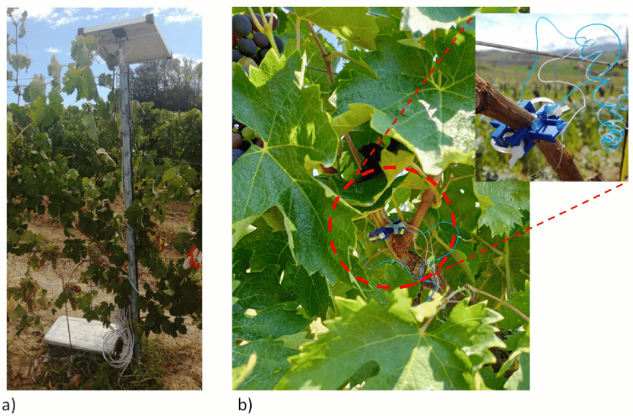

Figure 2 Bioristor installation in grapevines (Adopted from Finco et al., 2022)

Image Caption: (a) IoT control unit; (b) Bioristor installed in two-year-old cane branches (Adopted from Finco et al., 2022)

### 3.3 Geographic information systems (GIS)

Geographic Information Systems (GIS) are employed for refined plot-based management and yield prediction. By integrating satellite data with ground-based measurements, GIS enhances the precision of vineyard management practices. This integration allows for the assessment of spatial variability in vine health and soil moisture, which is crucial for targeted management practices and optimizing water-use efficiency (Mucalo et al., 2024). GIS tools help in generating detailed maps that guide viticulturists in making informed decisions about resource allocation and vineyard management.

### 3.4 Machine learning and data analytics

Machine learning and data analytics are transforming precision viticulture by predicting disease outbreaks, yield, and quality metrics. The integration of IoT with machine learning models provides predictive tools that are essential for improving land productivity and crop quality (Rezk et al., 2020). These models are used to forecast vineyard conditions, such as frost damage and grapevine diseases, offering agronomists advanced tools for sustainable vineyard management (Pero et al., 2024). The use of AI models in processing and interpreting big data helps in understanding the agronomic and physiological status of vineyards, enabling proactive management strategies (Ferro and Catania, 2023).

## 4 Case Studies in Precision Viticulture

### 4.1 Achieving higher yields

Precision viticulture (PV) has been instrumental in enhancing grape yields by employing site-specific management practices. A French winery has successfully implemented precise fertilization and irrigation techniques to optimize grape production. This approach involves the use of advanced technologies such as variable rate application (VRA) and remote sensing to monitor and manage vineyard conditions effectively. By analyzing soil moisture levels and employing variable rate nutrient applications, the winery has been able to tailor its fertilization and irrigation strategies to the specific needs of different vineyard zones, thereby increasing yields while minimizing environmental impact (Matese and Gennaro, 2015; Balafoutis et al., 2017). The integration of IoT and machine learning technologies further supports these efforts by providing predictive tools that enhance land productivity and crop quality (Pero et al., 2024).

### 4.2 Precision pest and disease management

In Italy, a vineyard has adopted artificial intelligence (AI) to enhance its pest and disease management strategies, particularly for combating downy mildew. By integrating AI with IoT-driven machine learning models, the vineyard can predict high-risk periods for disease outbreaks, allowing for timely and precise pesticide applications. This method not only reduces the amount of chemicals used but also minimizes the environmental footprint of vineyard operations (Mucalo et al., 2024; Pero et al., 2024). The use of satellite data and ground-based measurements provides detailed insights into vine health and environmental conditions, enabling the vineyard to implement targeted management practices that improve sustainability and productivity (Spachos and Gregori, 2019; Mucalo et al., 2024). This case exemplifies how advanced analytics and AI can revolutionize traditional viticulture practices, leading to more sustainable and efficient vineyard management (Santesteban, 2019; Ferro and Catania, 2023).

#### 4.3 Improving resource utilization efficiency

In the context of precision viticulture, the implementation of sensor networks has proven to be a pivotal strategy for enhancing resource utilization efficiency, particularly in water management. An Australian vineyard successfully reduced its irrigation water usage by 50% through the deployment of advanced sensor networks. These networks integrate data from various sources, including remote and proximal sensors, to monitor the hydric stress status of the vineyard. This approach allows for precise irrigation scheduling, ensuring that water is applied only when necessary, thus conserving this vital resource (Finco et al., 2022). Additionally, a vineyard in Lleida, Spain, has further enhanced the precision of water management practices by integrating satellite data with ground-based measurements. This approach optimized water-use efficiency and reduced the environmental impact of vineyard operations (Figure 3) (Bellvert et al., 2020; Mucalo et al., 2024).. By adopting these technologies, the vineyard not only achieved significant water savings but also maintained or improved grape yield and quality, demonstrating the economic viability of precision irrigation systems (Bellvert et al., 2020).

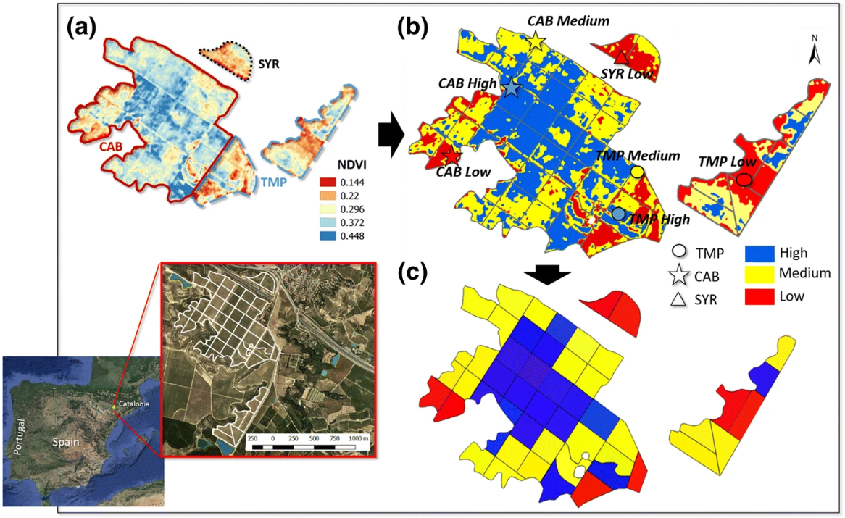

Figure 3 Optimizing precision irrigation management in Spanish vineyards using NDVI analysis (Adopted from Bellvert et al., 2020)

Image Caption: Study area shown as: a location of the vineyard (41° 39′42.92ʺ N, 0° 30′59.48ʺ E), Lleida (Spain) with the distribution of different varieties and airborne-acquired high-resolution interpolated NDVI map from July 2015, b classification of the NDVI map into three categories: High, Medium and Low using a K-mean clustering analysis, and c irrigation sectors classified by category. Symbols indicate the location of the ‘smart points’ (Adopted from Bellvert et al., 2020)

#### 4.4 Strategies for enhancing fruit quality

In California, a vineyard has leveraged remote sensing technologies to optimize harvest timing, ensuring that grapes are picked at their peak sugar content. Remote sensing provides detailed insights into the spatial variability of grapevine vigor and health, which are critical factors in determining the optimal harvest time (Hall et al., 2002). By utilizing high-resolution imagery and vegetation indices, the vineyard can monitor changes in grapevine physiology and sugar accumulation, allowing for precise timing of harvest operations (Hall et al., 2002; Ferro and Catania, 2023). This approach not only enhances fruit quality by ensuring that grapes are harvested at their optimal ripeness but also contributes to the overall sustainability of vineyard management by reducing the need for chemical interventions and improving resource efficiency (Hall et al., 2002; Mucalo et al., 2024). The use of remote sensing in this context exemplifies how technology can be harnessed to improve both the quality and sustainability of viticulture practices (Hall et al., 2002; Ferro and Catania, 2023).

## 5 Contributions of Precision Viticulture to Sustainability

### 5.1 Reducing resource waste

Precision viticulture plays a crucial role in minimizing the use of fertilizers and pesticides by employing site-specific management techniques. This approach allows for the precise application of inputs only where needed, significantly reducing waste and environmental impact. For instance, the application of the reduce principle in precision farming can cut fertilizer waste by up to 50%, thereby enhancing land productivity and minimizing harmful environmental effects such as groundwater pollution and greenhouse gas emissions (Undari and Arista, 2024). Additionally, precision agriculture substitutes information and knowledge for physical inputs, reducing environmental loading by applying fertilizers and pesticides only where and when they are needed (Bongiovanni and Lowenberg‐DeBoer, 2004).

### 5.2 Optimizing energy consumption

The use of precision equipment in viticulture can lead to a reduction in energy inputs, which is both cost-effective and environmentally beneficial. A life cycle assessment of vineyards using precision viticulture techniques showed a reduction in the product carbon footprint (PCF) of grapes, with within-farm energy use being a significant factor in greenhouse gas emissions reduction (Balafoutis et al., 2017). This demonstrates the potential of precision techniques to optimize energy consumption while maintaining or even increasing yield.

### 5.3 Reducing environmental impact

Precision viticulture helps protect surrounding ecosystems by lowering pesticide residues and fertilizer runoff (Oberti et al., 2016). By integrating satellite data with ground-based measurements, viticulturists can enhance precision viticulture, reducing reliance on chemical interventions and improving overall vineyard sustainability (Mucalo et al., 2024). This targeted management approach minimizes the environmental footprint of vineyard techniques, contributing to the preservation of biodiversity and soil health (Karimi et al., 2020).

### 5.4 Addressing climate change

Precision viticulture aids vineyards in adapting to extreme weather conditions, such as heat and drought, through precise management practices. The integration of IoT and machine learning in precision viticulture provides predictive tools essential for improved land productivity and crop quality, helping vineyards mitigate the impacts of climate change (Pero et al., 2024). Moreover, precision techniques like variable rate irrigation and nutrient management offer significant potential for reducing greenhouse gas emissions, thus contributing to climate change mitigation (Balafoutis et al., 2017).

## 6 Challenges in Implementing Precision Viticulture

### 6.1 Technological costs and return on investment

The high costs associated with precision viticulture technologies, such as sensors, GPS, and variable-rate application equipment, pose a significant barrier to adoption, particularly for small and medium-sized grape growers. These growers often struggle to justify the initial investment due to uncertain returns and the need for substantial capital outlay (Arnó et al., 2009; García, 2012; Moreiro, 2017). The variability in implementation costs, depending on the specific technical and economic objectives of each vineyard, further complicates the decision-making process for these growers (García, 2012).

### 6.2 Complexity of data integration and analysis

Integrating and analyzing data from various sources, such as remote sensing, sensors, and GPS, in real-time is a complex challenge in precision viticulture. The vast amount of data generated requires cross-sectoral expertise to manage effectively, which can be daunting for vineyard managers (Finco et al., 2022; Ferro and Catania, 2023; Mucalo et al., 2024). The integration of satellite data with ground-based measurements is crucial for enhancing precision and sustainability, yet it remains a challenging task due to the need for sophisticated data processing and interpretation techniques (Mucalo et al., 2024). Additionally, the use of machine learning and advanced analytics, while promising, adds another layer of complexity that requires specialized knowledge to implement effectively (Santesteban, 2019; Pero et al., 2024).

### 6.3 Operational complexity and training requirements

Precision viticulture (PV) involves the integration of advanced technologies such as IoT, machine learning, and remote sensing to optimize vineyard management. However, the implementation of these technologies requires high skill levels from operators. The complexity arises from the need to manage and interpret large volumes of data collected from various sensors and platforms, such as UAVs and wireless sensor networks, which are used to monitor vineyard conditions in real-time (Pero et al., 2024; Spachos and Gregori, 2019; Ferro and Catania, 2023). Operators must be proficient in using these technologies and in understanding the data to make informed decisions about vineyard management. This necessitates comprehensive training programs to equip vineyard managers and workers with the necessary skills to effectively utilize precision viticulture technologies (Sharma et al., 2021; Ferro and Catania, 2023).

### 6.4 Regional adaptation issues

The application of precision viticulture technologies is often challenged by regional adaptation issues. Different regions have unique environmental conditions, such as climate, soil type, and topography, which can affect the performance and effectiveness of precision technologies. For instance, the variability in water availability and soil moisture levels across regions can impact the success of precision irrigation systems (Finco et al., 2022; Pereyra et al., 2022). Additionally, the spatial variability within vineyards requires site-specific management practices, which may not be easily transferable across different regions (Balafoutis et al., 2017; Pereyra et al., 2022). This necessitates the customization of precision viticulture techniques to suit local conditions, which can be resource-intensive and may limit the widespread adoption of these technologies (Balafoutis et al., 2017; Finco et al., 2022; Pereyra et al., 2022).

## 7 Future Directions and Technological Improvements

### 7.1 Development of low-cost precision equipment

The advancement of precision viticulture is heavily reliant on the development of affordable and miniaturized technologies. The integration of wireless sensor networks and smart UAVs has shown promise in providing real-time, high-resolution data collection, which is crucial for optimizing vineyard management practices in a cost-effective manner (Spachos and Gregori, 2019). Unmanned Aerial Systems (UASs) are particularly noted for their low operating costs and flexibility, making them ideal for widespread adoption in precision viticulture (Sassu et al., 2021). In addition, integrating low-cost collaborative robots (collaborative robots) in vineyards can automate tasks such as chemical spraying, making it easier for small and medium-sized winemakers to use them. This method aims to reduce costs while maintaining the safety and efficiency of the grape planting process (Tomazzoli et al., 2024). The continued innovation in these areas is expected to make precision equipment more accessible to smaller vineyards, thereby democratizing the benefits of precision agriculture (Matese et al., 2015).

### 7.2 Advanced applications of artificial intelligence and big data

Artificial intelligence (AI) and machine learning (ML) are poised to revolutionize precision viticulture by enhancing decision support systems (Wu, 2024). The integration of IoT with ML models has already demonstrated significant potential in optimizing vineyard management, such as improving land productivity and crop quality through predictive analytics (Pero et al., 2024). The use of AI in processing and interpreting big data can provide deeper insights into vineyard agronomic and physiological status, enabling more precise management of spatial variability (Ferro and Catania, 2023; Fang, 2024). As these technologies evolve, they will offer more sophisticated tools for vineyard management, leading to increased efficiency and sustainability (Santesteban, 2019).

### 7.3 Integration with carbon neutrality and sustainable agriculture

Precision viticulture can play a pivotal role in promoting sustainable agriculture by integrating carbon footprint monitoring into its management practices (Bača et al., 2024). The use of satellite solutions has been highlighted for their ability to enhance sustainability by reducing the environmental footprint of vineyard techniques through precise on-field adaptation strategies (Mucalo et al., 2024). By incorporating carbon neutrality goals into precision management, vineyards can not only improve their environmental impact but also align with global sustainability standards (Matese and Gennaro, 2015).

### 7.4 International cooperation and technology sharing

The future of precision viticulture will benefit greatly from international cooperation and the sharing of technology and best practices. Transnational collaboration can facilitate the standardization of management solutions and promote the adoption of innovative technologies across different regions (Hall et al., 2002). By sharing knowledge and resources, the global viticulture community can accelerate the development and implementation of precision technologies, ultimately leading to more sustainable and efficient vineyard management practices (Ammoniaci et al., 2021).

**8 Concluding Remarks**

Precision viticulture leverages advanced technologies such as remote sensing, IoT, machine learning, and UAVs to optimize vineyard management, thereby improving both the quality and quantity of grape production while minimizing environmental impacts. The integration of these technologies allows for precise monitoring and management of vineyard conditions, which is crucial for adapting to regional variability and ensuring efficient resource use.

Moreover, the successful implementation of precision viticulture requires a comprehensive approach that considers technological integration, cost-effectiveness, and regional adaptability. The economic viability of these technologies is enhanced when they are tailored to specific vineyard conditions, as demonstrated by the use of variable rate applications and precision irrigation systems that optimize water use and reduce greenhouse gas emissions. This highlights the importance of aligning technological advancements with economic indices to support sustainable practices in viticulture.

Continued advancements in technology and increased collaboration among stakeholders are expected to drive the global adoption of precision agriculture practices. The development of more sophisticated sensors, data processing algorithms, and decision support systems will further enhance the ability of viticulturists to manage vineyards sustainably and efficiently. As these technologies evolve, they will play an increasingly critical role in addressing the challenges of climate change and resource scarcity, ultimately contributing to the long-term sustainability of the viticulture industry.

**Acknowledgments**

We extend our gratitude to our research partners for their support and assistance during the process of compiling the literature.

**Conflict of Interest Disclosure**

The authors affirm that this research was conducted without any commercial or financial relationships that could be construed as a potential conflict of interest.

**References**

Ammoniaci, M., Kartsiotis, S., Perria, R., & Storchi, P. (2021). State of the Art of Monitoring Technologies and Data Processing for Precision Viticulture. Agriculture. <https://doi.org/10.3390/AGRICULTURE11030201>

Arnó, J., Casasnovas, J., Dasi, M., & Rosell, J. (2009). Review. Precision Viticulture. Research topics, challenges and opportunities in site-specific vineyard management. Spanish Journal of Agricultural Research, 7, 779-790. <https://doi.org/10.5424/SJAR/2009074-1092>

Bača, P., Mašán, V., Vanýsek, P., Burg, P., Binar, T., Burgová, J., & Abrham, Z. (2024). Assessing the Carbon Footprint of Viticultural Production in Central European Conditions. Sustainability. <https://doi.org/10.3390/su16156561.>

Balafoutis, A., Koundouras, S., Anastasiou, E., Fountas, S., & Arvanitis, K. (2017). Life Cycle Assessment of Two Vineyards after the Application of Precision Viticulture Techniques: A Case Study. Sustainability, 9, 1997. <https://doi.org/10.3390/SU9111997>

Bellvert, J., Mata, M., Vallverdú, X., Paris, C., & Marsal, J. (2020). Optimizing precision irrigation of a vineyard to improve water use efficiency and profitability by using a decision-oriented vine water consumption model. Precision Agriculture, 22, 319 - 341. <https://doi.org/10.1007/s11119-020-09718-2>

Bongiovanni, R., & Lowenberg‐DeBoer, J. (2004). Precision Agriculture and Sustainability. Precision Agriculture, 5, 359-387. <https://doi.org/10.1023/B:PRAG.0000040806.39604.aa>

Fang J., 2024, Breeding 5.0: AI-driven revolution in designed plant breeding, Molecular Plant Breeding, 15(1): 27-33 (doi: 10.5376/mpb.2024.15.0004)

Ferro, M., & Catania, P. (2023). Technologies and Innovative Methods for Precision Viticulture: A Comprehensive Review. Horticulturae. <https://doi.org/10.3390/horticulturae9030399>

Finco, A., Bentivoglio, D., Chiaraluce, G., Albéri, M., Chiarelli, E., Maino, A., Mantovani, F., Montuschi, M., Raptis, K., Semenza, F., Strati, V., Vurro, F., Marchetti, E., Bettelli, M., Janni, M., Anceschi, E., Sportolaro, C., & Bucci, G. (2022). Combining Precision Viticulture Technologies and Economic Indices to Sustainable Water Use Management. Water. <https://doi.org/10.3390/w14091493>

García, J. (2012). Consideraciones sobre el potencial de la Viticultura de Precisión en Galicia. Spanish journal of rural development, 3, 19-28. <https://doi.org/10.5261/2012.ESP1.02>

Hall, A., Lamb, D., Holzapfel, B., & Louis, J. (2002). Optical remote sensing applications in viticulture - a review. Australian Journal of Grape and Wine Research, 8, 36-47. <https://doi.org/10.1111/J.1755-0238.2002.TB00209.X>

Karimi, B., Cahurel, J., Gontier, L., Charlier, L., Chovelon, M., Mahe, H., & Ranjard, L. (2020). A meta-analysis of the ecotoxicological impact of viticultural practices on soil biodiversity. Environmental Chemistry Letters, 18, 1947 - 1966. <https://doi.org/10.1007/s10311-020-01050-5>

Marcu, I., Dragulinescu, A., Oprea, C., Suciu, G., & Balaceanu, C. (2022). Predictive Analysis and Wine-Grapes Disease Risk Assessment Based on Atmospheric Parameters and Precision Agriculture Platform. Sustainability. <https://doi.org/10.3390/su141811487>

Matese, A., & Gennaro, S. (2015). Technology in precision viticulture: a state of the art review. **, 7, 69-81. <https://doi.org/10.2147/IJWR.S69405>

Matese, A., Toscano, P., Gennaro, S., Genesio, L., Vaccari, F., Primicerio, J., Belli, C., Zaldei, A., Bianconi, R., & Gioli, B. (2015). Intercomparison of UAV, Aircraft and Satellite Remote Sensing Platforms for Precision Viticulture. Remote. Sens., 7, 2971-2990. <https://doi.org/10.3390/rs70302971>

Moreiro, L. (2017). Interest of seeing Precision Viticulture through two distributed competences: Determination of resources and schemes allowing some practical recommendations. **, 9, 01023. <https://doi.org/10.1051/BIOCONF/20170901023>

Mucalo, A., Matic, D., Morić-Španić, A., & Čagalj, M. (2024). Satellite Solutions for Precision Viticulture: Enhancing Sustainability and Efficiency in Vineyard Management. Agronomy. <https://doi.org/10.3390/agronomy14081862>

Oberti, R., Marchi, M., Tirelli, P., Calcante, A., Iriti, M., Tona, E., Hočevar, M., Baur, J., Pfaff, J., Schütz, C., & Ulbrich, H. (2016). Selective spraying of grapevines for disease control using a modular agricultural robot. Biosystems Engineering, 146, 203-215. <https://doi.org/10.1016/J.BIOSYSTEMSENG.2015.12.004.>

Ozdemir, G., Sessi̇z, A., & Pekitkan, F. (2017). Precision Viticulture tools to production of high quality grapes.. **, 209-218.

Pereyra, G., Pellegrino, A., Gaudin, R., & Ferrer, M. (2022). Evaluation of site-specific management to optimise Vitis vinifera L. (cv. Tannat) production in a vineyard with high heterogeneity. OENO One. <https://doi.org/10.20870/oeno-one.2022.56.3.5485>

Pero, C., Bakshi, S., Nappi, M., & Tortora, G. (2024). IoT-Driven Machine Learning for Precision Viticulture Optimization. IEEE Journal of Selected Topics in Applied Earth Observations and Remote Sensing, 17, 2437-2447. <https://doi.org/10.1109/JSTARS.2023.3345473>

Raihan, A. (2024). A Systematic Review of Geographic Information Systems (GIS) in Agriculture for Evidence-Based Decision Making and Sustainability. Global Sustainability Research. <https://doi.org/10.56556/gssr.v3i1.636.>

Rezk, N., Hemdan, E., Attia, A., El-Sayed, A., & El-Rashidy, M. (2020). An efficient IoT based smart farming system using machine learning algorithms. Multimedia Tools and Applications, 80, 773 - 797. <https://doi.org/10.1007/s11042-020-09740-6.>

Santesteban, L. (2019). Precision viticulture and advanced analytics. A short review.. Food chemistry, 279, 58-62. <https://doi.org/10.1016/j.foodchem.2018.11.140>

Sassu, A., Gambella, F., Ghiani, L., Mercenaro, L., Caria, M., & Pazzona, A. (2021). Advances in Unmanned Aerial System Remote Sensing for Precision Viticulture. Sensors (Basel, Switzerland), 21. <https://doi.org/10.3390/s21030956>

Spachos, P., & Gregori, S. (2019). Integration of Wireless Sensor Networks and Smart UAVs for Precision Viticulture. IEEE Internet Computing, 23, 8-16. <https://doi.org/10.1109/MIC.2018.2890234>

Sharma, A., Jain, A., Gupta, P., & Chowdary, V. (2021). Machine Learning Applications for Precision Agriculture: A Comprehensive Review. IEEE Access, 9, 4843-4873. <https://doi.org/10.1109/ACCESS.2020.3048415>

Tomazzoli, C., Ponza, A., Cristani, M., Olivieri, F., & Scannapieco, S. (2024). A Cobot in the Vineyard: Computer Vision for Smart Chemicals Spraying. Applied Sciences. <https://doi.org/10.3390/app14093777.>

Undari, D., & Arista, N. (2024). Potensi precision farming dalam penerapan prinsip reduce untuk mengurangi limbah sumber daya pertanian. Waste Handling and Environmental Monitoring. <https://doi.org/10.61511/whem.v1i2.2024.1239>

Wu W.C., 2024, Predicting wheat response to drought using machine learning algorithms, Plant Gene and Trait, 15(1): 1-7 (doi: 10.5376/pgt.2024.15.0001)

**Disclaimer/Publisher’s Note**

The statements, opinions, and data contained in all publications are solely those of the individual authors and contributors and do not represent the views of the publishing house and/or its editors. The publisher and/or its editors disclaim all responsibility for any harm or damage to persons or property that may result from the application of ideas, methods, instructions, or products discussed in the content. Publisher remains neutral with regard to jurisdictional claims in published maps and institutional affiliations.