Feature Review

**Wild Tea Species as a Genetic Resource for Future Breeding Programs**

Jie Huang, Xiazhen Huang, Meifang Li *

Tropical Medicinal Plant Research Center, Hainan Institute of Tropical Agricultural Resources, Sanya, 572025, Hainan, China

* Corresponding author, meifang.li@hitar.org

**Abstract**This study reviews the significance and potential utilization of wild tea species in tea breeding programs. Wild tea species provide rich genetic diversity that supports the genetic improvement of cultivated tea. These wild relatives possess critical traits such as resistance to pests and diseases, tolerance to abiotic stresses, and quality enhancement, which are key to improving tea yield, quality, and adaptability to environmental changes. The study also explores the application of modern breeding technologies, including genome sequencing, genome-wide association studies (GWAS), and marker-assisted selection (MAS), as well as strategies for balancing the development and conservation of wild tea species. Future research and international collaboration will enhance the efficient utilization of wild tea resources, thereby promoting the sustainable development of the tea industry.

**Keywords**Wild tea species; Genetic diversity; Tea breeding; Pest and disease resistance; Abiotic stress tolerance

**1 Introduction**

Tea cultivation holds significant economic importance globally, as it is one of the most widely consumed beverages, produced from the leaves of the tea plant, *Camellia sinensis*. This evergreen crop is cultivated in over 50 countries, with China and India being the largest producers (Meegahakumbura et al., 2018; Xia et al., 2020). The economic value of tea is not only due to its widespread consumption but also its cultural significance and health benefits, which have driven the demand for high-quality tea products (Xia et al., 2020). The tea industry relies heavily on the genetic diversity of tea plants to improve yield, quality, and resistance to environmental stresses (Li et al., 2023).

However, tea breeding faces several challenges, primarily due to the limited genetic base resulting from conventional breeding methods, which are slow and often constrained by low cross-compatibility and genetic drag (Mukhopadhyay et al., 2015). The genetic improvement of tea is further complicated by its large and complex genome, which poses difficulties in genetic studies and breeding programs (Zhang et al., 2015). To overcome these challenges, there is a pressing need for greater genetic diversity to enhance breeding efforts and develop tea varieties that can withstand biotic and abiotic stresses while maintaining high quality (Chen et al., 2019; Niu et al., 2019).

Wild tea species represent an untapped reservoir of genetic diversity that could be crucial for future breeding programs. These wild relatives of cultivated tea, such as *Camellia taliensis*, possess valuable traits like abiotic tolerance and biotic resistance, which are not present in cultivated varieties. The genetic resources found in wild tea species can provide insights into the domestication and evolutionary history of tea plants, offering potential for the discovery of genes associated with important traits such as stress resistance and flavor. By leveraging the genetic diversity of wild tea species, breeders can develop new tea cultivars with improved characteristics, ensuring the sustainability and economic viability of the tea industry in the face of changing environmental conditions.

**2 Diversity and Distribution of Wild Tea Species**

**2.1 Taxonomy and classification of wild tea species**

Wild tea species, primarily belonging to the genus Camellia, are classified under the section Thea. This section includes *Camellia sinensis*, the most widely cultivated tea plant, and its wild relatives. The classification within this section has been challenging due to reliance on macromorphological features, which can be variable. However, recent studies have utilized foliar sclereids, which are stable anatomical features, to address taxonomic issues. These sclereids exhibit a wide diversity and can be categorized into 12 types, providing a reliable basis for classification and identification of both wild and cultivated tea species (Zhang et al., 2009).

**2.2 Geographic distribution and ecological niches**

Wild tea species are predominantly found in subtropical regions, with significant populations in China, particularly in Yunnan and Guizhou provinces. These regions provide diverse ecological niches, ranging from lowland subtropical forests to high-altitude mountainous areas. The distribution of wild tea is influenced by various environmental factors, including temperature, precipitation, and soil pH. For instance, *Camellia taliensis*, a wild tea species, is distributed from the west and southwest of Yunnan province to northern Myanmar, thriving in diverse habitats that contribute to its genetic diversity (Rao et al., 2018). The subtropical forests of China, rich in plant species, serve as crucial habitats for these wild tea species, supporting their conservation and utilization.

**2.3 Genetic diversity in wild tea compared to cultivated varieties**

Wild tea species exhibit significant genetic diversity, which is crucial for breeding programs aimed at improving cultivated varieties. Studies using molecular markers such as EST-SSR and SNPs have revealed high levels of genetic diversity in wild tea populations. For example, *Camellia taliensis* populations in Qianjiazhai show high genetic diversity at the species level, with substantial gene flow among populations at different altitudes (Rao et al., 2018; Wang et al., 2023). In contrast, cultivated tea varieties, while also diverse, often show less genetic variation compared to their wild counterparts. This is evident in the genetic analysis of *Camellia sinensis* populations, where cultivated types exhibit a higher level of genetic diversity than pure wild types, but less than ancient landraces and admixed wild types (Niu et al., 2019). The genetic diversity in wild tea species provides a valuable resource for breeding programs, offering traits that can enhance disease resistance, stress tolerance, and other desirable characteristics in cultivated tea plants (Goh et al., 2023; Huang, 2024).

**3 Genetic Traits in Wild Tea Species**

**3.1 Disease and pest resistance**

Wild tea species possess significant genetic traits that contribute to disease and pest resistance, making them valuable resources for breeding programs. For instance, certain genotypes of *Camellia sinensis*, such as *Cd19* and *Cd289*, have demonstrated strong resistance to the tea green leafhopper, *Empoasca onukii*, under field conditions, which is a major pest in East Asia (Yorozuya et al., 2021). The genetic diversity found in wild tea species, such as those from the Guizhou plateau, also provides a rich pool of alleles that can be harnessed to develop resistant cultivars (Niu et al., 2019). These genetic resources are crucial for enhancing the resilience of tea plants against biotic stresses.

**3.2 Abiotic stress tolerance**

Wild tea species are known for their ability to tolerate a range of abiotic stresses, including drought, salinity, and temperature extremes. *Camellia taliensis*, a wild relative of the cultivated tea tree, exhibits a remarkable expansion of late embryogenesis abundant (*LEA*) genes, which are associated with stronger stress resistance compared to cultivated varieties (Zhang et al., 2015). This genetic trait is particularly valuable for breeding programs aimed at developing tea plants that can withstand the challenges posed by climate change and other environmental stresses (Singh and Abhilash, 2018).

**3.3 Quality-related traits**

The genetic diversity in wild tea species also extends to quality-related traits such as flavor, aroma, and phytochemical content. Genome-wide association studies have identified candidate genes involved in flavonoid biosynthesis, such as *CsANR*, *CsF3*’*5*’*H*, and *CsMYB5*, which play a crucial role in the production of catechins, key bioactive compounds in tea (Zhang et al., 2020). Additionally, genes associated with terpene biosynthesis, which contribute to tea aroma, have been significantly amplified in the tea plant genome through recent tandem duplications (Figure 1) (Xia et al., 2020). These findings highlight the potential of wild tea species to enhance the quality attributes of cultivated tea.

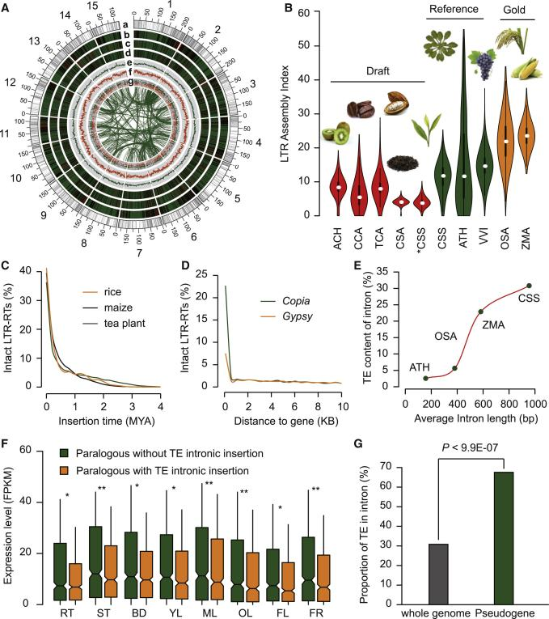

Figure 1 Landscape of the tea plant genome: transcription factors (Adopted from Xia et al., 2020)

Image caption: (a), gene density (b), intact LTR-RTs from the copia (c) and gypsy families (d), GC content (e), SSR density (f), and differentially expressed genes between leaf and root tissues (g) are shown. The inner circle represents the collinear blocks identified in the tea plant genome. (B) LAI evaluation of the genome assemblies of two tea plant varieties and seven other plant species, CSS, *Camellia sinensis* var. sinensis; CSA, *C. sinensis* var. *assamica*; OSA, *Oryza sativa* ssp. *japonica*; ZMA, *Zea mays*; CCA, *Coffea canephora*; TCA, *Theobroma cacao*; ACH, *Actinidia chinensis*; ATH, *Arabidopsis thaliana*; VVI, *Vitis vinifera*. * CSS indicates the previous assembly of *C. sinensis* var. *sinensis* (Wei et al., 2018). (C) Estimated times of insertion for intact LTR-RTs (≤4 MYA) of the tea plant, rice, and maize. (D) Distribution of the distance of tea plant LTR-RTs to protein-coding genes. Only distances≤10 kb are plotted. (E) Repeat content in introns of the tea plant and other three representative plants. (F) Expression levels of duplicated genes with (orange color) or without (green color) intronic TE insertions in eight tissues of tea plant: roots (RT), stems (ST), apical buds (BD), young leaves (YL), mature leaves (ML), old leaves (OL), flowers (FL) and fruits (FR). P**<0.01; P*<0.05. (G) Proportion of TEs in intronic regions of protein-coding genes and pseudogenes of the tea plant (Adopted from Xia et al., 2020)

**4 Tools and Technologies for Utilizing Wild Tea Species in Breeding**

**4.1 Advances in genomic sequencing and annotation for tea**

Recent advancements in genomic sequencing have significantly enhanced our understanding of tea plant genetics. The assembly of high-quality reference genomes for wild tea species, such as the ancient tea tree, has provided valuable insights into the genetic makeup and evolutionary history of tea plants (Zhang et al., 2020). These genomic resources facilitate the identification of candidate genes associated with important traits like flavonoid biosynthesis, which are crucial for tea quality. Additionally, the development of comprehensive transcriptome datasets for wild relatives of tea, such as *Camellia taliensis*, has enabled the identification of genes involved in stress response and tea quality, further supporting breeding efforts (Zhang et al., 2015).

**4.2 Application of genome-wide association studies (GWAS)**

Genome-wide association studies (GWAS) have become a pivotal tool in tea breeding, allowing researchers to link specific genetic variations with desirable traits. For instance, GWAS has been employed to identify SNPs associated with quality-related metabolites in tea, such as catechins and caffeine, which are essential for improving tea quality through breeding (Yamashita et al., 2020). Moreover, GWAS has been used to study traits like the timing of spring bud flush, providing markers for marker-assisted selection (MAS) in breeding programs (Wang et al., 2019). These studies leverage large-scale SNP data to uncover genetic markers that can be used to enhance tea plant traits.

**4.3 Molecular breeding techniques**

Molecular breeding techniques, including marker-assisted selection (MAS), have been instrumental in accelerating tea breeding programs. The development of molecular markers, such as unigene-derived microsatellite markers, has facilitated genetic analysis and gene mapping in tea (Sharma et al., 2009). These markers allow for the efficient selection of desirable traits, such as yield, quality, and resistance, by providing a genetic basis for breeding decisions (Li et al., 2023). The integration of genomic data with MAS enables breeders to make informed selections, thereby improving the efficiency and effectiveness of breeding programs.

**4.4 Emerging technologies**

Emerging technologies like CRISPR-Cas9 and epigenetic studies hold great promise for the future of tea breeding. CRISPR-Cas9 offers precise genome editing capabilities, allowing for the targeted modification of genes associated with important traits, potentially overcoming limitations of traditional breeding methods (Mukhopadhyay et al., 2015). Additionally, understanding epigenetic modifications in tea plants can provide insights into gene expression regulation and stress responses, offering new avenues for enhancing tea plant resilience and quality (Wang et al., 2019). These technologies represent the frontier of genetic improvement in tea, providing innovative tools for developing superior tea cultivars.

**5 Case Study: Resistance of Wild Tea Species to Blister Blight**

**5.1 Background on tea blight and its impact on cultivation**

Tea is one of the most widely consumed beverages, made from the tender leaves of the tea plant. Various biotic and abiotic factors are directly related to tea yield. Among the biotic factors, the most destructive is blister blight, caused by the obligate parasitic fungus Exobasidium vexans Massee. The pathogen invades the tender leaves of tea plants, directly impacting the economic growth of tea-producing countries due to the significant export value of tea. Numerous studies have identified the symptoms, epidemiology, and control strategies of this pathogen. Traditionally, control measures have relied on copper-based fungicides, but these approaches are not long-term sustainable solutions due to environmental concerns and the potential development of resistance in pathogens (Figure 2) (Sen et al., 2020). Therefore, identifying genetic resistance in tea species is crucial for sustainable disease management.

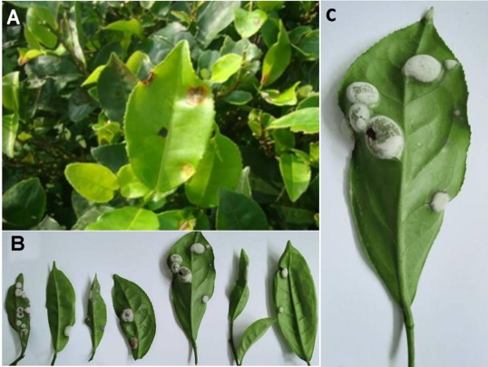

Figure 2 Symptoms of blister blight in tea (Adopted from Sen et al., 2020)

Image caption: A: Infected leaves in tea bush; B: Various degree of infection; C: Typical symptoms of infection (Adopted from Sen et al., 2020)

**5.2 Identification of resistance genes in a specific wild tea species**

Research has identified several genetic markers and genes associated with resistance to blister blight in tea plants. Notably, the transcription factor CsWRKY14 has been isolated from *Camellia sinensis* and shown to play a critical role in mediating resistance through the salicylic acid (SA) signaling pathway (Liu et al., 2021). This gene is more highly expressed in resistant cultivars, suggesting its potential as a genetic resource for breeding programs. Additionally, a functional molecular marker, EST-SSR073, has been identified, which is associated with blister blight resistance, facilitating marker-assisted selection in breeding programs (Karunarathna et al., 2020).

**5.3 Experimental breeding trials integrating resistance genes into cultivated tea**

Experimental breeding trials have focused on integrating these resistance genes into cultivated tea varieties. The use of marker-assisted selection (MAS) has been pivotal in these efforts, allowing for the precise incorporation of resistance traits into new cultivars. For instance, the EST-SSR073 marker has been used to track and select for resistance alleles in breeding populations, significantly expediting the breeding process (Karunarathna et al., 2020). These trials aim to produce cultivars that maintain high resistance levels while preserving desirable agronomic traits.

**5.4 Analysis of outcomes and implications for future breeding**

The outcomes of these breeding trials have been promising, with new tea cultivars exhibiting enhanced resistance to blister blight. The integration of resistance genes like CsWRKY14 has not only improved disease resistance but also contributed to better stress tolerance overall (Zhang et al., 2015; Liu et al., 2021). These advancements underscore the potential of wild tea species as genetic resources for breeding programs. The success of these trials highlights the importance of continued exploration of wild tea genetic diversity to discover additional resistance genes, which could be crucial for developing resilient tea cultivars in the face of evolving pathogen threats. This approach not only ensures sustainable tea production but also reduces reliance on chemical fungicides, aligning with environmental conservation goals.

**6 Challenges and Opportunities**

**6.1 Ethical and conservation concerns in using wild species**

The utilization of wild tea species as genetic resources for breeding programs presents significant ethical and conservation challenges. Wild tea species, such as *Camellia taliensis*, are crucial for maintaining biodiversity and ecological balance in their native habitats (Zhang et al., 2015). The exploitation of these species for genetic improvement must be balanced with conservation efforts to prevent the depletion of natural populations. Ethical considerations also arise in the context of bioprospecting, where the genetic resources of wild species are used without adequate benefit-sharing with local communities or countries of origin (Mukhopadhyay et al., 2015). Ensuring that conservation strategies are in place and that ethical guidelines are followed is essential to sustainably harness the genetic potential of wild tea species.

**6.2 Bridging the gap between research and practical applications**

There is a notable gap between the extensive research conducted on wild tea species and their practical application in breeding programs. While genomic and transcriptomic studies have identified valuable genetic traits in wild species, such as stress resistance and quality improvement (Zhang et al., 2015; Zhang et al., 2022), translating these findings into practical breeding strategies remains a challenge. The complexity of tea plant genomes and the long breeding cycles further complicate the integration of research into practice (Mukhopadhyay et al., 2015; Lubanga et al., 2020). Bridging this gap requires the development of efficient genomic selection strategies and the application of biotechnological tools to accelerate breeding processes and enhance the genetic gain in tea breeding programs (Lubanga et al., 2020).

**6.3 Potential for global collaboration in wild tea resource utilization**

The global nature of tea cultivation and consumption presents a unique opportunity for international collaboration in the utilization of wild tea resources. Collaborative efforts can facilitate the sharing of genetic resources, research findings, and breeding technologies across countries, enhancing the genetic diversity and resilience of tea cultivars worldwide (Xia et al., 2020). Such collaborations can also promote the development of standardized ethical guidelines and conservation strategies, ensuring that the benefits of wild tea species are shared equitably and sustainably (Niu et al., 2019; Shim et al., 2024). By fostering global partnerships, the tea industry can leverage the genetic potential of wild species to address challenges such as climate change, pest resistance, and quality improvement, ultimately benefiting producers and consumers alike.

**7 Future Perspectives**

**7.1 Integrating wild tea genetic resources into sustainable breeding programs**

The integration of wild tea genetic resources into breeding programs offers a promising avenue for enhancing the genetic diversity and resilience of cultivated tea varieties. Wild tea species, such as *Camellia taliensis*, possess valuable traits like abiotic tolerance and biotic resistance, which are crucial for the genetic improvement of cultivated tea trees (Zhang et al., 2015). The use of advanced genomic tools, such as genome-wide association studies and transcriptomics, can facilitate the identification of beneficial alleles from wild relatives, enabling their incorporation into breeding programs (Mukhopadhyay et al., 2015; Zhang et al., 2020). By leveraging these genetic resources, breeders can develop new tea cultivars with improved stress resistance and quality traits, ensuring the sustainability of tea agriculture in the face of climate change and other environmental challenges (Li et al., 2023).

**7.2 Long-term benefits for biodiversity and tea agriculture**

The utilization of wild tea species in breeding programs not only enhances the genetic base of cultivated tea but also contributes to the conservation of biodiversity. By maintaining a diverse genetic pool, the risk of genetic erosion is minimized, which is vital for the long-term sustainability of tea agriculture (Mukhopadhyay et al., 2015; Zhao et al., 2021). The genetic diversity found in wild tea populations, such as those in the Guizhou plateau and Qianjiazhai Nature Reserve, provides a reservoir of traits that can be harnessed to improve yield, quality, and resilience of tea plants (Niu et al., 2019). This approach not only supports the development of robust tea cultivars but also promotes the conservation of wild tea species, ensuring their survival and continued availability as genetic resources for future breeding efforts (Figure 3) (Samarina et al., 2022).

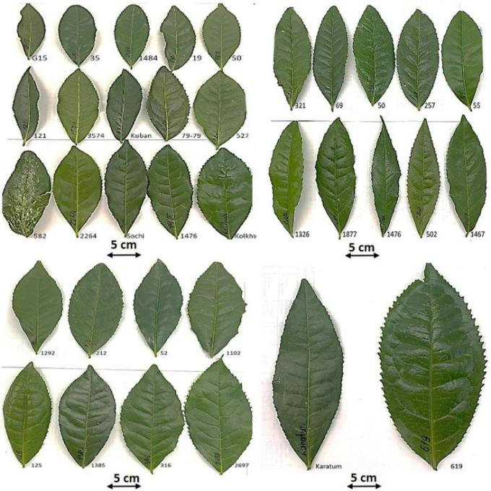

Figure 3 Morphological variability of the typical mature leaves of the mutant forms and cultivars of tea collection in FRC SSC RAS, Sochi, Russia (Adopted from Samarina et al., 2022)

**7.3 Recommendations for policy and investment**

To fully realize the potential of wild tea species in breeding programs, strategic policy and investment initiatives are essential. Governments and stakeholders should prioritize the conservation of wild tea habitats and support research initiatives aimed at characterizing and utilizing these genetic resources (Meegahakumbura et al., 2018). Investment in biotechnological tools and infrastructure, such as genomic selection and marker-assisted breeding, can accelerate the development of improved tea varieties (Lubanga et al., 2022). Additionally, fostering collaborations between research institutions, tea producers, and policymakers can facilitate the exchange of knowledge and resources, driving innovation in tea breeding (Mukhopadhyay et al., 2015; Li et al., 2023). By aligning policy and investment with the goals of sustainable agriculture and biodiversity conservation, the tea industry can achieve greater resilience and productivity in the long term.

**8 Conclusion**

Wild tea species play a crucial role in future breeding programs by serving as a rich reservoir of genetic diversity that can be harnessed to improve cultivated tea varieties. These wild relatives, such as *Camellia taliensis*, offer valuable traits like abiotic tolerance and biotic resistance, which are essential for enhancing the genetic improvement of tea trees. The genetic diversity found in wild tea species provides a broader genetic base that can be utilized to develop new cultivars with improved yield, quality, and stress resistance. The integration of wild genetic resources into breeding programs can lead to the discovery of novel alleles and genes that are pivotal for the biosynthesis of important compounds, such as flavonoids, which contribute to tea quality and health benefits.

Preserving wild genetic resources is of paramount importance for the sustainability and advancement of tea breeding programs. The genetic information and diversity present in wild tea species are irreplaceable assets that can help mitigate the challenges posed by climate change, pests, and diseases. Conservation of these genetic resources ensures that future breeding efforts have access to a wide array of genetic material, which is crucial for developing resilient and high-quality tea cultivars. As the demand for tea continues to grow globally, maintaining the genetic diversity of wild tea species will be essential for meeting future agricultural and consumer needs, thereby securing the economic and cultural significance of tea worldwide.

**Acknowledgments**

The authors sincerely thank Dr. Qian for carefully reviewing the initial draft of the manuscript and providing detailed revision suggestions. The authors also extend deep gratitude to the two anonymous peer reviewers for their valuable comments and suggestions on the manuscript of this study.

**Conflict of Interest Disclosure**

The authors affirm that this research was conducted without any commercial or financial relationships that could be construed as a potential conflict of interest.

**References**

Chen, X., Luo, X., Fan, M., Zeng, W., Yang, C., Wu, J., Zhao, C., Zhang, Y., & Zhao, P. (2019). Endophytic fungi from the branches of *Camellia taliensis* (W. W. Smith) Melchior, a widely distributed wild tea plant. World Journal of Microbiology and Biotechnology, 35. https://doi.org/10.1007/s11274-019-2686-x

Goh, S., An, B., Hong, S., Hu, S., & Yi, P. (2023). Genetic Diversity Analysis of Tea Trees in Gimhae Wild Tea Colonies. The Korean Tea Society. https://doi.org/10.29225/jkts.2023.29.3.29

Huang D.D., 2024, Molecular mechanisms of tea plant resistance to major pathogens, Molecular Pathogens, 15(1): 30-39 (doi: 10.5376/mp.2024.15.0004)

Karunarathna, K., Mewan, K., Weerasena, O., Perera, S., & Edirisinghe, E. (2020). A functional molecular marker for detecting blister blight disease resistance in tea (*Camellia sinensis* L.). Plant Cell Reports, 40, 351 - 359. https://doi.org/10.1007/s00299-020-02637-6

Li, H., Song, K., Zhang, X., Wang, D., Dong, S., Liu, Y., & Yang, L. (2023). Application of Multi-Perspectives in Tea Breeding and the Main Directions. International Journal of Molecular Sciences, 24. https://doi.org/10.3390/ijms241612643

Liu, S., Zhang, Q., Guan, C., Wu, D., Zhou, T., & Yu, Y. (2021). Transcription factor WRKY14 mediates resistance of tea plants (*Camellia sinensis* (L.) O. Kuntze) to blister blight. Physiological and Molecular Plant Pathology, 115, 101667. https://doi.org/10.1016/J.PMPP.2021.101667

Lubanga, N., Massawe, F., Mayes, S., Gorjanc, G., & Bančič, J. (2022). Genomic selection strategies to increase genetic gain in tea breeding programs. The Plant Genome, 16. https://doi.org/10.1002/tpg2.20282

Meegahakumbura, M., Wambulwa, M., Li, M., Thapa, K., Sun, Y., Möller, M., Xu, J., Yang, J., Liu, J., Liu, B., Li, D., & Gao, L. (2018). Domestication Origin and Breeding History of the Tea Plant (*Camellia sinensis*) in China and India Based on Nuclear Microsatellites and cpDNA Sequence Data. Frontiers in Plant Science, 8. https://doi.org/10.3389/fpls.2017.02270

Mukhopadhyay, M., Mondal, T., & Chand, P. (2015). Biotechnological advances in tea (*Camellia sinensis* [L.] O. Kuntze): a review. Plant Cell Reports, 35, 255 - 287. https://doi.org/10.1007/s00299-015-1884-8

Niu, S., Song, Q., Koiwa, H., Qiao, D., Zhao, D., Chen, Z., Liu, X., & Wen, X. (2019). Genetic diversity, linkage disequilibrium, and population structure analysis of the tea plant (*Camellia sinensis*) from an origin center, Guizhou plateau, using genome-wide SNPs developed by genotyping-by-sequencing. BMC Plant Biology, 19. https://doi.org/10.1186/s12870-019-1917-5

Rao, M., Steinbauer, M., Xiang, X., Zhang, M., Mi, X., Zhang, J., , K., & Svenning, J. (2018). Environmental and evolutionary drivers of diversity patterns in the tea family (Theaceae s.s.) across China. Ecology and Evolution, 8, 11663 - 11676. https://doi.org/10.1002/ece3.4619

Samarina, L., Matskiv, A., Shkhalakhova, R., Koninskaya, N., Hanke, M., Flachowsky, H., Shumeev, A., Manakhova, K., Malyukova, L., Liu, S., Zhu, J., Gvasaliya, M., Malyarovskaya, V., Ryndin, A., Pchikhachev, E., & Reim, S. (2022). Genetic Diversity and Genome Size Variability in the Russian Genebank Collection of Tea Plant [*Camellia sinensis* (L). O. Kuntze]. Frontiers in Plant Science, 12. <https://doi.org/10.3389/fpls.2021.800141>

Sen S, Rai M, Das D, et al. Blister blight a threatened problem in tea industry: A review[J]. Journal of King Saud University-Science, 2020, 32(8): 3265-3272.

Sharma, R., Bhardwaj, P., Negi, R., Mohapatra, T., & Ahuja, P. (2009). Identification, characterization and utilization of unigene derived microsatellite markers in tea (*Camellia sinensis* L.). BMC Plant Biology, 9, 53 - 53. https://doi.org/10.1186/1471-2229-9-53

Shim, D., Jeon, S., Kim, J., & Yoon, D. (2024). Comparative Phylogenetic Analysis of Ancient Korean Tea ‘Hadong Cheon-Nyeon Cha (*Camellia sinensis* var. sinensis)’ Using Complete Chloroplast Genome Sequences. Current Issues in Molecular Biology, 46, 1091 - 1106. https://doi.org/10.3390/cimb46020069

Singh, A., & Abhilash, P. (2018). Wild Relatives of Cultivated Plants in India. A Reservoir of Alternative Genetic Resources and More, A.K. Singh, Springer (2017) 309 pp., Price 156.99 £, ISBN: 9789811051166. Genetic Resources and Crop Evolution, 65, 2049 - 2056. https://doi.org/10.1007/s10722-018-0662-1

Wang, F., Cheng, X., Cheng, S., Li, W., & Huang, X. (2023). Genetic diversity of the wild ancient tea tree (*Camellia taliensis*) populations at different altitudes in Qianjiazhai, PloS One, 18 4, e0283189 . https://doi.org/10.1371/journal.pone.0283189

Wang, R., Gao, X., Yang, J., & Kong, X. (2019). Genome-wide association study to identify favorable SNP allelic variations and candidate genes that control the timing of spring bud flush of tea (*Camellia sinensis*) using SLAF-seq.. Journal of agricultural and food chemistry. https://doi.org/10.1021/acs.jafc.9b03330

Xia, E., Tong, W., Hou, Y., An, Y., Chen, L., Wu, Q., Liu, Y., Yu, J., Li, F., Li, R., Li, P., Zhao, H., Ge, R., Huang, J., Mallano, A., Zhang, Y., Liu, S., Deng, W., Song, C., Zhang, Z., Zhao, J., Wei, S., Zhang, Z., Xia, T., Wei, C., & Wan, X. (2020). The reference genome of tea plant and resequencing of 81 diverse accessions provide insights into genome evolution and adaptation of tea plants.. Molecular plant. https://doi.org/10.1016/j.molp.2020.04.010

Xia, E., Tong, W., Wu, Q., Wei, S., Zhao, J., Zhang, Z., Wei, C., & Wan, X. (2020). Tea plant genomics: achievements, challenges and perspectives. Horticulture Research, 7. https://doi.org/10.1038/s41438-019-0225-4

Yamashita, H., Uchida, T., Tanaka, Y., Katai, H., Nagano, A., Morita, A., & Ikka, T. (2020). Genomic predictions and genome-wide association studies based on RAD-seq of quality-related metabolites for the genomics-assisted breeding of tea plants. Scientific Reports, 10. https://doi.org/10.1038/s41598-020-74623-7

Yorozuya, H., Sudo, M., & Sato, Y. (2021). Field evaluation of resistance to tea green leafhopper, Empoasca onukii, in tea plant. Entomologia Experimentalis et Applicata, 169. https://doi.org/10.1111/eea.13096

Zhang, H., Xia, E., Huang, H., Jiang, J., Liu, B., & Gao, L. (2015). De novo transcriptome assembly of the wild relative of tea tree (*Camellia taliensis*) and comparative analysis with tea transcriptome identified putative genes associated with tea quality and stress response. BMC Genomics, 16. https://doi.org/10.1186/s12864-015-1494-4

Zhang, W., Hu, Y., Li, Z., Wang, P., & Xu, M. (2009). Foliar sclereids in tea and its wild allies, with reference to their taxonomy. Australian Systematic Botany, 22, 286-295. https://doi.org/10.1071/SB08027

Zhang, W., Luo, C., Scossa, F., Zhang, Q., Usadel, B., Fernie, A., Mei, H., & Wen, W. (2020). A phased genome based on single sperm sequencing reveals crossover pattern and complex relatedness in tea plants.. The Plant journal : for cell and molecular biology. https://doi.org/10.1111/tpj.15051

Zhang, Y., Zhang, J., Yan, C., Fang, M., Wang, L., Huang, Y., & Wang, F. (2022). Metabolome and Microbiome Signatures in the Leaves of Wild Tea Plant Resources Resistant to Pestalotiopsis theae. Frontiers in Microbiology, 13. https://doi.org/10.3389/fmicb.2022.907962

Zhao, Y., Wang, R., Liu, Q., Dong, X., & Zhao, D. (2021). Genetic Diversity of Ancient *Camellia sinensis* (L.) O.Kuntze in Sandu County of Guizhou Province in China. Diversity. https://doi.org/10.3390/d13060276

**Disclaimer/Publisher's Note**

The statements, opinions, and data contained in all publications are solely those of the individual authors and contributors and do not represent the views of the publishing house and/or its editors. The publisher and/or its editors disclaim all responsibility for any harm or damage to persons or property that may result from the application of ideas, methods, instructions, or products discussed in the content. Publisher remains neutral with regard to jurisdictional claims in published maps and institutional affiliations.